**Establishing, Designing Innovative Network Infrastructure for Systemantech**

A Network Proposal presented to the

**Information Communications Technology Department S.T.I College Global City**

**As Partial fulfillment of the Requirements for the degree Bachelor of Science in Information Technology**

S**ubmitted by:**

Aristain, Julius

Icaonapo, Ian Christopher

Lalaguna, Zyrell

Madelo, Hendrick Marc

Magallanes, Analiza

Virtudazo, Rose-Ann

**Presented to:**

Dave John Ravina

# 1.1 Company Profile

**Systemantech**

*We Make Technology Work for You*

As the company’s CEO, Dave John Ravina, has a great affinity for IT Solutions and Services providers, particularly for enterprises looking to outsource their IT operations through basic labor augmentation or more complicated outsourcing of IT Service Operation or Managed Services. Systemantech was established as a result of this idea. Systemantech began its full operation on January 1, 2007 and became one of the major players in IT Outsourcing Services field of Level 1, Level 2 support. In 2008, Systemantech expanded its operation by establishing support offices in Cebu and in Davao to support Visayas and Mindanao clients. In 2009, Systemantech adopted ITIL best practices thru training and passing of the ITILv3 Foundation certification and establishing the Enterprise IT Management, Network Management System and Server and Applications Monitoring.

In 2012, Systemantech started professionalizing its services by developing the competency of its personnel through training.

In 2015, Systemantech was recognized as one of the 25 most promising IT Services Companies by CIO Outlook.

Systemantech continues to improve in order to attain its vision of being the preferred Managed Services and IT Management provider.

Our commitment is to improve client business through the use of technology, supported by competent professional and to ensure continues improvement that provides exponential benefits to the clients and company.

# 1.2 Problems Statement of the Problem

They are expecting the Internal Support Team to develop the network infrastructure plan. This will include, but is not limited to:

1. Recommendations on network equipment

To construct a network and to keep communication flowing, network equipment is required. Having a fast internet service provider is not enough; it should also be linked with good network equipment that can manage the company's necessary or required speed. Here is a list of the network equipment that we propose for Systemantech.

Reception hall, Basement, Cctv Room

|  |  |
| --- | --- |
| **HARDWARE** | **BRAND** |
| Processor | Intel Core i3-9100 |
| Motherboard | ASUS H310M |
| RAM | HyperX FURY DDR4 RAM 4GB |
| HDD | Seagate Barracuda 500gb |
| SSD | Ramsta SSD S800 120gb |
| KEYBOARD | A4Tech KRS-8572 USB |
| MOUSE | A4Tech OP-720 USB |
| MONITOR | AOC 22 inch monitor TN PC Computer Display Screen |
| UPS | APC UPS 650VA-360W Uninterruptible Power Supply |
| POWER SUPPLY | Aero Cool Rave 600W Power Supply |

Training Room, Accounting Department, Human Resource Department, Customer

Service Department, Marketing Department, Quality Assurance Department,

Finance Department

|  |  |
| --- | --- |
| **HARDWARE** | **BRAND** |
| Processor | Intel Core i5-9400F |
| Motherboard | ASUS H310M |
| RAM | HyperX FURY DDR4 RAM 4GB |
| HDD | Seagate Barracuda 500gb |
| SSD | Ramsta SSD S800 120gb |
| KEYBOARD | A4Tech KRS-8572 USB |
| MOUSE | A4Tech OP-720 USB |
| MONITOR | AOC 22 inch monitor TN PC Computer Display Screen |
| UPS | APC UPS 650VA-360W Uninterruptible Power Supply |
| POWER SUPPLY | Aero Cool Rave 600W Power Supply |

System Department, System Admin Department, It Support, Research and

Developers Department, Network Operation Department

|  |  |
| --- | --- |
| **HARDWARE** | **BRAND** |
| Processor | Intel Core i5-9400F |
| Motherboard | ASUS H310M |
| Graphics Card | PALIT GeForce® 1050 Ti StormX 4096MB GDDR5 Graphics Card |
| RAM | HyperX FURY DDR4 RAM 4GB |
| HDD | Seagate Barracuda 1TB |
| SSD | Ramsta SSD S800 120gb |
| KEYBOARD | A4Tech KRS-8572 USB |
| MOUSE | A4Tech OP-720 USB |
| MONITOR | AOC 22 inch monitor TN PC Computer Display Screen |
| UPS | APC UPS 650VA-360W Uninterruptible Power Supply |
| POWER SUPPLY | Aero Cool Rave 600W Power Supply |

Server

|  |  |
| --- | --- |
| **HARDWARE** | **BRAND** |
| Processor | 16 cores: Intel Xeon Gold 6246R. |
| RAM | T340 2XHCW 64GB RAM 1TB |
| Storage | SuperMicro 2U 24-Bay 2.5 |
| Graphics Card | Intel HD Graphics 620 |
| Connector | VGA, Display port, serial, 4 x NIC ports |

Routers and Switches

|  |  |
| --- | --- |
| **HARDWARE** | **BRAND** |
| ROUTERS | CISCO2801 Cisco 2801 |
| SWITCHES | CISCO CBS220-24T-4G |

Firewall

|  |
| --- |
| **BRAND** |
| ASA5505-BUN-K9 Cisco ASA 5505 Firewall |

2. Recommendation on network cabling

The selection of the proper cabling system has a considerable influence on a company's long-term performance. As a result, we advise either connecting every networking wire to the ceiling or installing an overhead cabling solution. Because it is more versatile and allows for easier rerouting, removal, and addition of wires. Also, to prevent the wires from being bent, because once the cable is bent, there is a risk of network troubles and poor data transfer, especially because we will be using fiber optic connections. We also suggest disconnecting the power line from the data cable since electrical wirings can cause EMI (Electromagnetic

Interference), which can distort information sent along other surrounding cables. Hence, we strongly recommend this cabling solution for enabling Systemantech connections throughout their enterprise.

We’re recommending to use the fiber optic cables because it provides more bandwidth to carry more than the other cables. Fiber optic cables is not only fast, but also much better in terms of transmitting cleaner signal on large distances without losing signal. We are also going to use CAT6A for all the connections needed from modem, router, patch panels and to the faceplates to users. CAT6a could support max transmission speed up to 1000 Mbps/ 10 Gbps and a max bandwidth of 500 MHz.

**Cables:**

- **CAT6a Snaggles Shielded SFTP PVC CMX Ethernet Network Patch Cable**

3. Network Wiring Plan

# a. Physical Layout (Basement)

# 

# a1. Physical Layout (Ground Floor)

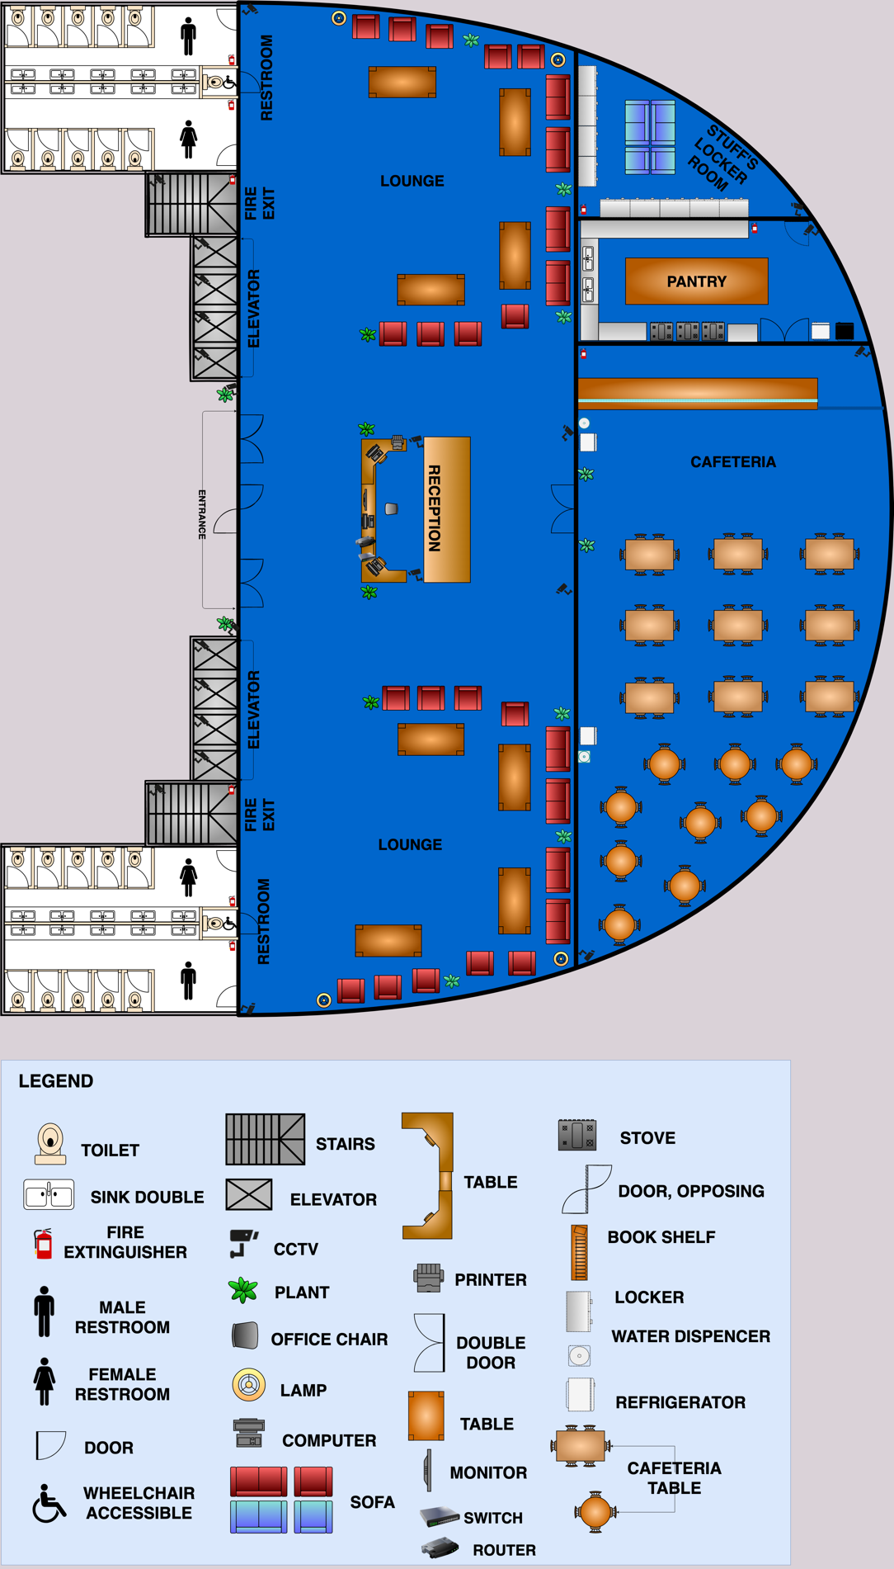

# a2. Physical Layout (2nd Floor)

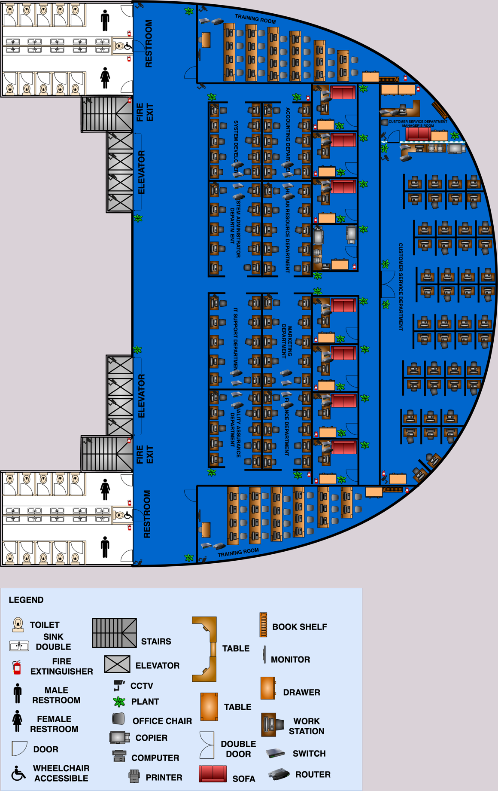

# a3. Physical Layout (3rd Floor)

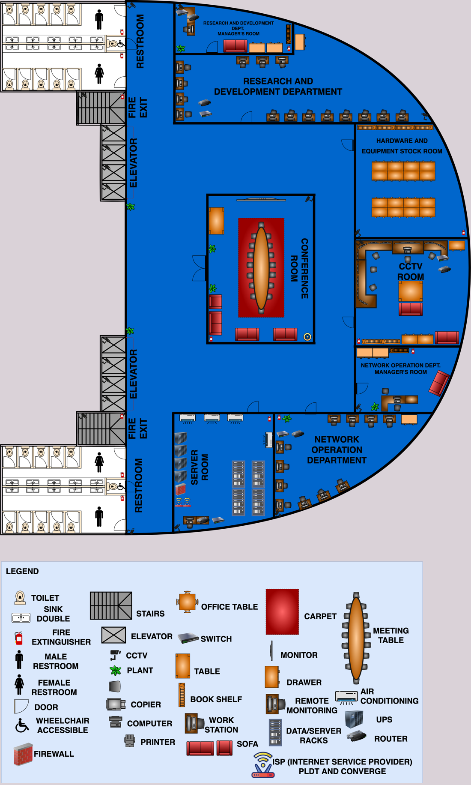

**a4. Physical Layout (4th Floor)**

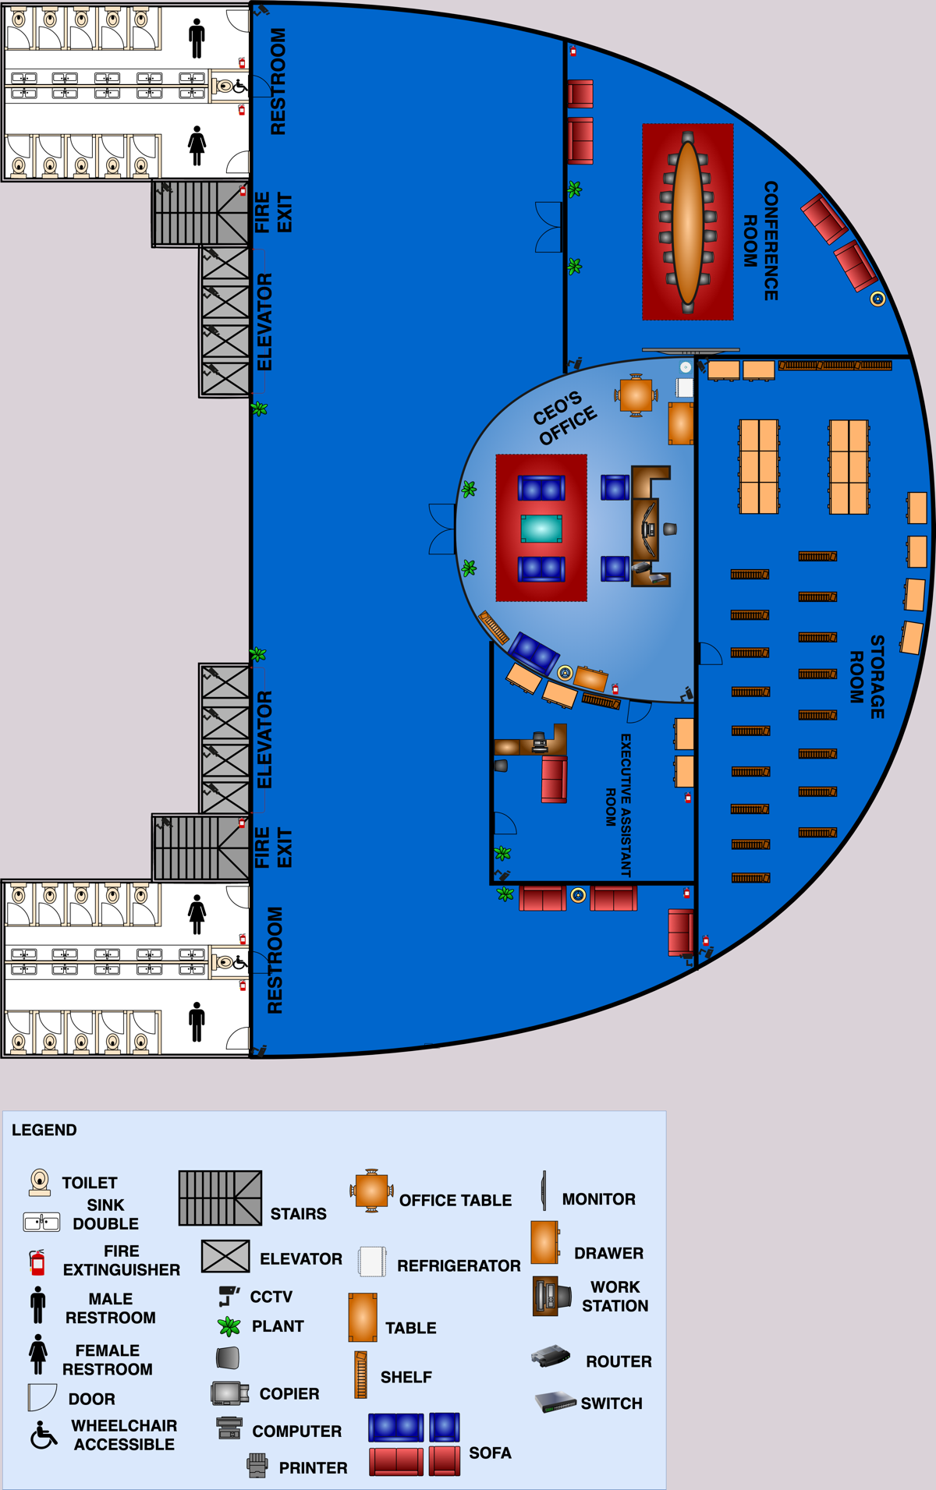

# a5. Logical Cabling Layout (Basement)

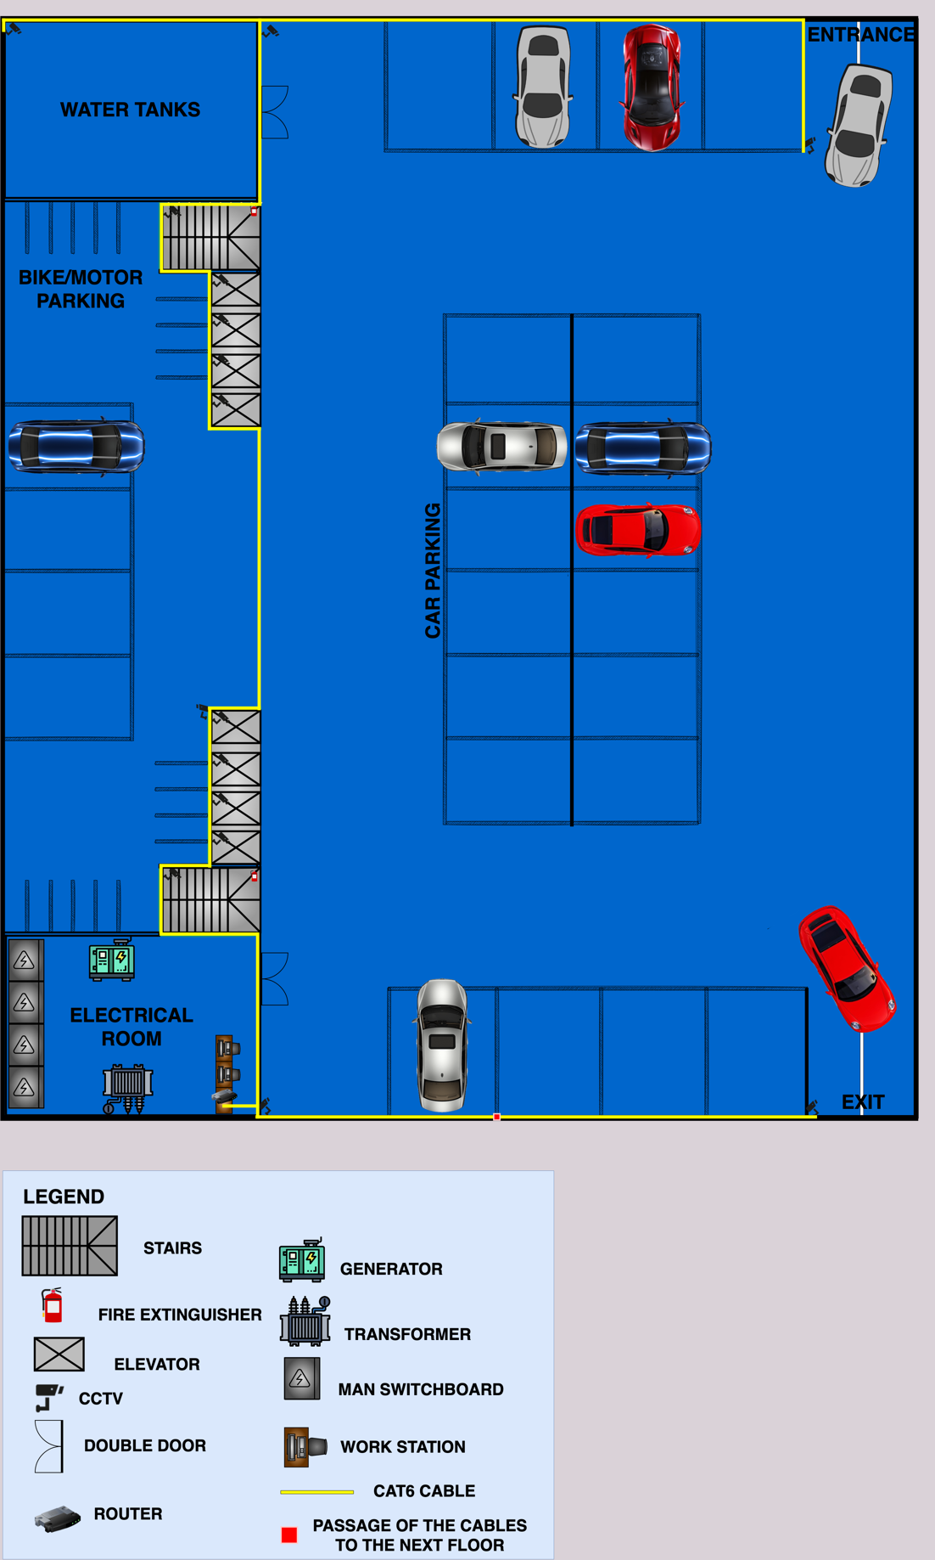

# a6. Logical Cabling Layout (Ground Floor)

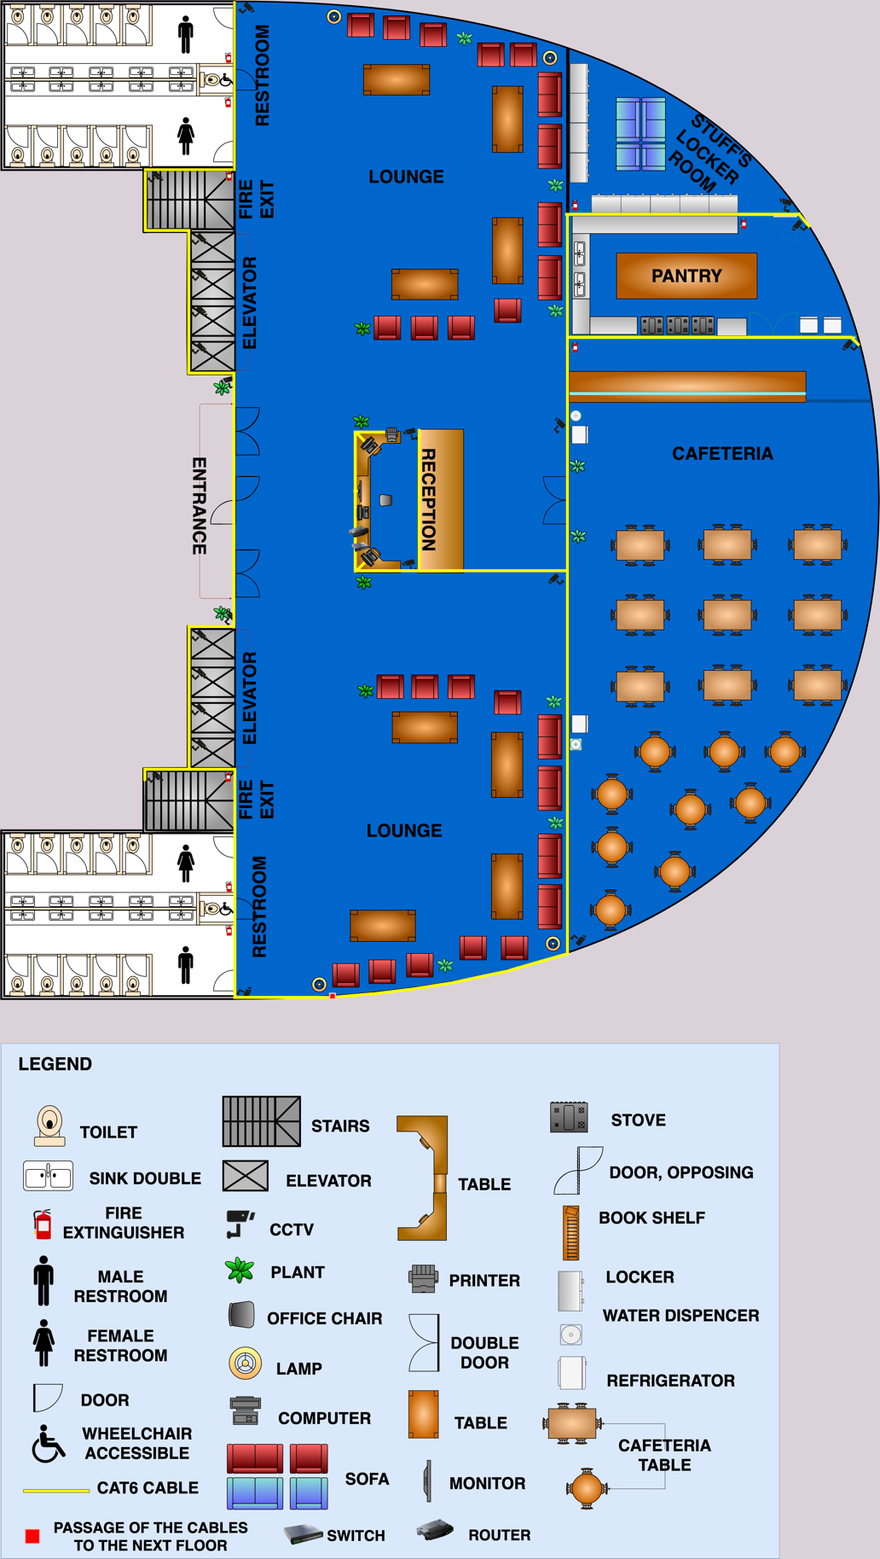

# a7. Logical Cabling Layout (2nd Floor)

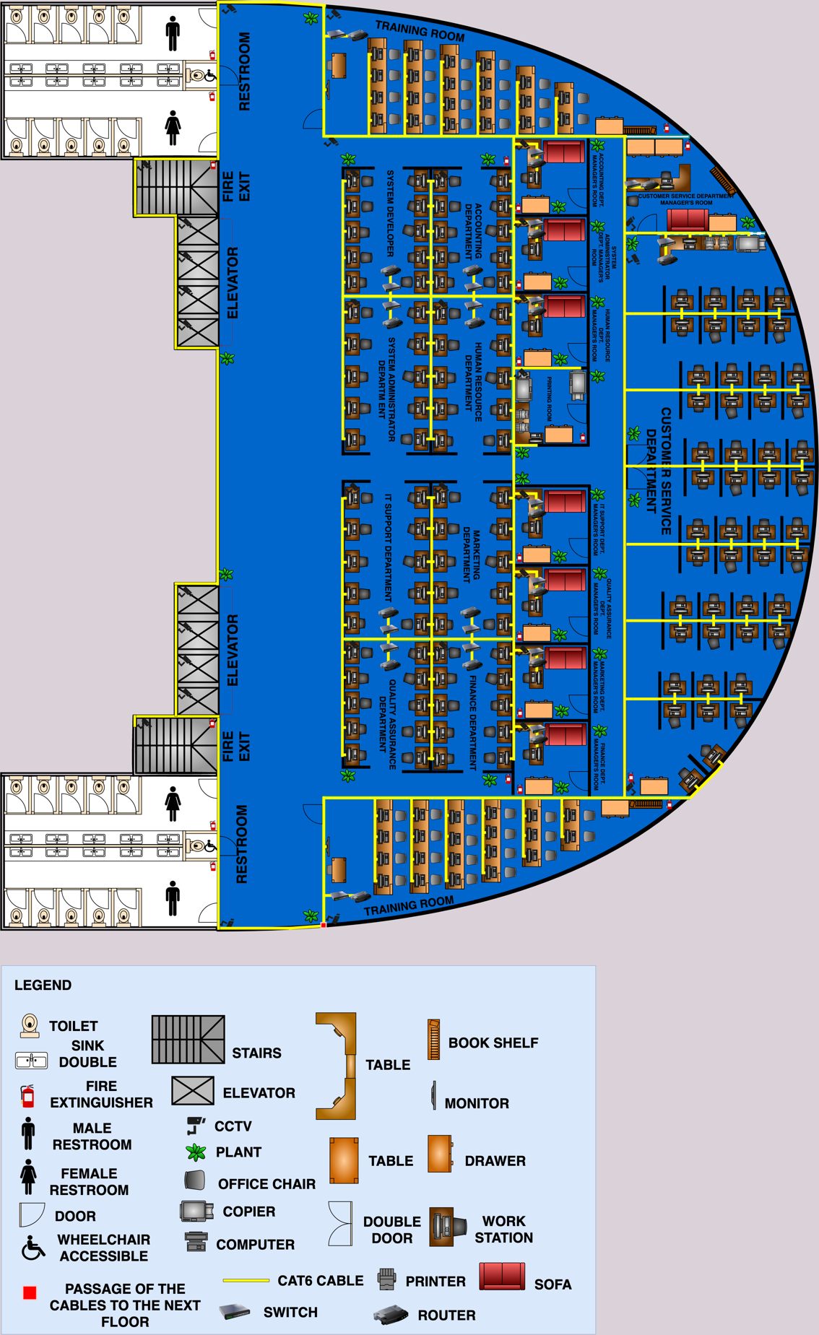

# a8. Logical Cabling Layout (3rd Floor)

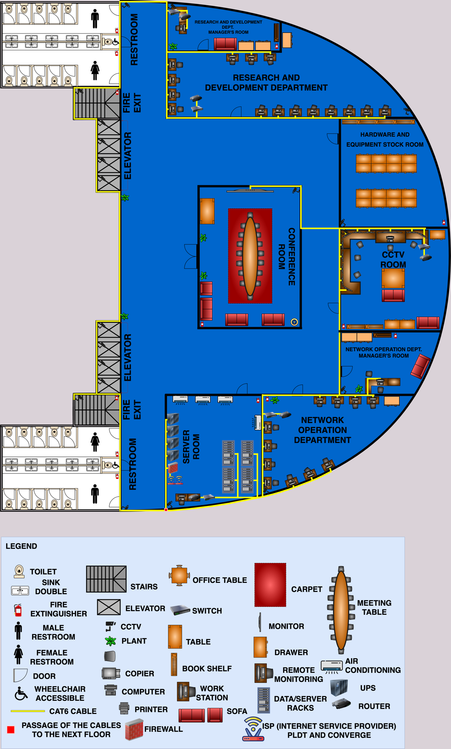

**a9. Logical Cabling Layout (4th Floor)**

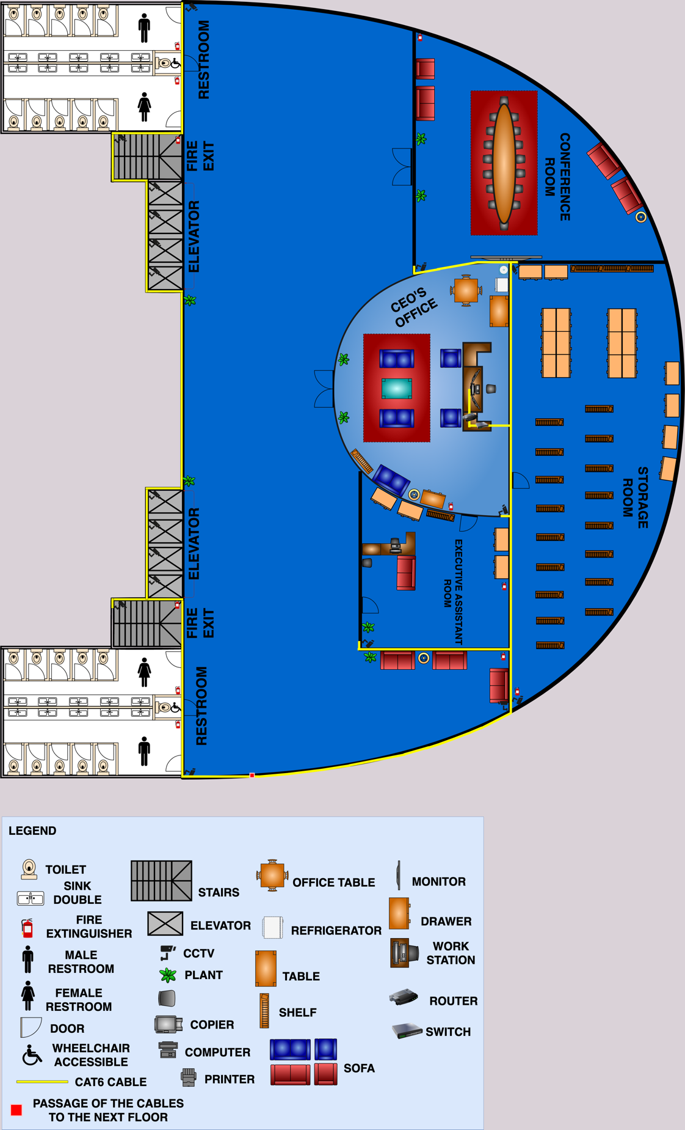

# b. A cabling plan for the server room

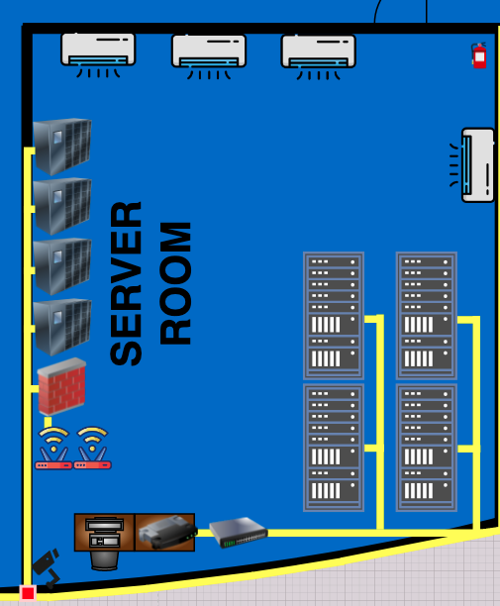

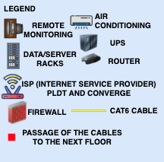

c. Layouts of all MDFs and IDFs

4. An IP addressing scheme for all devices on the network

## CLASS B NETWORKS

*RECEPTION HALL*

*1ST Floor*

|  |  |
| --- | --- |
| Default Gateway | 130.10.10.0 |
| FastEthernet0/0 | 130.10.10.1 |
| Router 1 Serial1/0 | 131.168.10.1 |
| Router 1 Serial1/1 | 132.168.10.1 |
| PC1 | 130.10.10.2 |
| PC2 | 130.10.10.3 |
| PC3 | 130.10.10.4 |
| Reserve IP Address | 130.10.10.5 – 30 |

*BASEMENTS*

|  |  |
| --- | --- |
| Default Gateway | 130.10.20.0 |
| FastEthernet0/0 | 130.10.20.1 |
| Router 2 Serial1/1 | 132.168.10.2 |
| PC 6 | 130.10.20.2 |
| PC 7 | 130.10.20.3 |
| Reserve IP Address | 130.10.20.4 – 30 |

*SERVER*

*3rd Floor*

|  |  |
| --- | --- |
| Server IP Address | 147.168.10.0 |
| Default Gateway | 130.10.30.0 |
| FastEthernet0/0 | 130.10.30.2 |
| FastEthernet0/1 | 147.168.10.1 |
| Router 0 Serial1/0 | 131.168.10.2 |
| Router 0 Serial1/1 | 133.168.10.1 |
| Router 0 Serial1/2 | 136.168.10.1 |
| Pc 0 | 130.10.30.2 |
| Reserve IP Address | 130.10.30.3 – 30 |

*TRAINING ROOM1*

*2nd Floor*

|  |  |
| --- | --- |
| Default Gateway | 130.10.40.0 |
| FastEthernet0/0 | 130.10.40.1 |
| Router 16 Serial1/0 | 137.168.10.1 |
| Router 16 Serial1/1 | 138.168.10.2 |
| Router 16 Serial1/2 | 136.168.19.2 |
| PC 8 | 130.10.40.2 |
| PC 9 | 130.10.40.3 |
| PC 10 | 130.10.40.4 |
| PC11 | 130.10.40.5 |
| PC 12 | 130.10.40.6 |
| PC 13 | 130.10.40.7 |
| PC 14 | 130.10.40.8 |
| PC 15 | 130.10.40.9 |
| PC 16 | 130.10.40.10 |
| PC17 | 130.10.40.11 |
| PC 18 | 130.10.40.12 |
| PC 19 | 130.10.40.13 |
| PC 20 | 130.10.40.14 |
| PC 21 | 130.10.40.15 |
| PC 22 | 130.10.40.16 |
| PC 23 | 130.10.40.17 |
| PC 24 | 130.10.40.18 |
| PC 25 | 130.10.40.19 |
| PC 26 | 130.10.40.20 |
| PC 27 | 130.10.40.21 |
| PC 28 | 130.10.40.22 |
| Reserve IP Address | 130.10.40.23 – 50 |

*ACCOUNTING DEPARTMENT*

*2nd Floor*

|  |  |
| --- | --- |
| Default Gateway | 130.20.50.0 |
| FastEthernet0/0 | 130.20.50.1 |
| Router 17 Serial1/0 | 137.168.10.2 |
| Router 17 Serial1/1 | 139.168.10.2 |
| Router 17 Serial1/2 | 140.168.10.1 |
| PC 29 | 130.20.50.2 |
| PC 30 | 130.20.50.3 |
| PC 31 | 130.20.50.4 |
| PC 32 | 130.20.50.5 |
| PC 33 | 130.20.50.6 |
| PC 34 | 130.20.50.7 |
| PC 35 | 130.20.50.8 |
| PC 36 | 130.20.50.9 |
| PC 37 | 130.20.50.10 |
| PC 38 | 130.20.50.11 |
| PC 39 | 130.20.50.12 |
| PC 40 | 130.20.50.13 |
| Reserve IP Address | 130.20.50.14 – 50 |

*SYSTEM DEPARTMENT*

*2nd Floor*

|  |  |
| --- | --- |
| Default Gateway | 130.20.60.0 |
| FastEthernet0/0 | 130.20.60.1 |
| Router 18 Serial1/0 | 141.168.10.2 |
| Router 18 Serial1/2 | 138.168.10.1 |
| PC 43 | 13.20.60.2 |
| PC 44 | 13.20.60.3 |
| PC 45 | 13.20.60.4 |
| PC 46 | 13.20.60.5 |
| PC 47 | 13.20.60.6 |
| PC 48 | 13.20.60.7 |
| PC 49 | 13.20.60.8 |
| PC 50 | 13.20.60.9 |
| PC 51 | 13.20.60.10 |
| PC 52 | 13.20.60.11 |
| Reserve IP Address | 13.20.60.12 – 50 |

*HUMAN RESOURCE DEPARTMENT*

*2nd Floor*

|  |  |
| --- | --- |
| Default Gateway | 130.20.70.0 |
| FastEthernet0/0 | 130.20.70.1 |
| Router 20 Serial1/1 | 142.168.10.1 |
| Router 20 Serial1/2 | 140.168.10.2 |
| PC 53 | 130.20.70.2 |
| PC 54 | 130.20.70.3 |
| PC 55 | 130.20.70.4 |
| PC 56 | 130.20.70.5 |
| PC 57 | 130.20.70.6 |
| PC 58 | 130.20.70.7 |
| PC 59 | 130.20.70.8 |
| PC 60 | 130.20.70.9 |
| PC 61 | 130.20.70.10 |
| PC 62 | 130.20.70.11 |
| PC 63 | 130.20.70.12 |
| PC 64 | 130.20.70.13 |
| Reserve IP Address | 130.20.70.14 - 50 |

*SYSTEM ADMIN DEPARTMENT*

*2nd Floor*

|  |  |
| --- | --- |
| Default Gateway | 130.20.80.0 |
| FastEthernet0/0 | 130.20.80.1 |
| Router 21 Serial1/0 | 141.168.10.1 |
| Router 21 Serial1/1 | 144.168.10.2 |
| PC 67 | 130.20.80.2 |
| PC 68 | 130.20.80.3 |
| PC 69 | 130.20.80.4 |
| PC 70 | 130.20.80.5 |
| PC 71 | 130.20.80.6 |
| PC 72 | 130.20.80.7 |
| PC 73 | 130.20.80.8 |
| PC 74 | 130.20.80.9 |
| PC 75 | 130.20.80.10 |
| PC 76 | 130.20.80.11 |
| Reserve IP Address | 130.20.80.12 - 50 |

*CUSTOMER SERVICE DEPARTMENT*

*2nd Floor*

*1st Switch*

|  |  |
| --- | --- |
| Default Gateway | 130.70.90.0 |
| FastEthernet0/0 | 130.70.90.1 |
| Router 5 Serial1/1 | 139.168.10.1 |
| PC 77 | 130.70.90.2 |
| PC 78 | 130.70.90.3 |
| PC 79 | 130.70.90.4 |
| PC 80 | 130.70.90.5 |
| PC 81 | 130.70.90.6 |
| PC 82 | 130.70.90.7 |
| PC 83 | 130.70.90.8 |
| PC 84 | 130.70.90.9 |
| PC 85 | 130.70.90.10 |
| PC 86 | 130.70.90.11 |
| PC 87 | 130.70.90.12 |
| PC 88 | 130.70.90.13 |
| PC 89 | 130.70.90.14 |
| PC 90 | 130.70.90.15 |
| PC 91 | 130.70.90.16 |
| PC 92 | 130.70.90.17 |
| PC 93 | 130.70.90.18 |
| PC 94 | 130.70.90.19 |
| PC 95 | 130.70.90.20 |
| PC 96 | 130.70.90.21 |
| PC 97 | 130.70.90.22 |
| PC 98 | 130.70.90.23 |
| PC 99 | 130.70.90.24 |
| PC 100 | 130.70.90.25 |
| Reserve IP Address | 130.70.90.26 - 50 |

*2nd Switch*

|  |  |
| --- | --- |
| Default Gateway | 130.80.90.0 |
| FastEthernet0/0 | 130.80.90.1 |
| Router 6 Serial1/1 | 139.168.10.1 |
| PC 101 | 130.80.90.2 |
| PC 102 | 130.80.90. |
| PC 103 | 130.80.90. |
| PC 104 | 130.80.90. |
| PC 105 | 130.80.90. |
| PC 106 | 130.80.90. |
| PC 107 | 130.80.90. |
| PC 108 | 130.80.90. |
| PC 109 | 130.80.90. |
| PC 110 | 130.80.90. |
| PC 111 | 130.80.90. |
| PC 112 | 130.80.90. |
| PC 113 | 130.80.90. |
| PC 114 | 130.80.90. |
| PC 115 | 130.80.90. |
| PC 116 | 130.80.90. |
| PC 117 | 130.80.90. |
| PC 118 | 130.80.90. |
| PC 119 | 130.80.90. |
| PC 120 | 130.80.90. |
| PC 121 | 130.80.90. |
| PC 122 | 130.80.90. |
| PC 123 | 130.80.90. |
| PC 124 | 130.80.90. |
| Reserve IP Address | 130.80.90.26 - 50 |

*MARKETING DEPARTMENT*

*2nd Floor*

|  |  |
| --- | --- |
| Default Gateway | 130.20.90.0 |
| FastEthernet0/0 | 130.20.90.1 |
| Router 22 Serial1/0 | 142.168.10.2 |
| Router 22 Serial1/1 | 143.168.10.1 |
| PC 125 | 130.20.90.2 |
| PC 126 | 130.20.90.3 |
| PC 127 | 130.20.90.4 |
| PC 128 | 130.20.90.5 |
| PC 129 | 130.20.90.6 |
| PC 130 | 130.20.90.7 |
| PC 131 | 130.20.90.8 |
| PC 132 | 130.20.90.9 |
| PC 133 | 130.20.90.10 |
| PC 134 | 130.20.90.11 |
| PC 135 | 130.20.90.12 |
| PC 136 | 130.20.90.13 |
| Reserve IP Address | 130.20.90.14 - 50 |

*IT SUPPORT DEPARTMENT*

*2nd Floor*

|  |  |
| --- | --- |
| Default Gateway | 130.30.90.0 |
| FastEthernet0/0 | 130.30.90.1 |
| Router 23 Serial1/1 | 145.168.10.2 |
| Router 23 Serial1/2 | 144.168.10.1 |
| PC 139 | 130.30.90.2 |
| PC 140 | 130.30.90.3 |
| PC 141 | 130.30.90.4 |
| PC 142 | 130.30.90.5 |
| PC 143 | 130.30.90.6 |
| PC 144 | 130.30.90.7 |
| PC 145 | 130.30.90.8 |
| PC 146 | 130.30.90.9 |
| PC 147 | 130.30.90.10 |
| PC 148 | 130.30.90.11 |
| Reserve IP Address | 130.30.90.12 - 50 |

*QUALITY ASSURANCE DEPARTMENT*

*2nd Floor*

|  |  |
| --- | --- |
| Default Gateway | 130.50.90.0 |
| FastEthernet0/0 | 130.50.90.1 |
| Router 25 Serial1/0 | 145.168.10.1 |
| Router 25 Serial1/2 | 146.168.10.2 |
| PC 151 | 130.50.90.2 |
| PC 152 | 130.50.90.3 |
| PC 153 | 130.50.90.4 |
| PC 154 | 130.50.90.5 |
| PC 155 | 130.50.90.6 |
| PC 156 | 130.50.90.7 |
| PC 157 | 130.50.90.8 |
| PC 158 | 130.50.90.9 |
| PC 159 | 130.50.90.10 |
| PC 160 | 130.50.90.11 |
| Reserve IP Address | 130.50.90. 12 - 50 |

*FINANCE DEPARTMENT*

*2nd Floor*

|  |  |
| --- | --- |
| Default Gateway | 130.40.90.0 |
| FastEthernet0/0 | 130.40.90.1 |
| Router 24 Serial1/1 | 143.168.10.2 |
| PC 149 | 130.40.90.2 |
| PC 150 | 130.40.90.3 |
| PC 161 | 130.40.90.4 |
| PC 162 | 130.40.90.5 |
| PC 163 | 130.40.90.6 |
| PC 164 | 130.40.90.7 |
| PC 165 | 130.40.90.8 |
| PC 166 | 130.40.90.9 |
| PC 167 | 130.40.90.10 |
| PC 168 | 130.40.90.11 |
| PC 169 | 130.40.90.12 |
| PC 170 | 130.40.90.13 |
| Reserve IP Address | 130.50.90.14 - 50 |

*TRAINING ROOM2*

*2nd Floor*

|  |  |
| --- | --- |
| Default Gateway | 130.60.90.0 |
| FastEthernet0/0 | 130.60.90.1 |
| Router 23 Serial1/1 | 146.168.10.1 |
| PC 171 | 130.60.90.2 |
| PC 172 | 130.60.90.3 |
| PC 173 | 130.60.90.4 |
| PC 174 | 130.60.90.5 |
| PC 175 | 130.60.90.6 |
| PC 176 | 130.60.90.7 |
| PC 177 | 130.60.90.8 |
| PC 178 | 130.60.90.9 |
| PC 179 | 130.60.90.10 |
| PC 180 | 130.60.90.11 |
| PC 181 | 130.60.90.12 |
| PC 182 | 130.60.90.13 |
| PC 183 | 130.60.90.14 |
| PC 184 | 130.60.90.15 |
| PC 185 | 130.60.90.16 |
| PC 186 | 130.60.90.17 |
| PC 187 | 130.60.90.18 |
| PC 188 | 130.60.90.19 |
| PC 189 | 130.60.90.20 |
| PC 190 | 130.60.90.21 |
| PC 191 | 130.60.90.22 |
| Reserve IP Address | 130.60.90.23 - 50 |

*CCTV ROOM*

*3rd Floor*

|  |  |
| --- | --- |
| Default Gateway | 130.95.90.0 |
| FastEthernet0/0 | 130.95.90.1 |
| Router 5 Serial1/0 | 134.168.10.2 |
| Router 5 Serial1/1 | 135.168.10.1 |
| PC 203 | 130.95.90.2 |
| PC 204 | 130.95.90.3 |
| PC 205 | 130.95.90.4 |
| PC 206 | 130.95.90.5 |
| PC 207 | 130.95.90.6 |
| PC 208 | 130.95.90.7 |
| PC 209 | 130.95.90.8 |
| PC 210 | 130.95.90.9 |
| PC 211 | 130.95.90.10 |
| PC 212 | 130.95.90.11 |
| Reserve IP Address | 130.95.90.12 - 50 |

*RESEARCH AND DEVELOPERS’ DEPARTMENT*

*3rd Floor*

|  |  |
| --- | --- |
| Default Gateway | 130.95.95.0 |
| FastEthernet0/0 | 130.95.95.1 |
| Router 15 Serial1/1 | 135.168.10.2 |
| PC 213 | 130.95.95.2 |
| PC 214 | 130.95.95.3 |
| PC 215 | 130.95.95.4 |
| PC 216 | 130.95.95.5 |
| PC 217 | 130.95.95.6 |
| PC 218 | 130.95.95.7 |
| PC 219 | 130.95.95.8 |
| PC 220 | 130.95.95.9 |
| PC 221 | 130.95.95.10 |
| PC 222 | 130.95.95.11 |
| PC 223 | 130.95.95.12 |
| PC 224 | 130.95.95.13 |
| PC 225 | 130.95.95.14 |
| PC 226 | 130.95.95.15 |
| PC 227 | 130.95.95.16 |
| PC 228 | 130.95.95.17 |
| Reserve IP Address | 130.95.95.18 - 50 |

*NETWORK OPERATION DEPARMENT*

*3rd Floor*

|  |  |
| --- | --- |
| Default Gateway | 130.90.90.0 |
| FastEthernet0/0 | 130.90.90.1 |
| Router 4 Serial1/0 | 134.168.10.1 |
| Router 4 Serial1/1 | 133.168.10.2 |
| PC 137 | 130.90.90.2 |
| PC 138 | 130.90.90.3 |
| PC 192 | 130.90.90.4 |
| PC 193 | 130.90.90.5 |
| PC 194 | 130.90.90.6 |
| PC 195 | 130.90.90.7 |
| PC 196 | 130.90.90.8 |
| PC 197 | 130.90.90.9 |
| PC 198 | 130.90.90.10 |
| PC 199 | 130.90.90.11 |
| PC 200 | 130.90.90.12 |
| PC 201 | 130.90.90.13 |
| PC 202 | 130.90.90.14 |
| Reserve IP Address | 130.90.90.15 - 50 |

*CEO OFFICE*

*4th Floor*

|  |  |
| --- | --- |
| Default Gateway | 130.100.100.0 |
| FastEthernet0/0 | 130.100.100.1 |
| Router 2 Serial1/2 | 147.168.10.1 |
| PC 5 | 130.100.100.2 |
| PC 6 | 130.100.100.3 |
| Reserve IP Address | 130.10.20.4 – 20 |

5. A cost projection for the implementation of the network, including:

1. Equipment purchase costs

Reception hall, Basement, Cctv Room

|  |  |  |  |  |
| --- | --- | --- | --- | --- |
| **HARDWARE** | **BRAND** | **QUANTITY** | **PRICE** | **TOTAL** |
| Processor | Intel Core i39100 | 15 | 3,600 | 54,000 |
| Motherboard | ASUS H310M | 15 | 3,510 | 52,650 |
| RAM | HyperX FURY DDR4 RAM 4GB | 15 | 11,499 | 172,485 |
| HDD | Seagate  Barracuda  500gb | 15 | 950 | 14,250 |
| SSD | Ramsta SSD S800 120gb | 15 | 2,090 | 31,350 |
| KEYBOARD | A4Tech KRS8572 USB | 15 | 1,860 | 27,900 |
| MOUSE | A4Tech OP-720 USB | 15 | 420 | 6,300 |
| MONITOR | AOC 22 inch monitor TN PC Computer  Display Screen | 15 | 165 | 2,475 |
| UPS | APC UPS  650VA-360W  Uninterruptible Power Supply | 15 | 5,499 | 82,485 |
| POWER SUPPLY | Aero Cool Rave  600W Power  Supply | 15 | 1,260 | 18,900 |
|  |  |  | **OVERALL TOTAL:** | 462,795 |

Training Room, Accounting Department, Human Resource Department, Customer

Service Department, Marketing Department, Quality Assurance Department,

Finance Department

|  |  |  |  |  |
| --- | --- | --- | --- | --- |
| **HARDWARE** | **BRAND** | **QUANTITY** | **PRICE** | **TOTAL** |
| Processor | Intel Core i59400F | 148 | 8,100.00 | 1,198,800 |
| Motherboard | ASUS H310M | 148 | 3,510 | 466,200 |
| RAM | HyperX FURY  DDR4 RAM  4GB | 148 | 1,400 | 207,200 |
| HDD | Seagate  Barracuda  500gb | 148 | 1,699 | 251, 452 |
| SSD | Ramsta SSD S800 120gb | 148 | 1,860 | 275,280 |
| KEYBOARD | A4Tech KRS8572 USB | 148 | 420 | 62,160 |
| MOUSE | A4Tech OP720 USB | 148 | 165 | 24,420 |
| MONITOR | AOC 22 inch monitor TN PC  Computer  Display Screen | 148 | 5,499 | 813,852 |
| UPS | APC UPS  650VA-360W  Uninterruptible Power Supply | 148 | 1,260 | 186,480 |
| POWER SUPPLY | Aero Cool  Rave 600W  Power Supply | 148 | 3,100 | 456,800 |
|  | |  | **OVERALL TOTAL:** | **P3,942,644** |

System Department, System Admin Department, It Support, Research and Developers Department, Network Operation Department

|  |  |  |  |  |
| --- | --- | --- | --- | --- |
| HARDWARE | BRAND | QUANTITY | PRICE | TOTAL |
| Processor | Intel Core i59400F | 59 | 8,100 | 477,900 |
| Motherboard | ASUS H310M | 59 | 3,510 | 207,090 |
| Graphics Card | PALIT  GeForce® 1050 Ti StormX  4096MB  GDDR5  Graphics Card | 59 | 11,499 | 678,441 |
| RAM | HyperX FURY  DDR4 RAM  4GB | 59 | 1,400 | 82,600 |
| HDD | Seagate Barracuda 1TB | 59 | 2,090 | 123,310 |
| SSD | Ramsta SSD S800 120gb | 59 | 1,860 | 109,740 |
| KEYBOARD | A4Tech KRS8572 USB | 59 | 420 | 24,780 |
| MOUSE | A4Tech OP720 USB | 59 | 165 | 9,735 |
| MONITOR | AOC 22-inch monitor TN PC  Computer  Display Screen | 59 | 5,499 | 324,441 |
| UPS | APC UPS  650VA-360W  Uninterruptible  Power Supply | 59 | 1,260 | 74,340 |
| POWER SUPPLY | Aero Cool  Rave 600W  Power Supply | 59 | 3,100 | 182,900 |
|  | |  | **OVERALL TOTAL:** | **P2,295,277** |

Server

|  |  |  |  |  |
| --- | --- | --- | --- | --- |
| **HARDWARE** | **SPECIFICATION** | **QUANTITY** | **PRICE** | **TOTAL** |
| Processor | 16 cores: Intel Xeon Gold 6246R. | 4 | P175,800 | P703,200 |
| RAM | T340 2XHCW 64GB RAM  1TB | 4 | P79,950 | P319,800 |
| Storage | SuperMicro 2U 24-Bay 2.5 | 4 | P66,450 | P265,800 |
| Graphics Card | Intel HD Graphics 620 | 4 | P31,500 | P126,000 |
| Connector | VGA, Display port, serial, 4 x NIC ports | 4 | P10,500 | P42,000 |
| **OVERALL TOTAL** | | | | **P1,456,800** |

Router and Switches

|  |  |  |  |  |
| --- | --- | --- | --- | --- |
| **HARDWARE** | **BRAND** | **QUANTITY** | **PRICE** | **TOTAL** |
| ROUTERS | CISCO2801 Cisco 2801 | 18 | P20,500 | P369,000 |
| SWITCHES | CISCO CBS220-24T-4G | 18 | P14,500 | P261,000 |
| **OVERALL TOTAL:** | | | | **P630,000** |

Firewall

|  |  |  |
| --- | --- | --- |
| **BRAND** | **QUANTITY** | **TOTAL** |
| ASA5505-BUN-K9 Cisco ASA 5505 Firewall | 1 | P30,345 |
| **OVERALL TOTAL:** | | **P30,345** |

1. Cabling and testing costs

|  |  |  |  |
| --- | --- | --- | --- |
| **EQUIPMENTS** | **PRICE** | **QUANTITY** | **TOTAL** |
| RJ-45 | P10 | 478 | P4,780 |
| CAT 6a Cable | P2,750 (305 meters) | 15 | P41,250 |
| RG6 Siamese Cable CCTV Coaxial Cable | P6,800 (305 meters) | 10 | P68,000 |
| Cisco CAB-CONSOLE-RJ45 | P4,590 | 17 | P78,030 |
|  | **OVERALL TOTAL:** | | **P192,060** |

1. Equipment installation costs

|  |  |  |  |
| --- | --- | --- | --- |
| **EQUIPMENT INSTALLATION COSTS** | |  |  |
| PRODUCT | PRICE | QUANTITY | TOTAL |
| CISCO2801 Cisco 2801 | P2,500 | 18 | P45,000 |
| CISCO CBS220-24T-4G | P2,500 | 18 | P45,000 |
| CCTV | P1,200 | 75 | P90,000.00 |
| RS148 Data  Center Server  Cabinet | P10,000.00 | 9 | P90,000.00 |
| APC UPS 650VA-  360W  Uninterruptible  Power Supply  (BVX650I-PH, Easy  UPS, 4 Outlet,  AVR/Surge) | P1,918 | 4 | P7,672.00 |
| Z |  | **OVERALL TOTAL:** | **P277,672** |

1. Training and support costs

|  |  |  |
| --- | --- | --- |
| **TRAINING AND SUPPORT COST** |  |  |
| Training costs for any department | | |
|  | **OVERALL TOTAL:** | **P18,000** |

# 1.3 Objectives

*Specific Objectives*

* To design the physical and logical layouts for network infrastructure of the new Systemantech Building.
* To construct a simulation facility to represent Systemantech.
* To deploy the proposed structured cabling design.
* To design and implement cabling facility.
* Acquisition design and implement cabling facility.
* To identify and acquire the necessary Network Devices and Equipment’s. o Budget o Device

# 1.4 Logical Configuration of proposed network

• Codes per router

PC4: CEO ROOM (4th Floor)

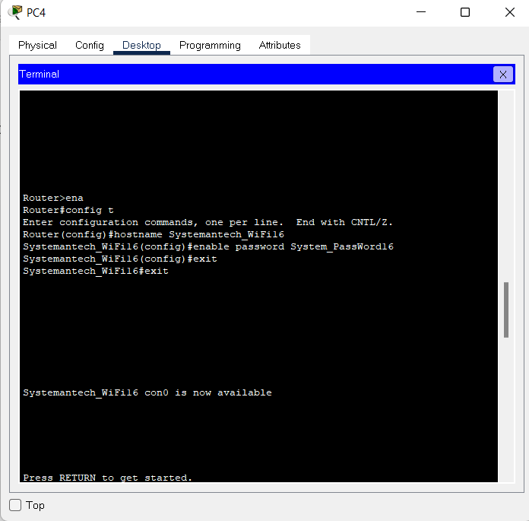

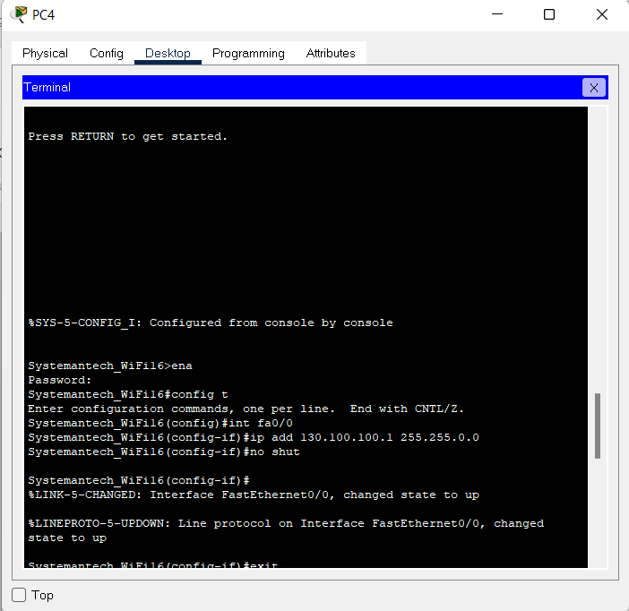

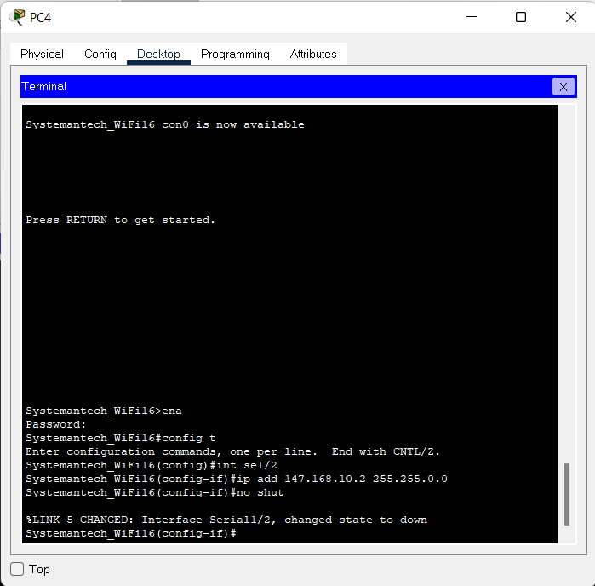

PC1: RECEPTION HALL (1st Floor)

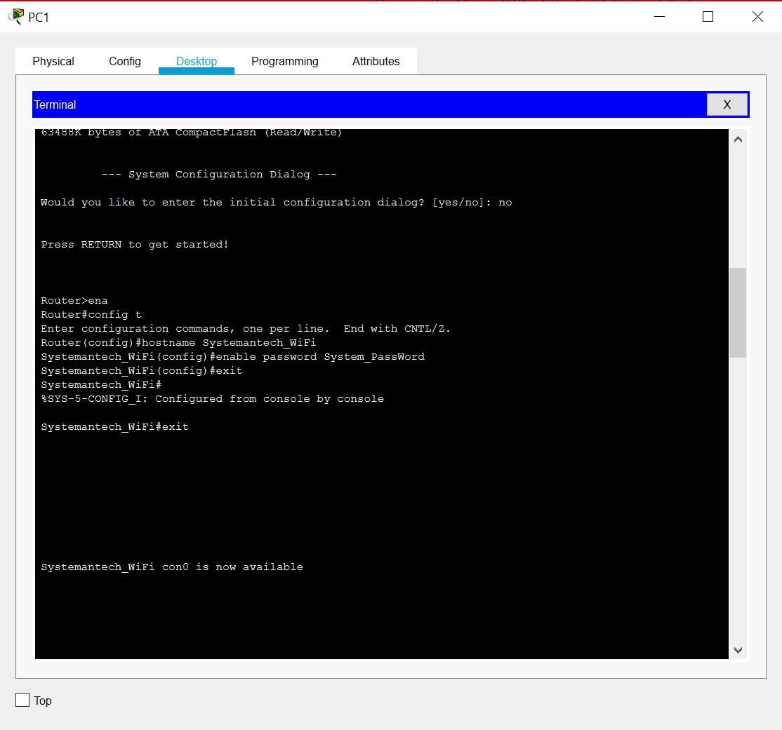

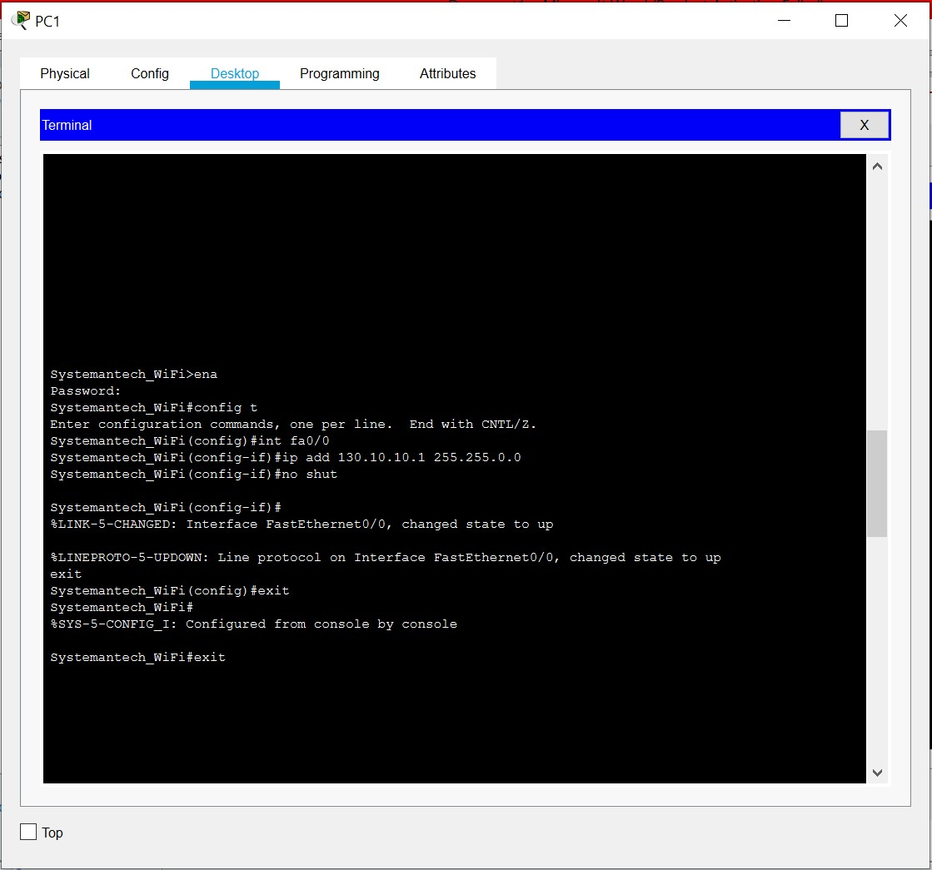

## Serial1/1: RECEPTION HALL (1st Floor) TO BASEMENT

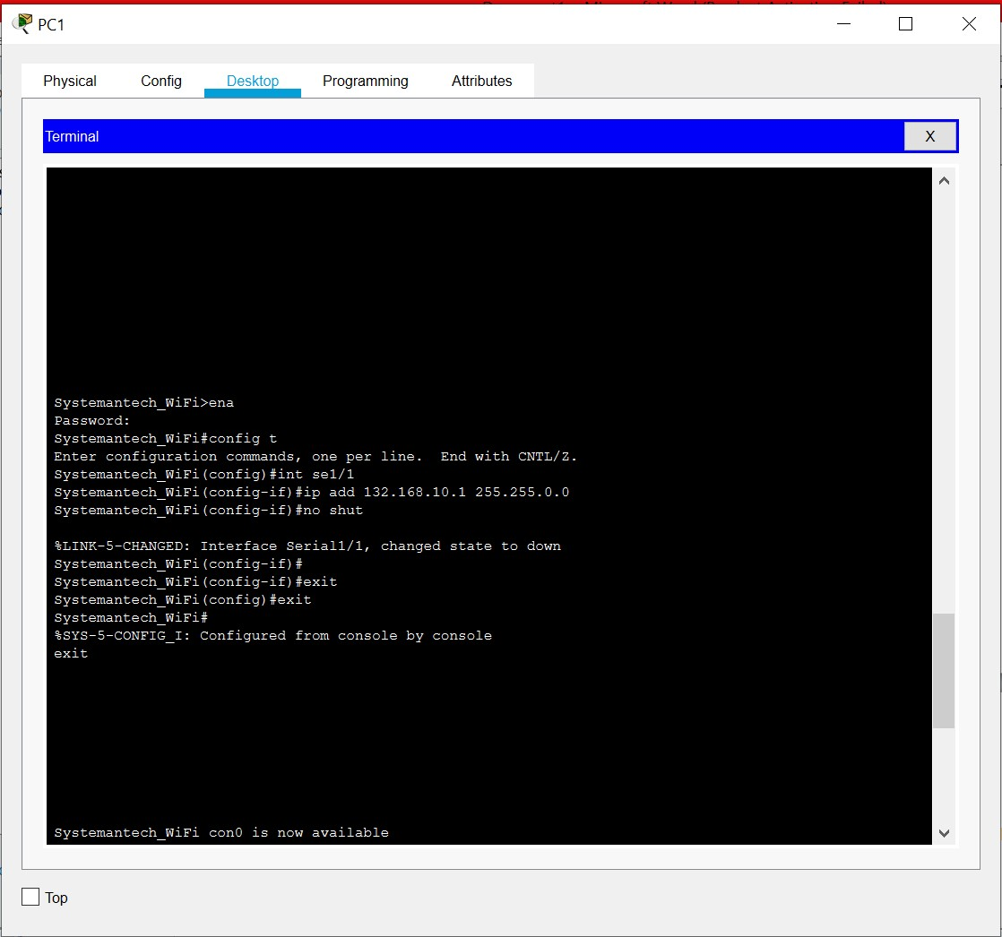

## Serial 1/0: RECEPTION HALL (1st Floor) TO SERVER ROOM (3rd Floor)

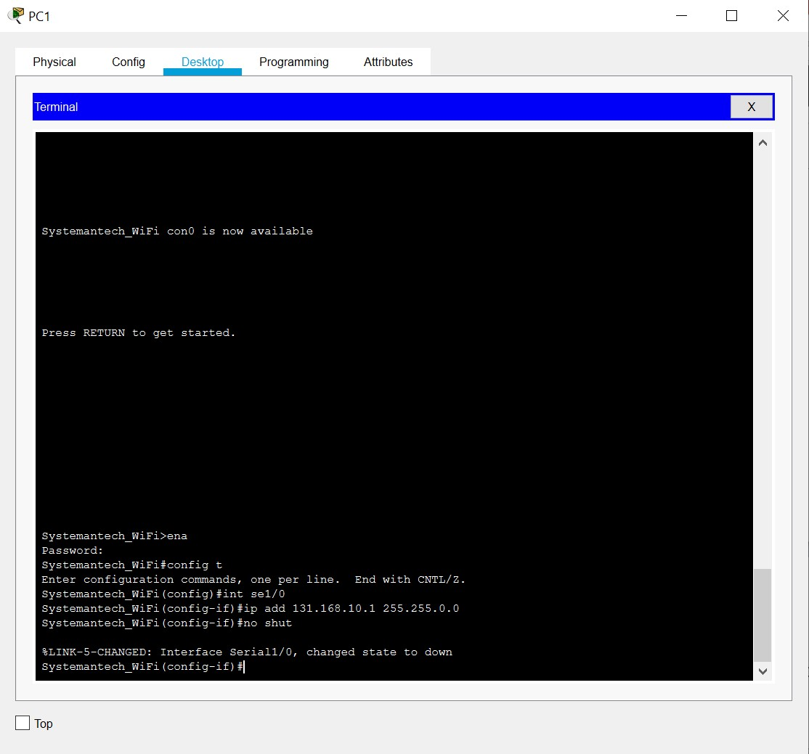

## PC 0: SERVER ROOM

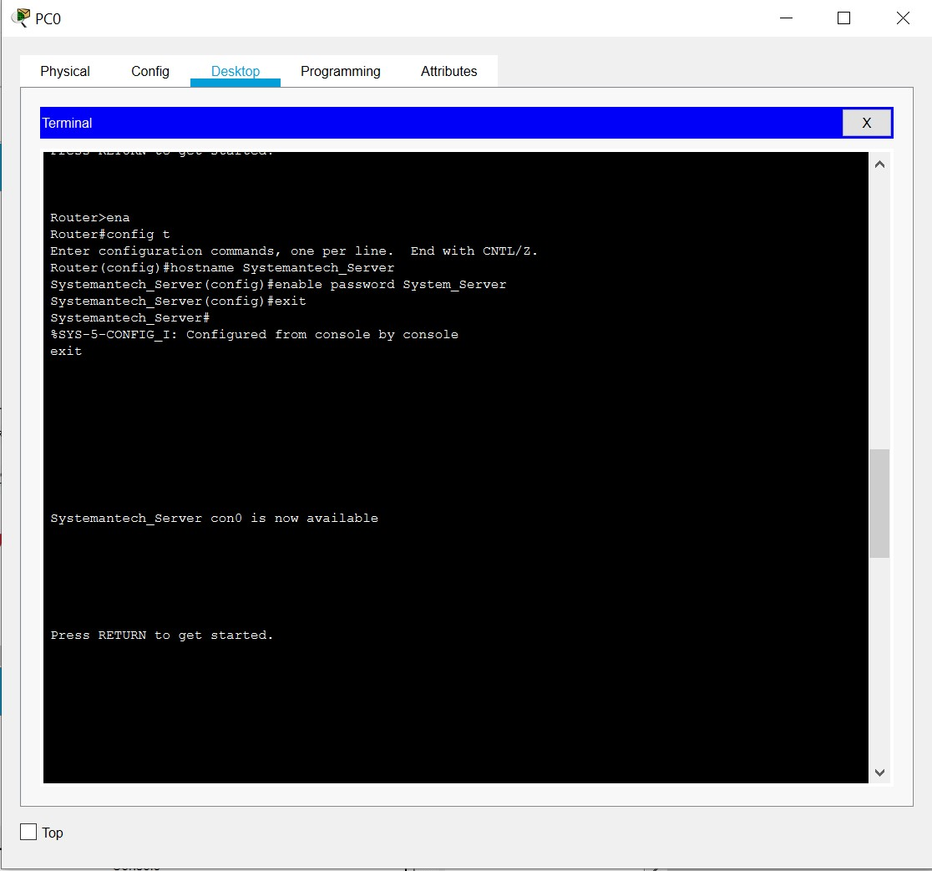

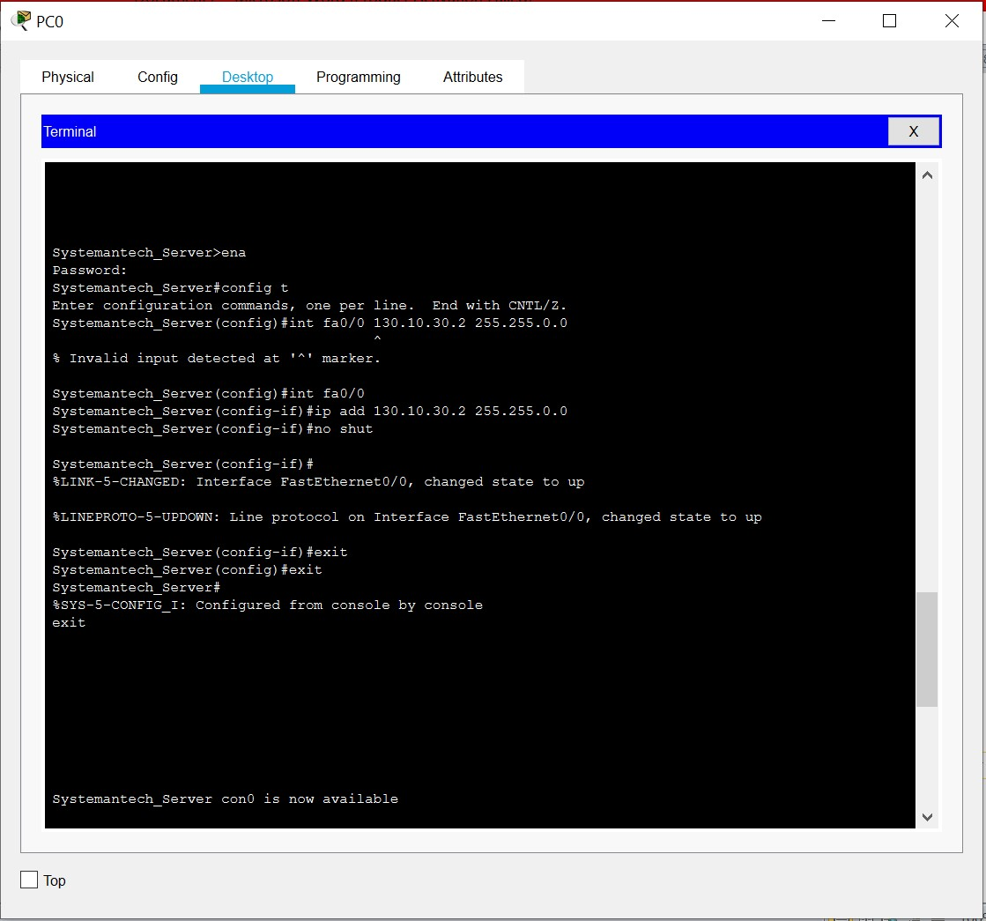

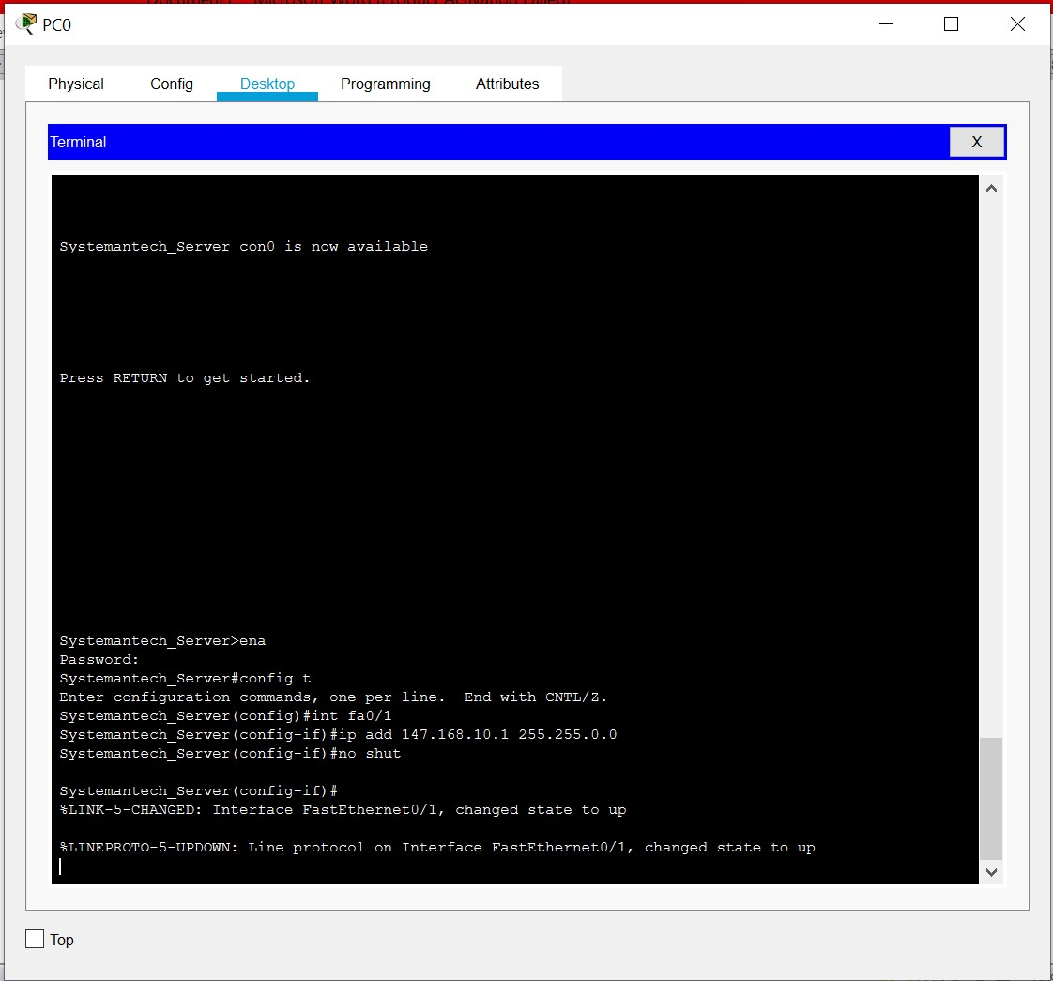

## Serial 1/0: SERVER ROOM TO RECEPTION HALL

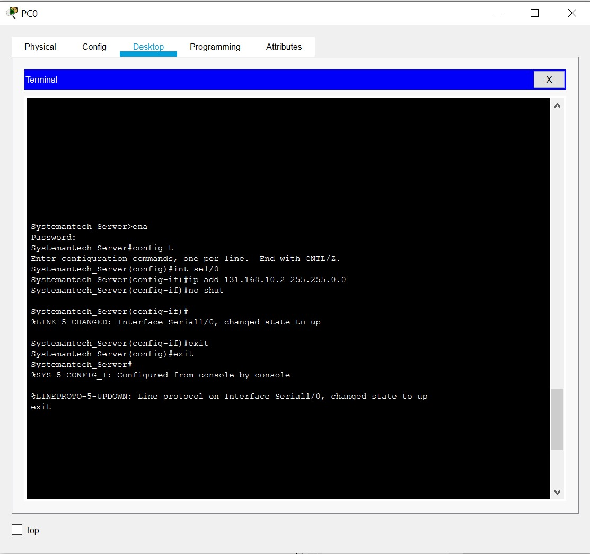

## Serial 1/1: SERVER ROOM TO NETWORK OPERATION DEPARTMENT

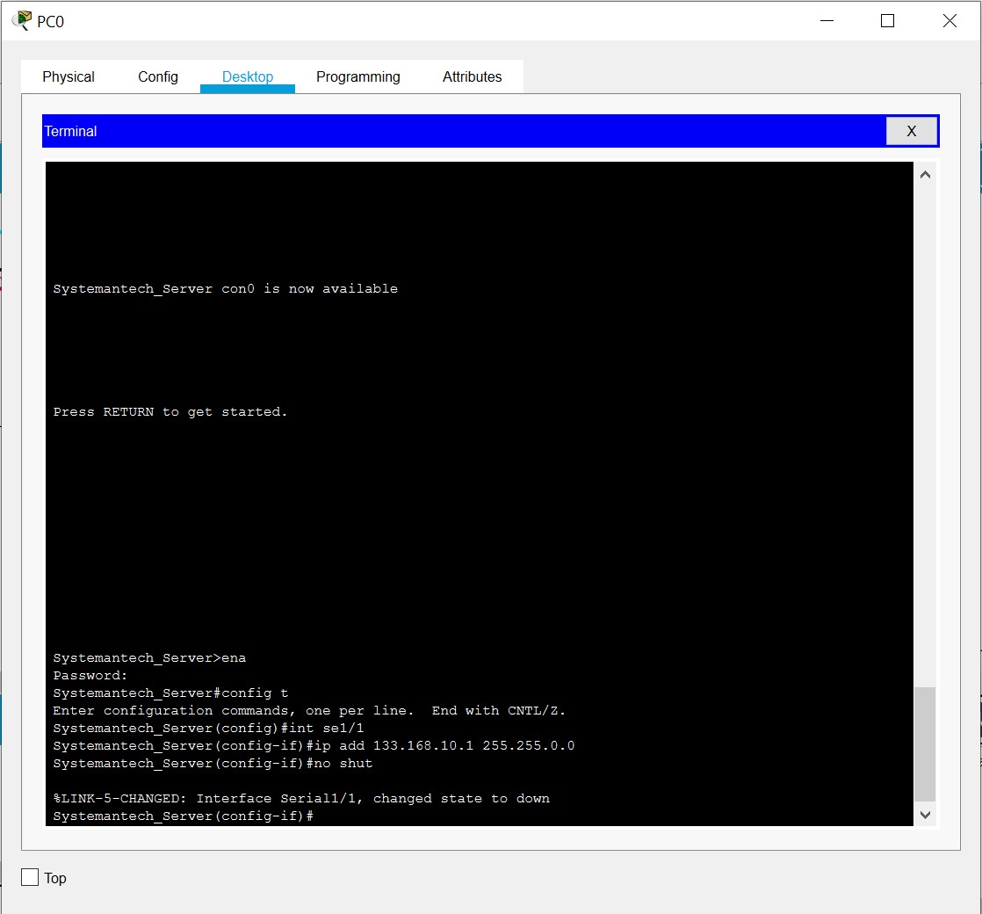

## Serial 1/2: SERVER ROOM TO TRANING ROOM

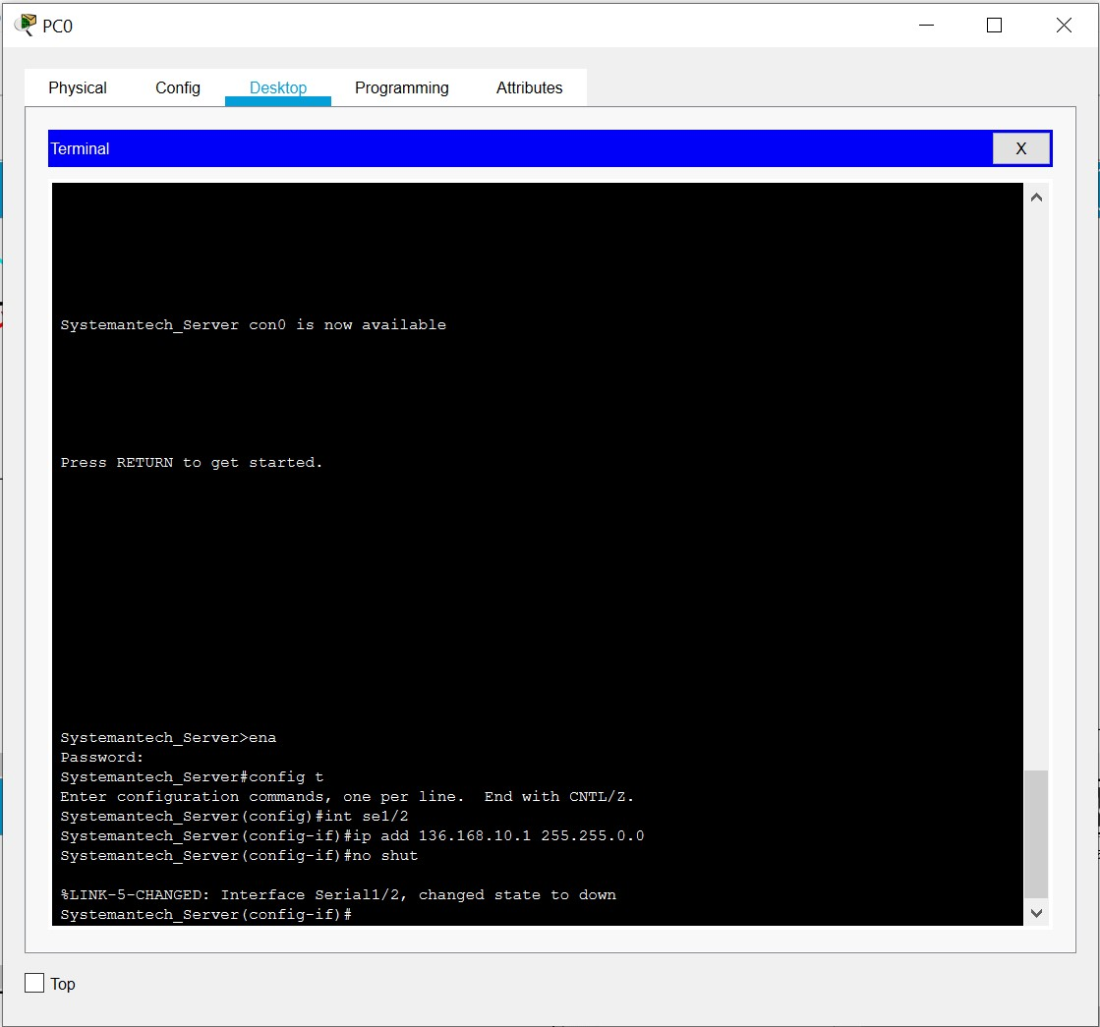

## PC 6: BASEMENT

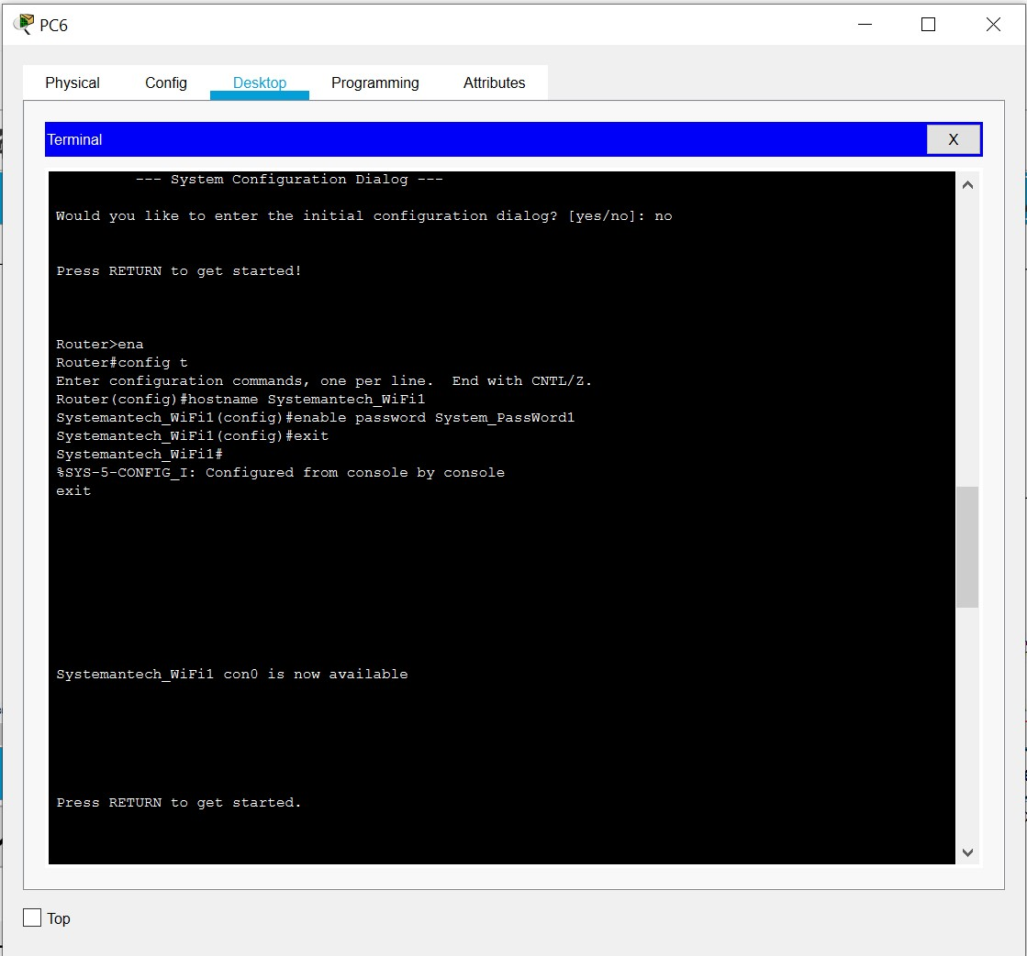

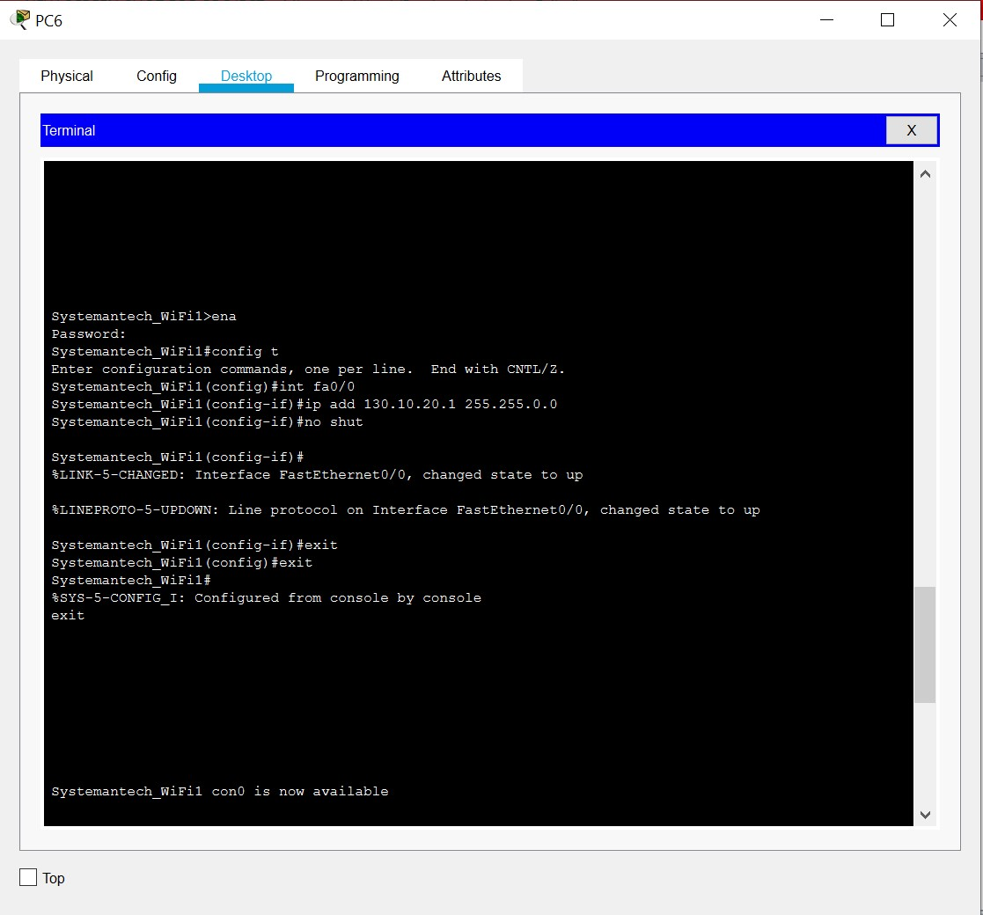

## Serial 1/1: BASEMENT TO RECEPTION HALL

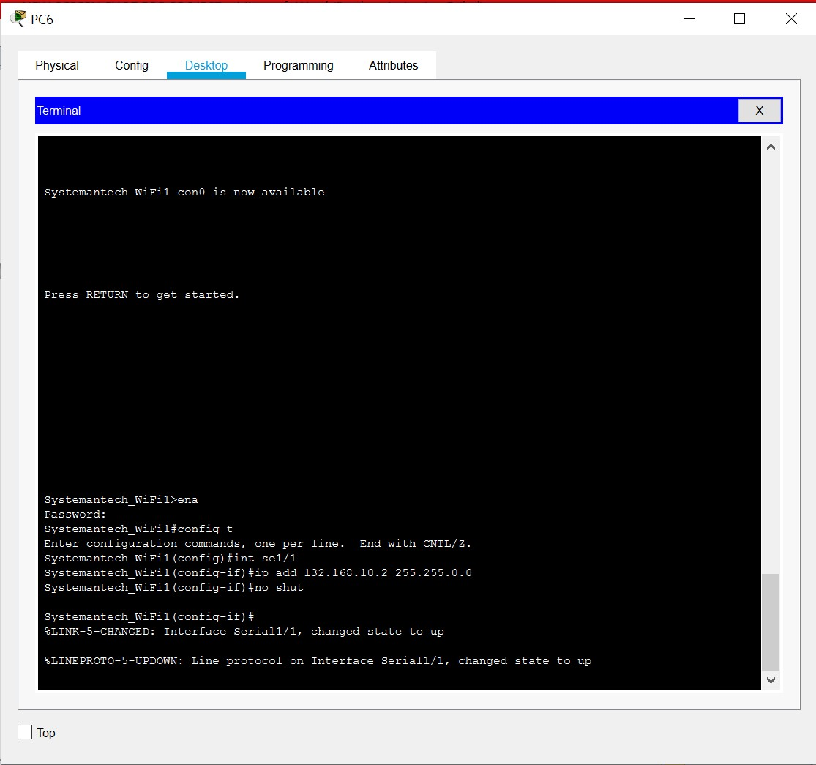

## PC 137: NETWORK OPERATION DEPARTMENT

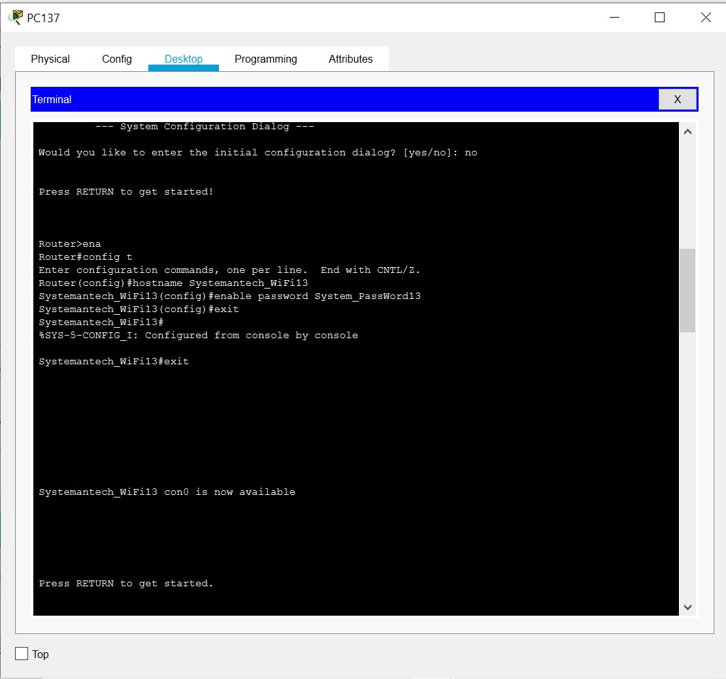

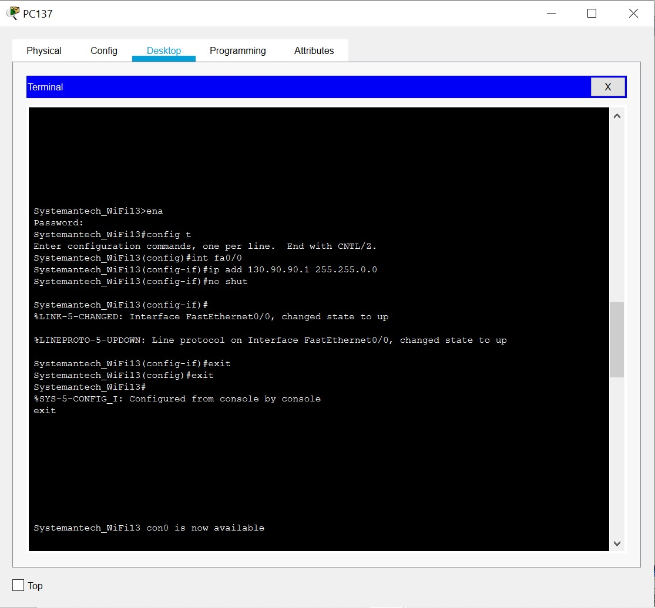

## Serial 1/1: NETWORK OPERATION DEPARTMENT TO SERVER ROOM

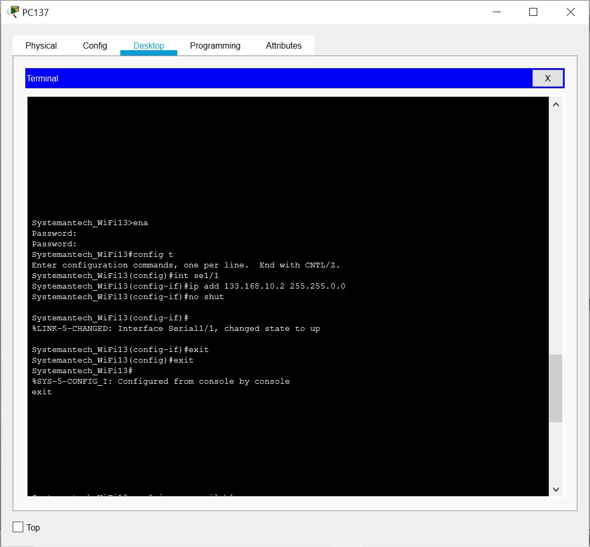

## Serial 1/1: NETWORK OPERATION DEPARTMENT TO CCTV ROOM

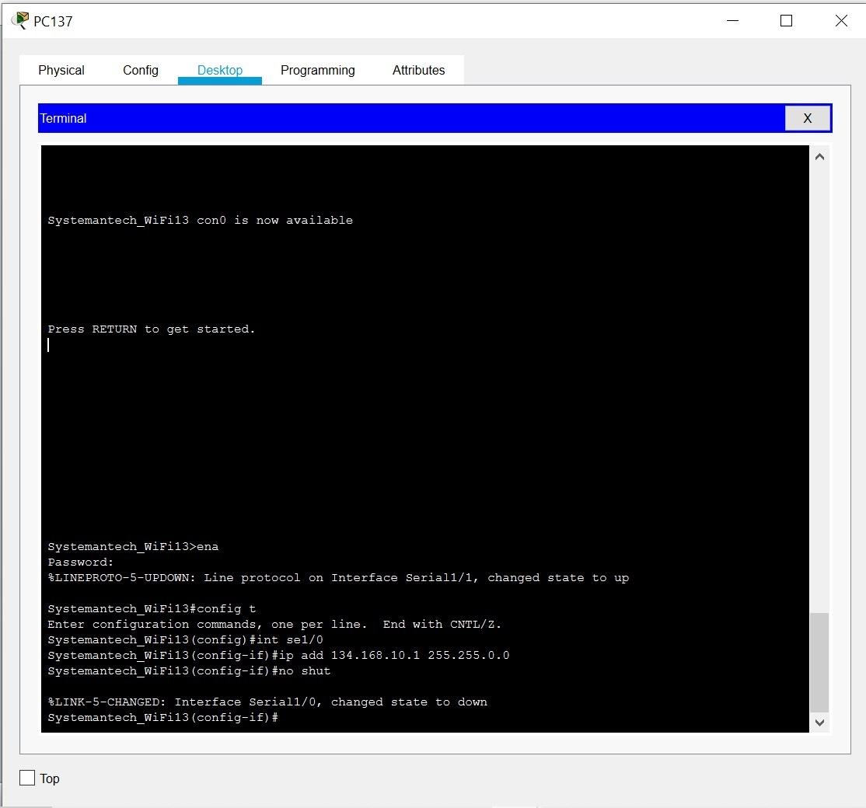

## PC 203: CCTV ROOM

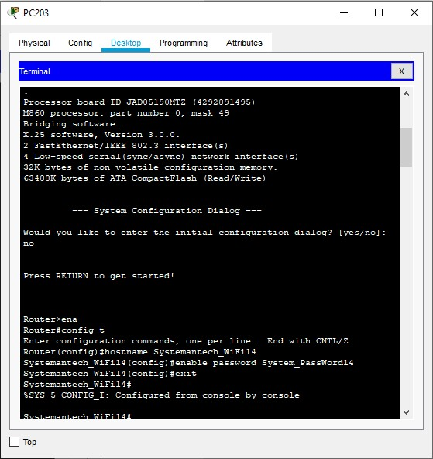

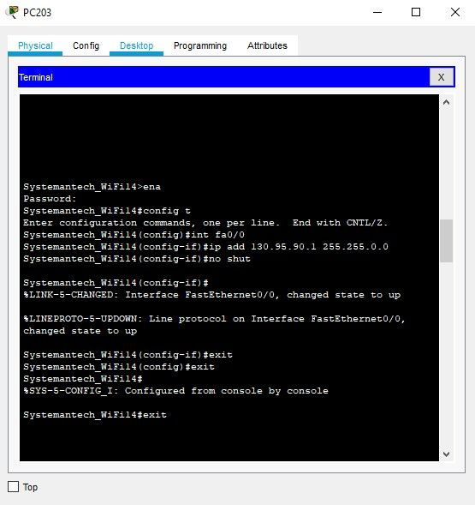

## Serial 1/0: CCTV ROOM TO NETWORK OPERATION DEPARTMENT

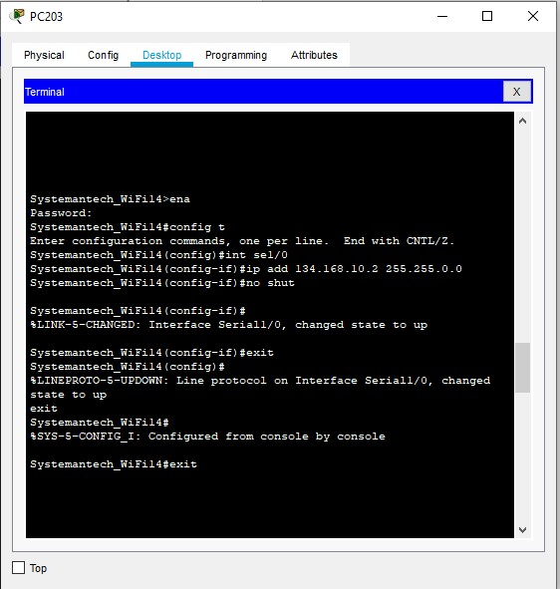

## Serial 1/1: CCTV ROOM TO RESEARCH DEV DEPARTMENT

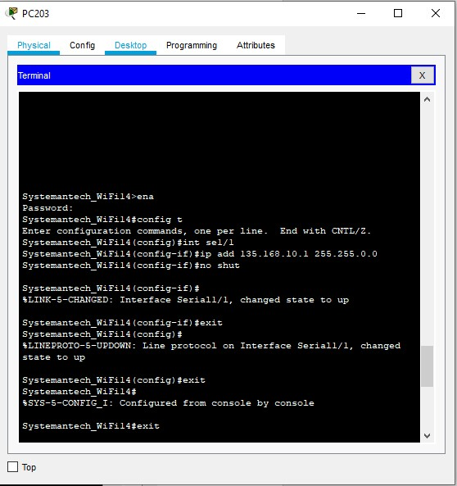

## PC213: RESEARCH AND DEV DEPARTMENT

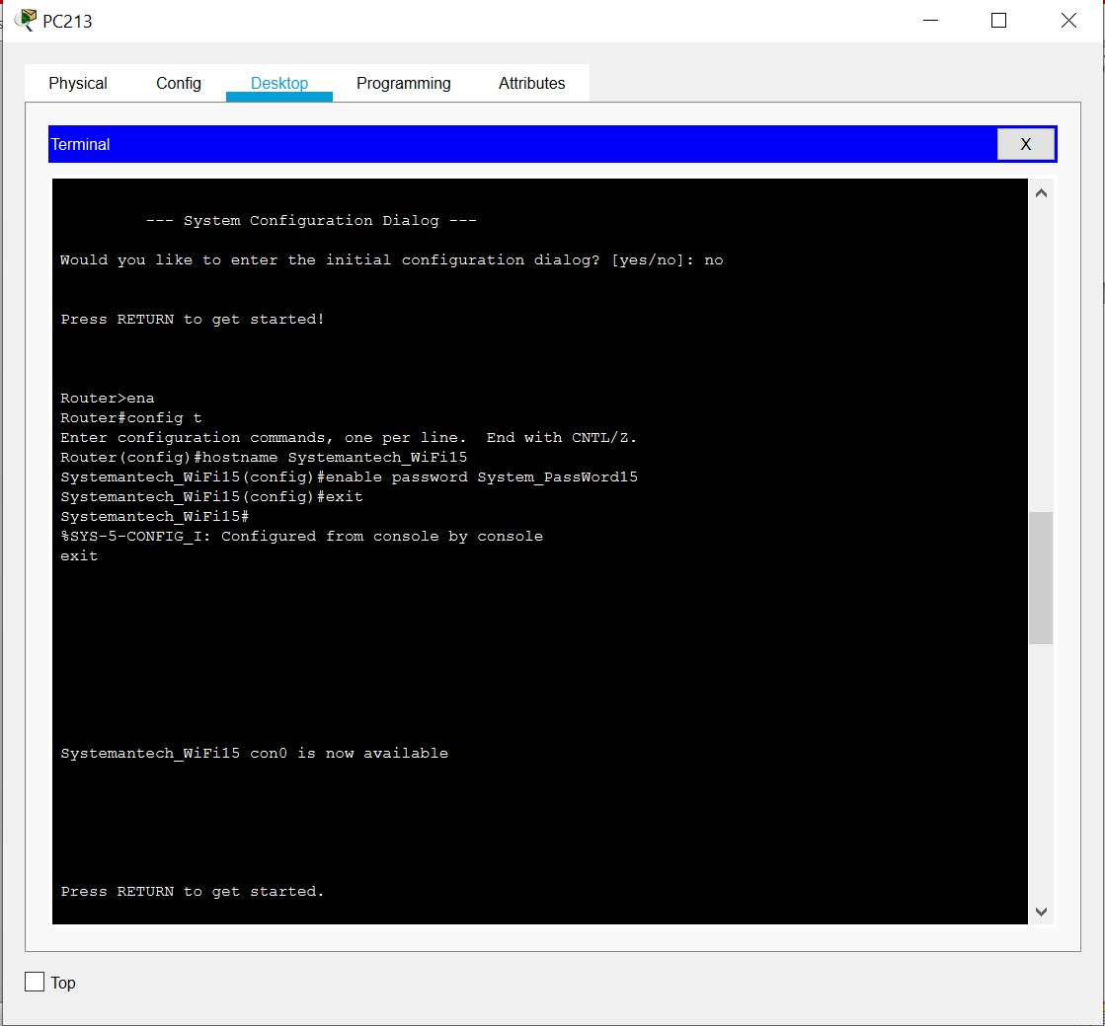

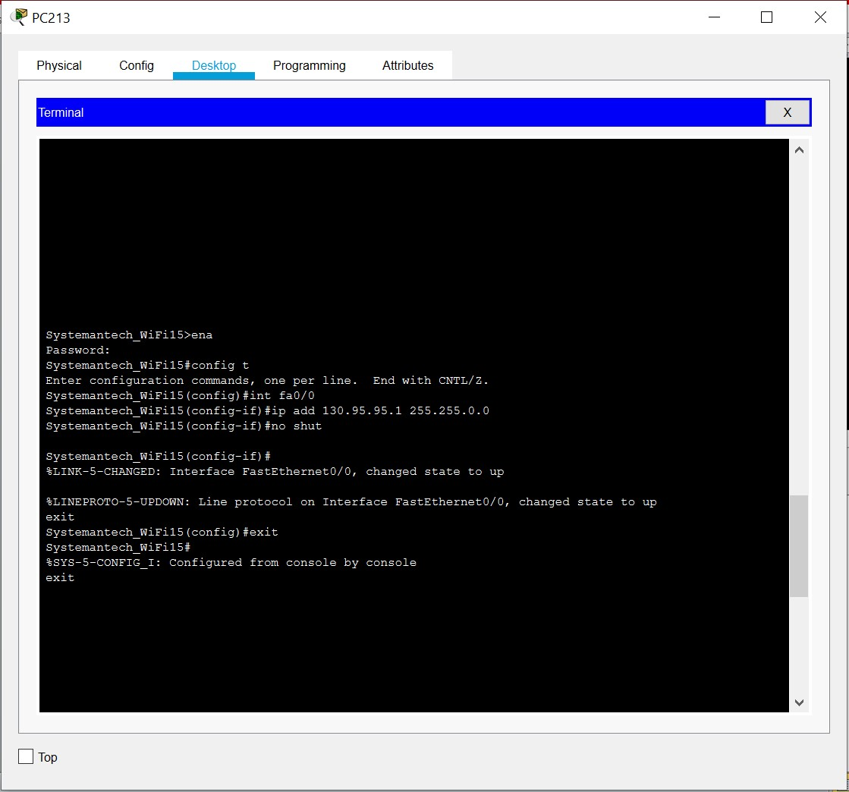

## Serial 1/1: RESEARCH AND DEV DEPARTMENT TO CCTV ROOM

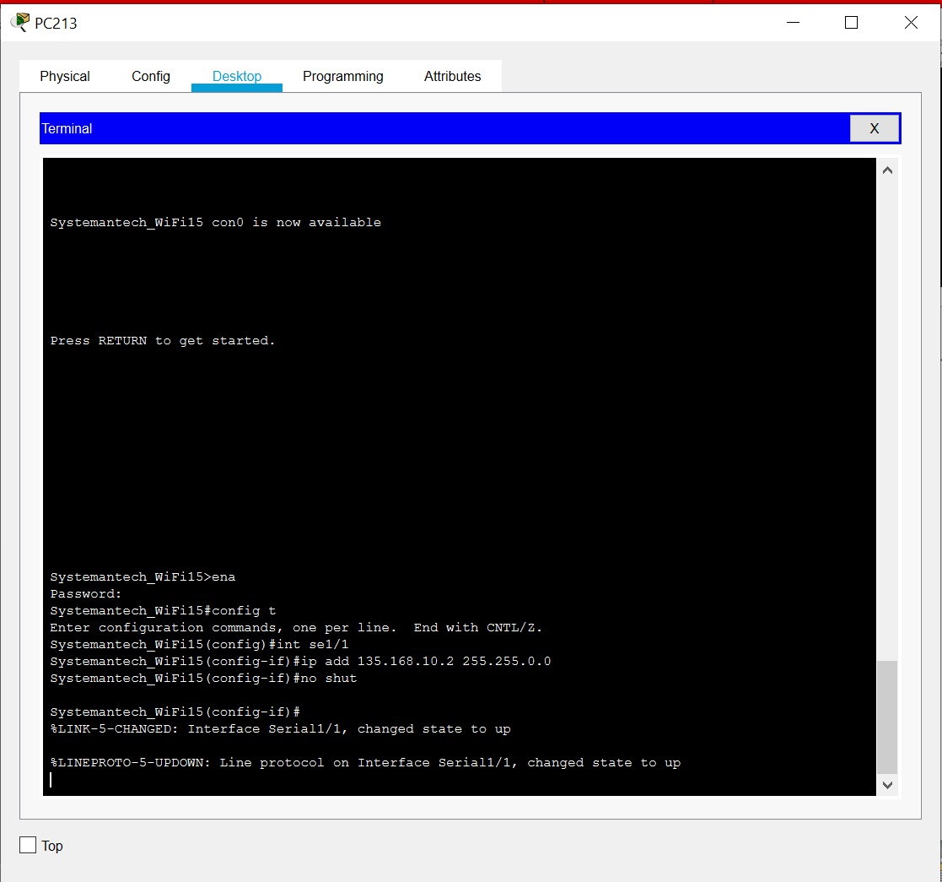

## PC8: TRAINING ROOM 1

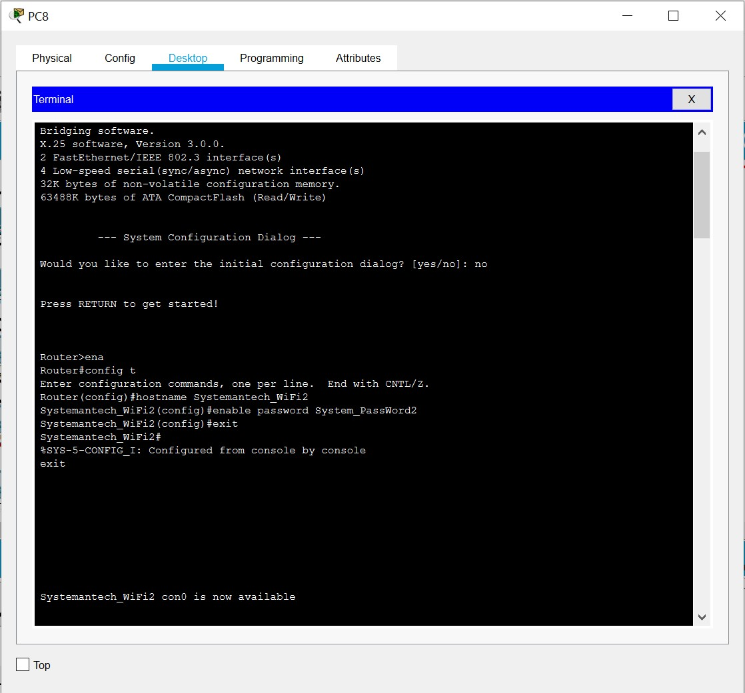

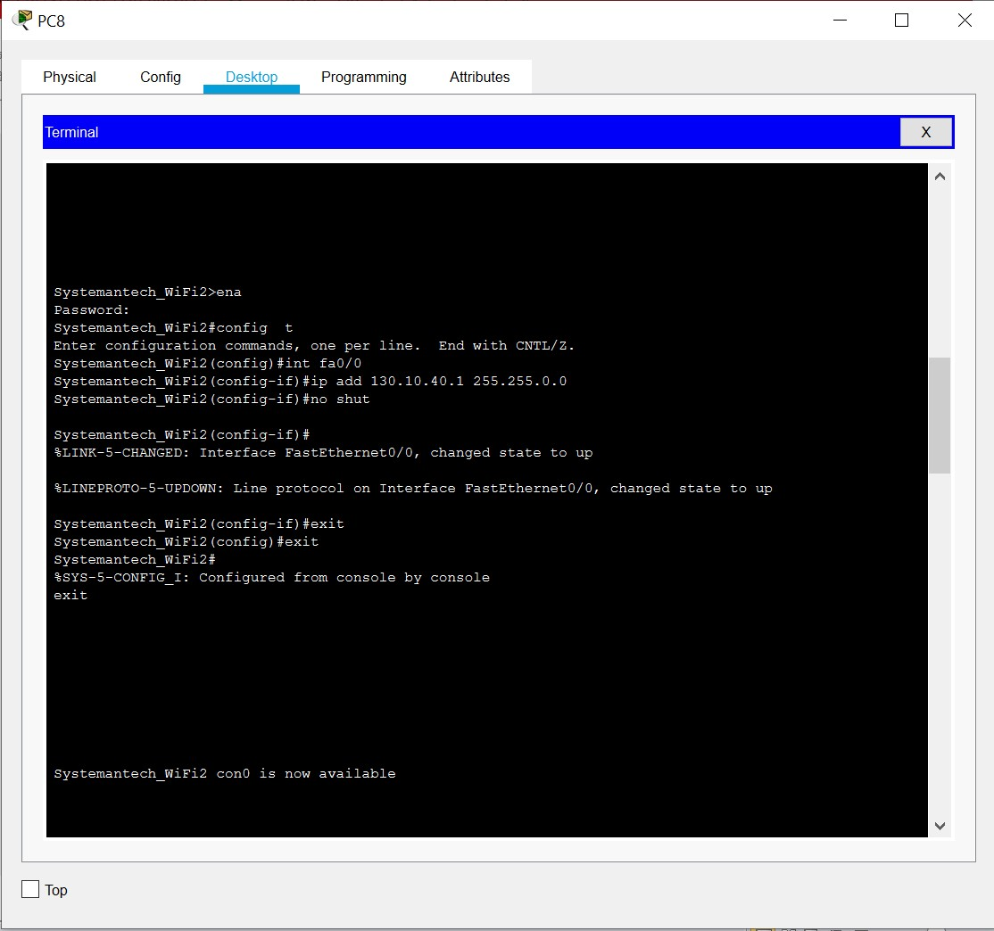

## Serial 1/0: TRAINING ROOM 1 TO ACCOUNTING DEPARTMENT

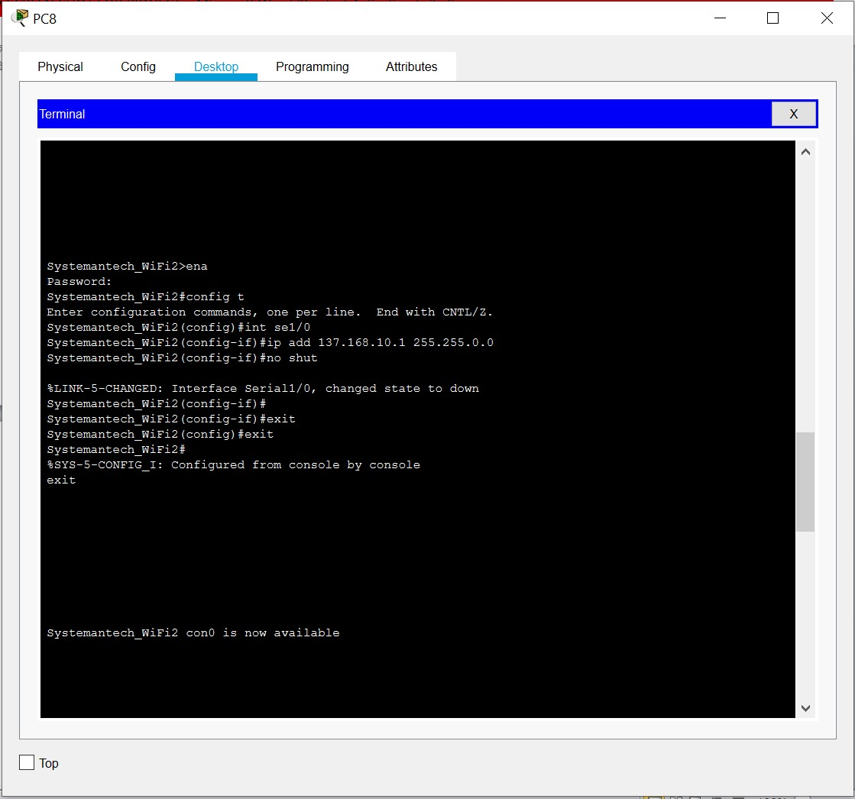

## Serial 1/1: TRAINING ROOM 1 TO SYSTEM DEPARTMENT

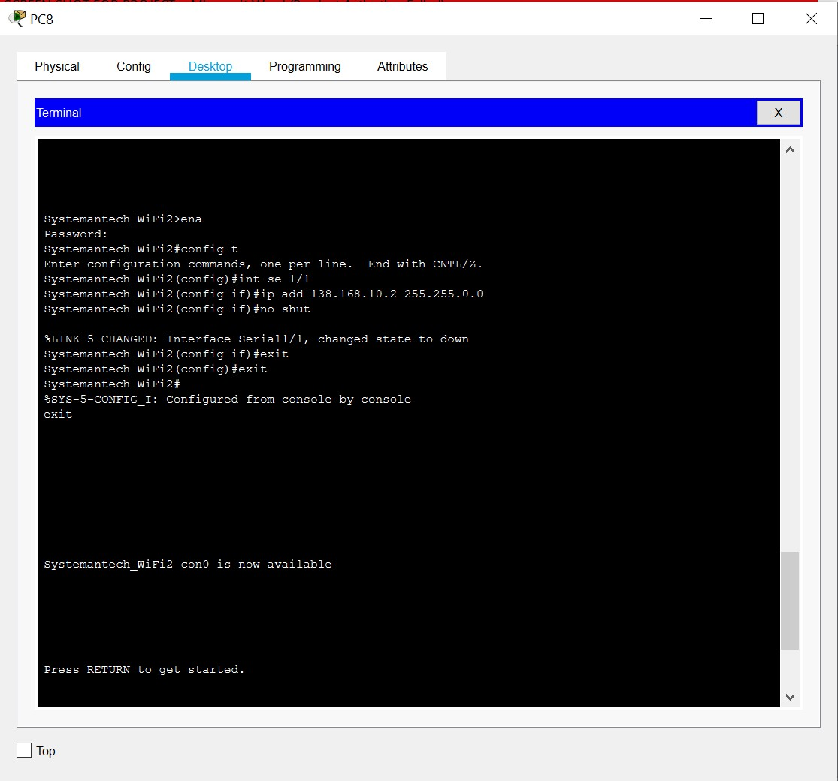

## Serial 1/2: TRAINING ROOM 1 TO SERVER ROOM

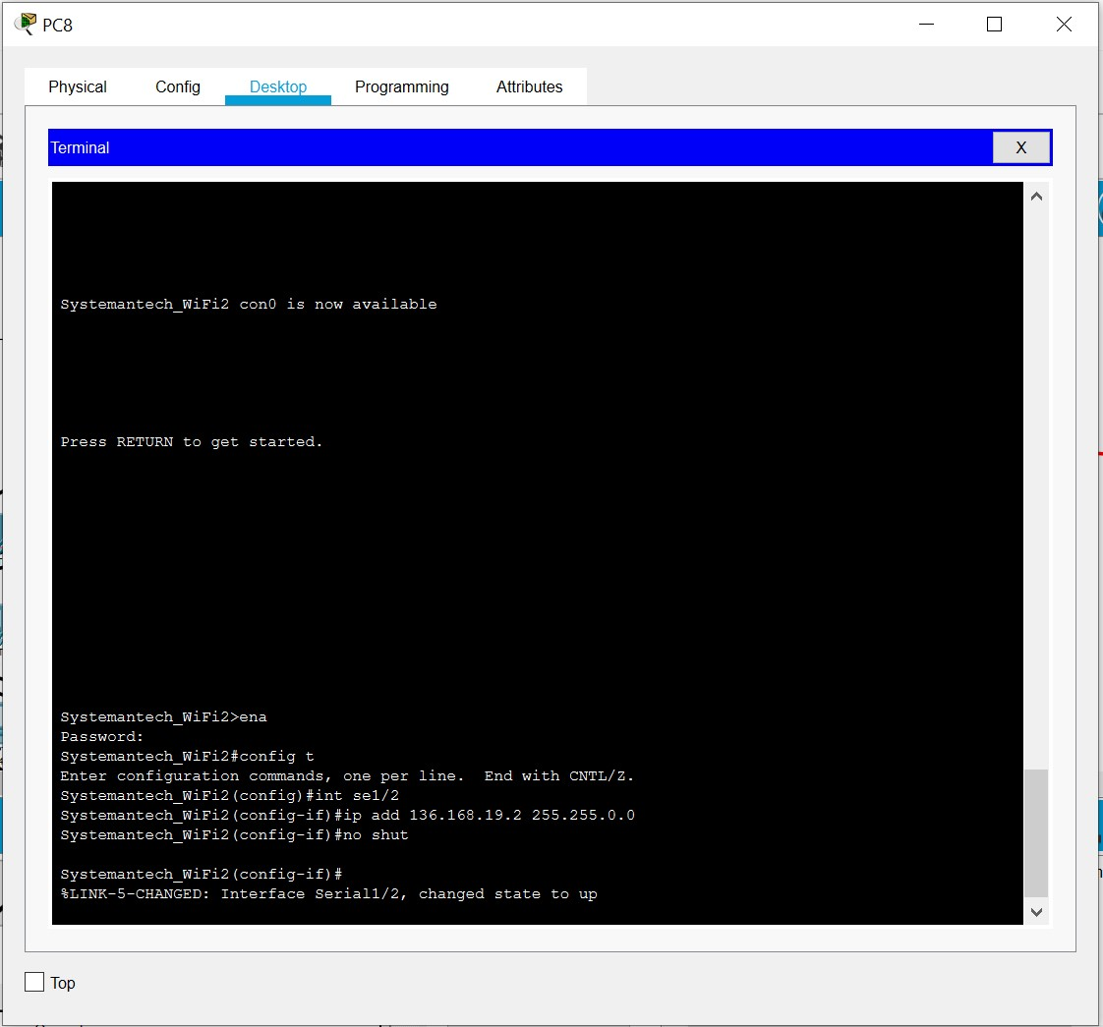

## PC29: ACCOUNTING DEPARTMENT

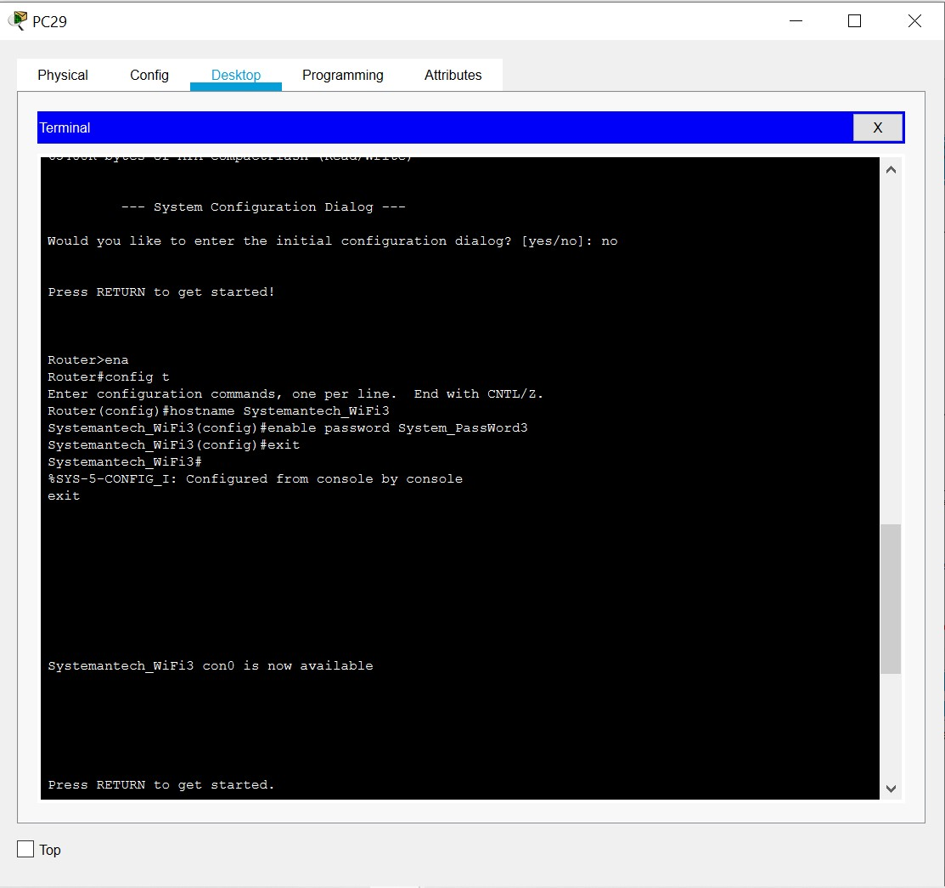

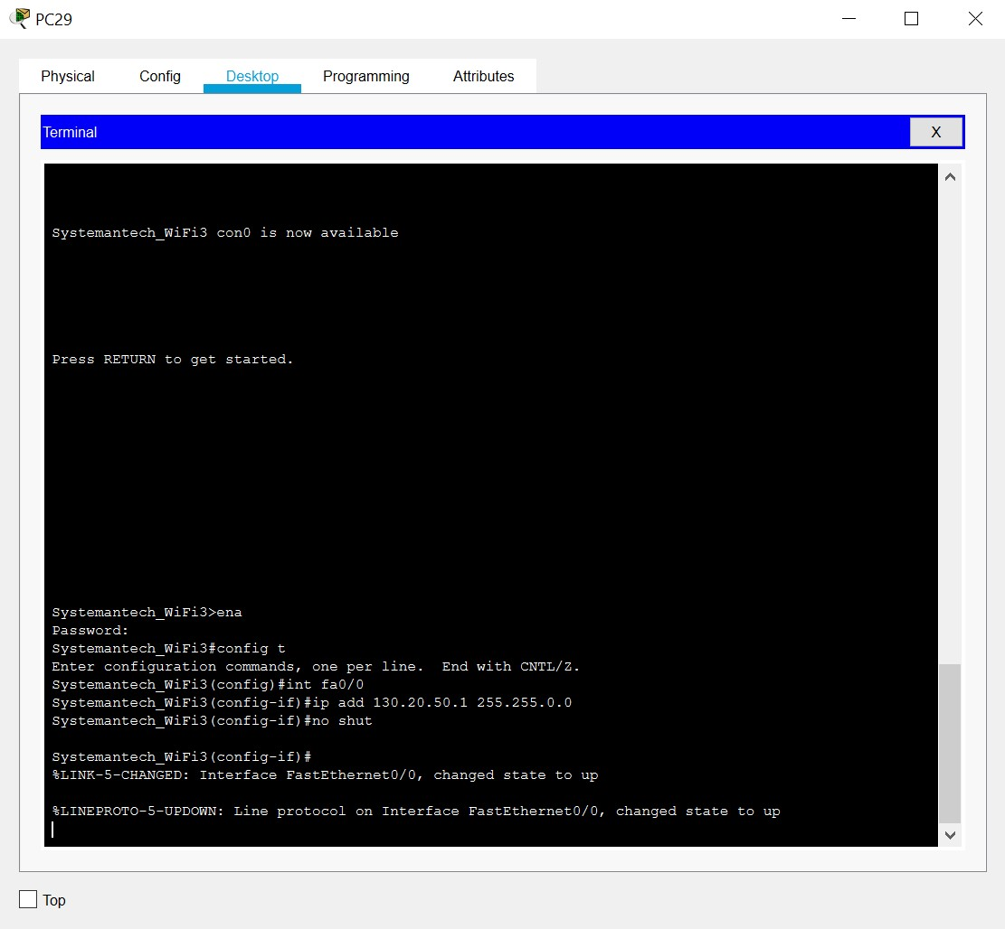

## Serial1/0: ACCOUNTING DEPARTMENT TO TRAINING ROOM1

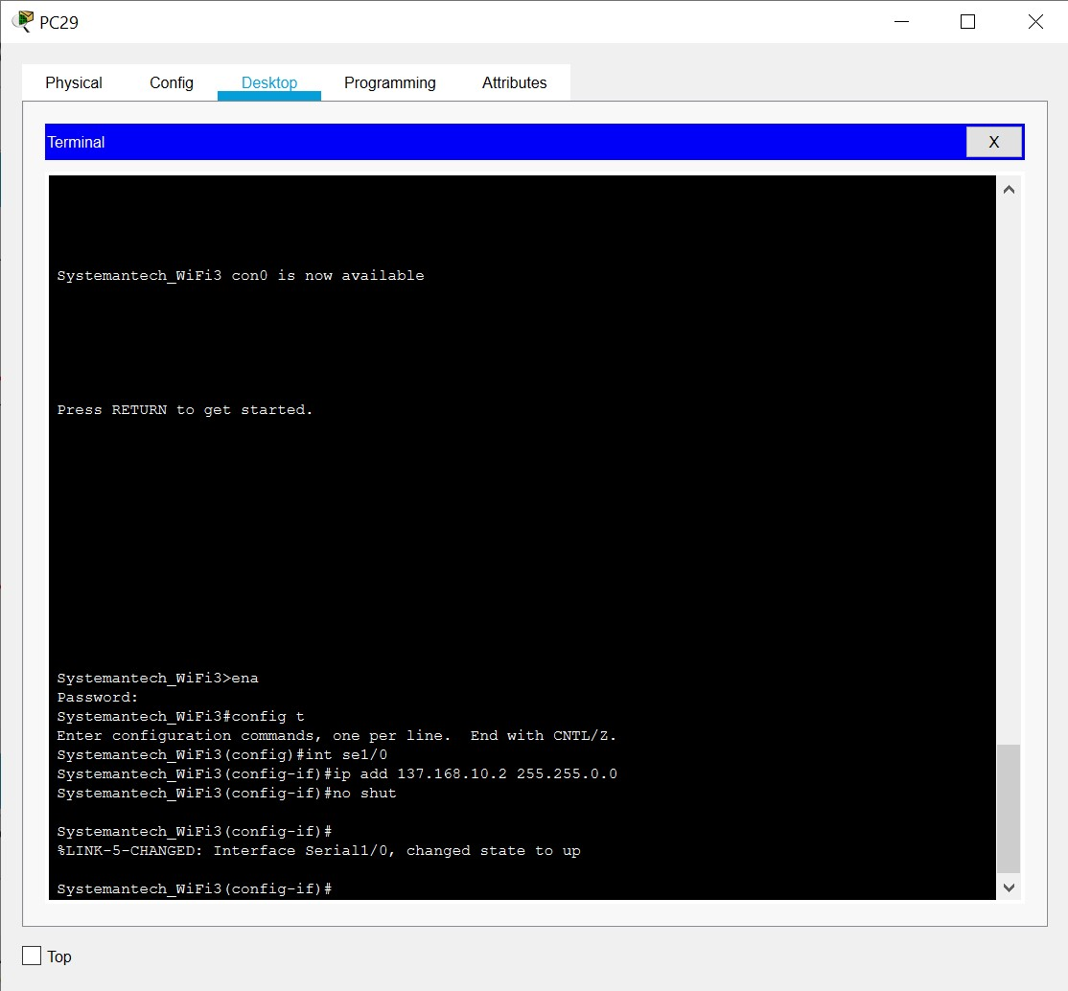

## Serial1/1: ACCOUNTING DEPARTMENT TO CUSTOMER SERVICE

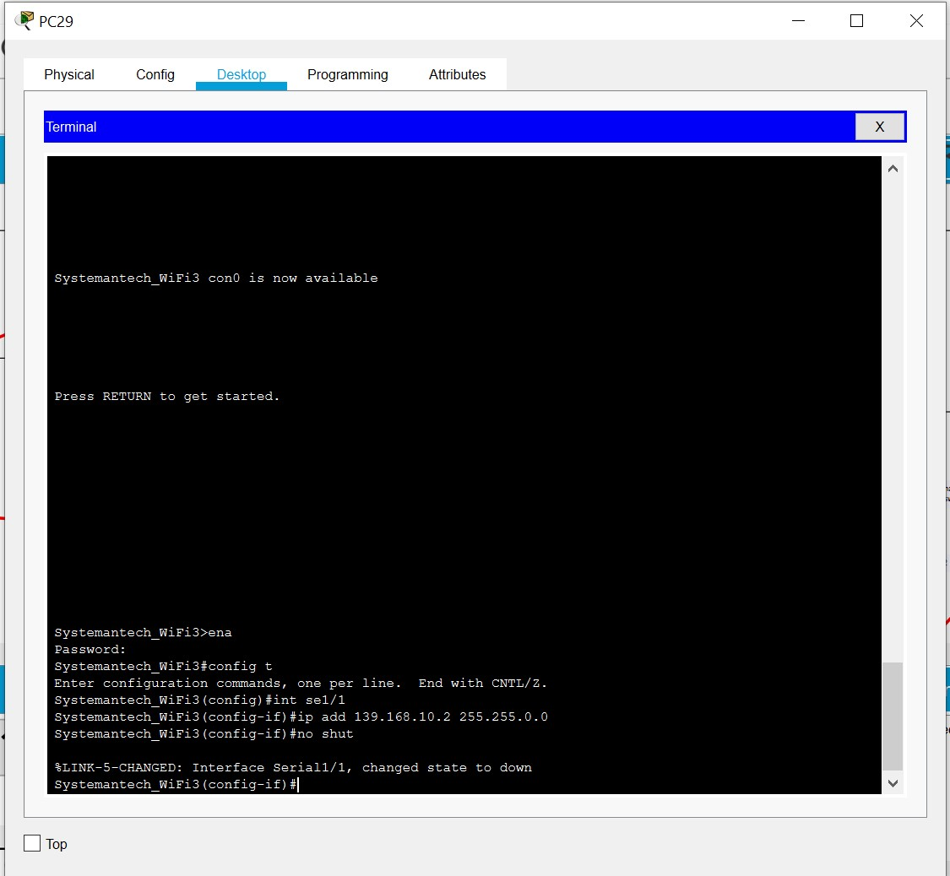

## Serial1/2: ACCOUNTING DEPARTMENT TO HUMAN RESOURCE

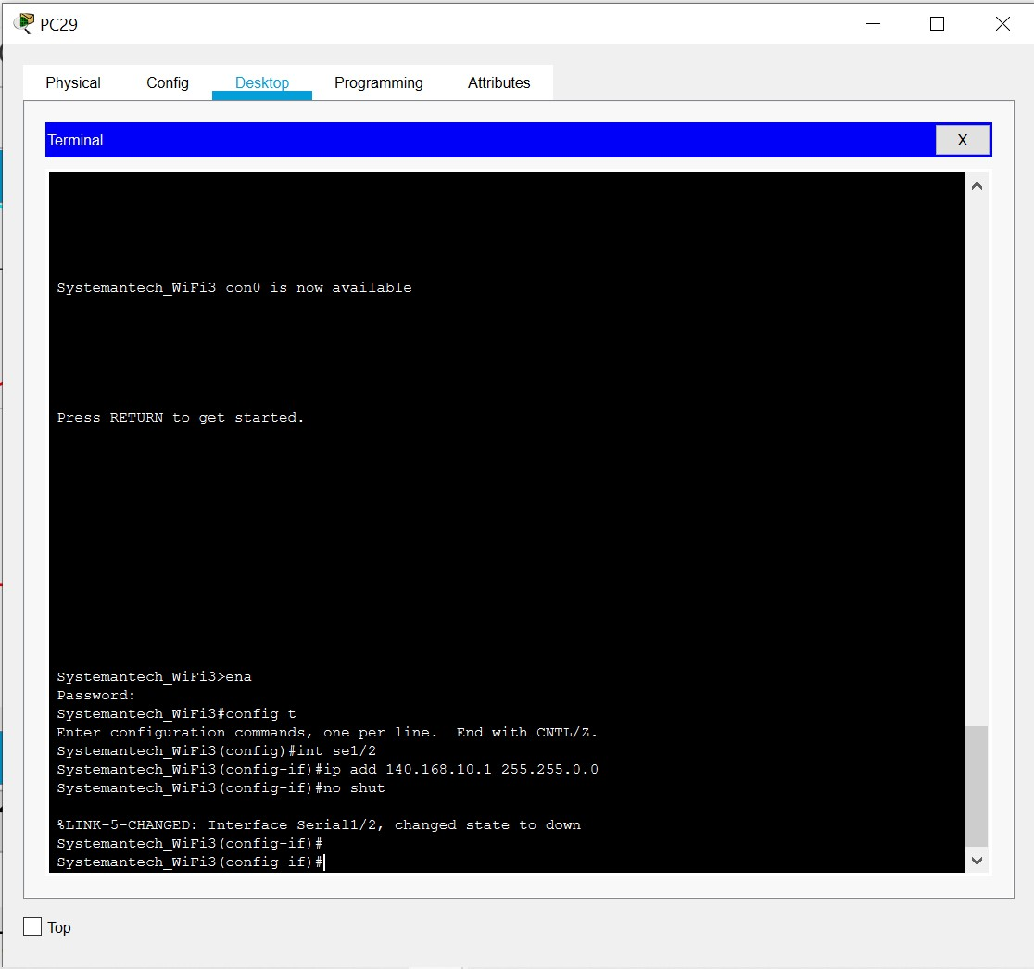

## PC 43: SYSTEM DEPARTMENT

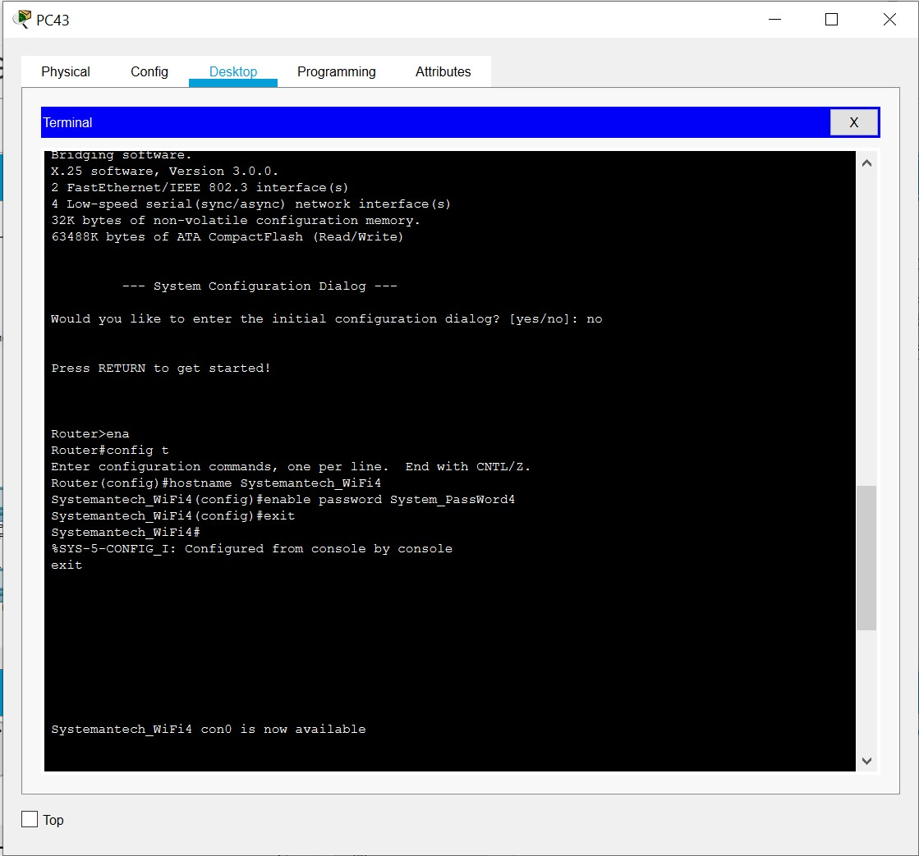

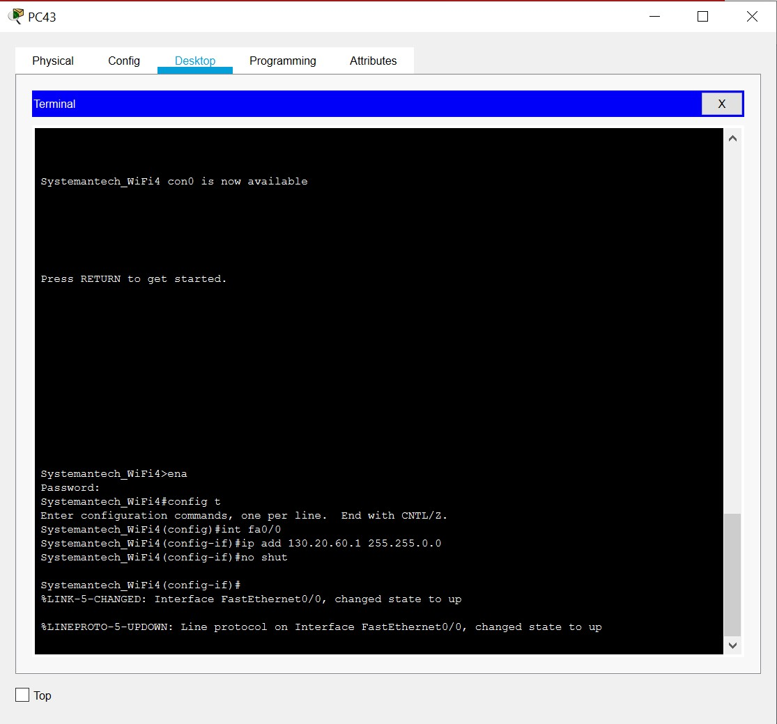

## Serial 1/0: SYSTEM DEPARTMENT TO SYSTEM ADMIN DEPARTMENT

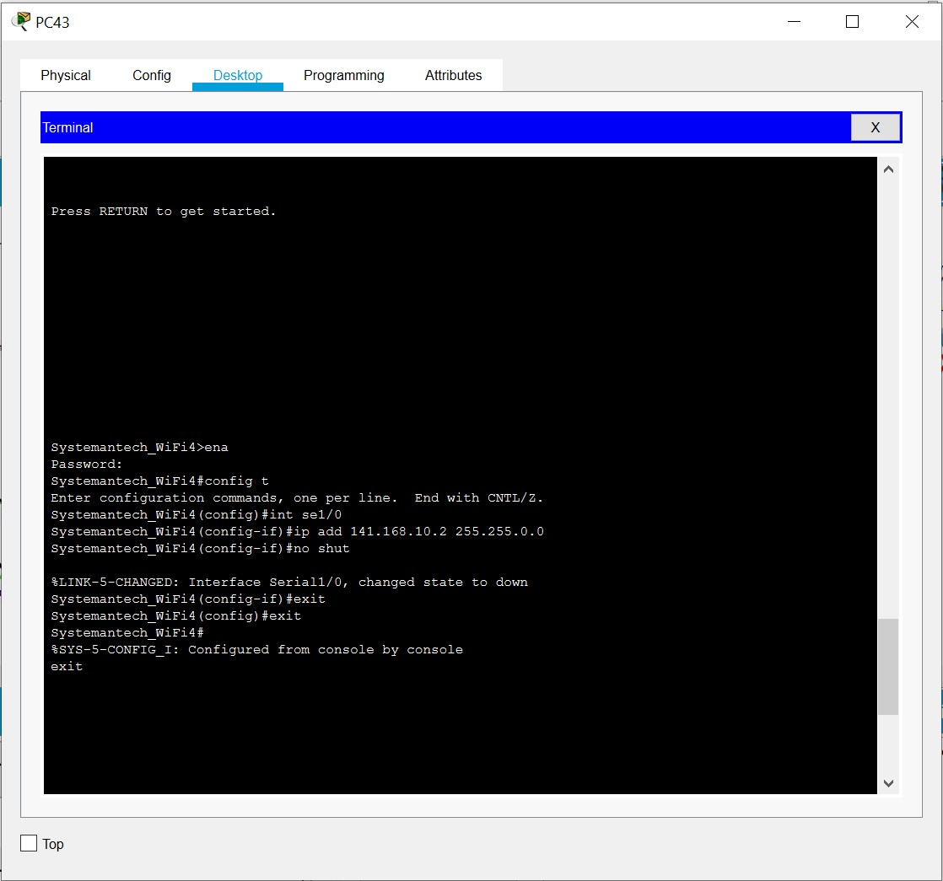

## Serial 1/1: SYSTEM DEPARTMENT TO TRAINING ROOM 1

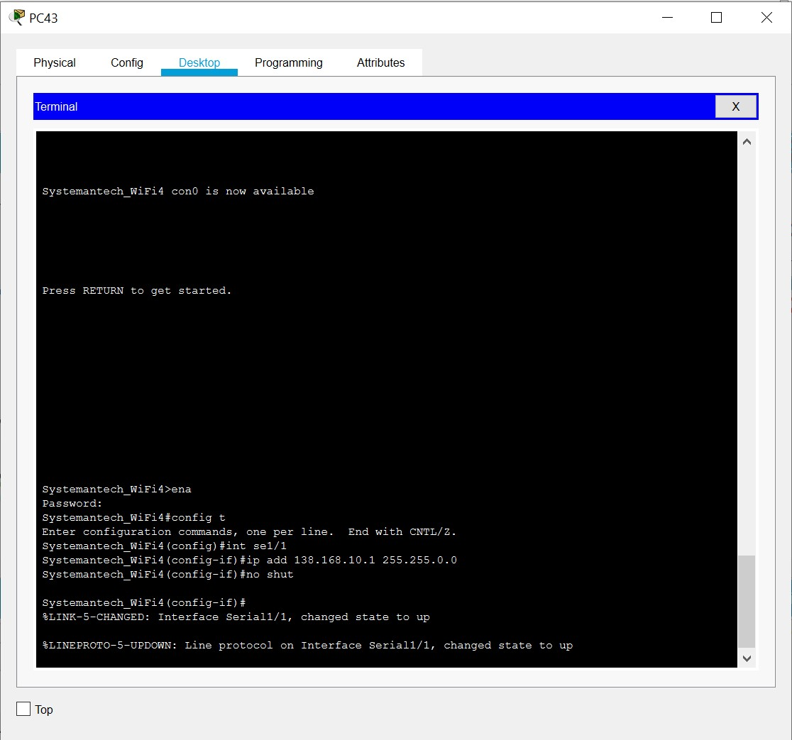

## PC 53: HUMAN RESOURCE DEPARTMENT

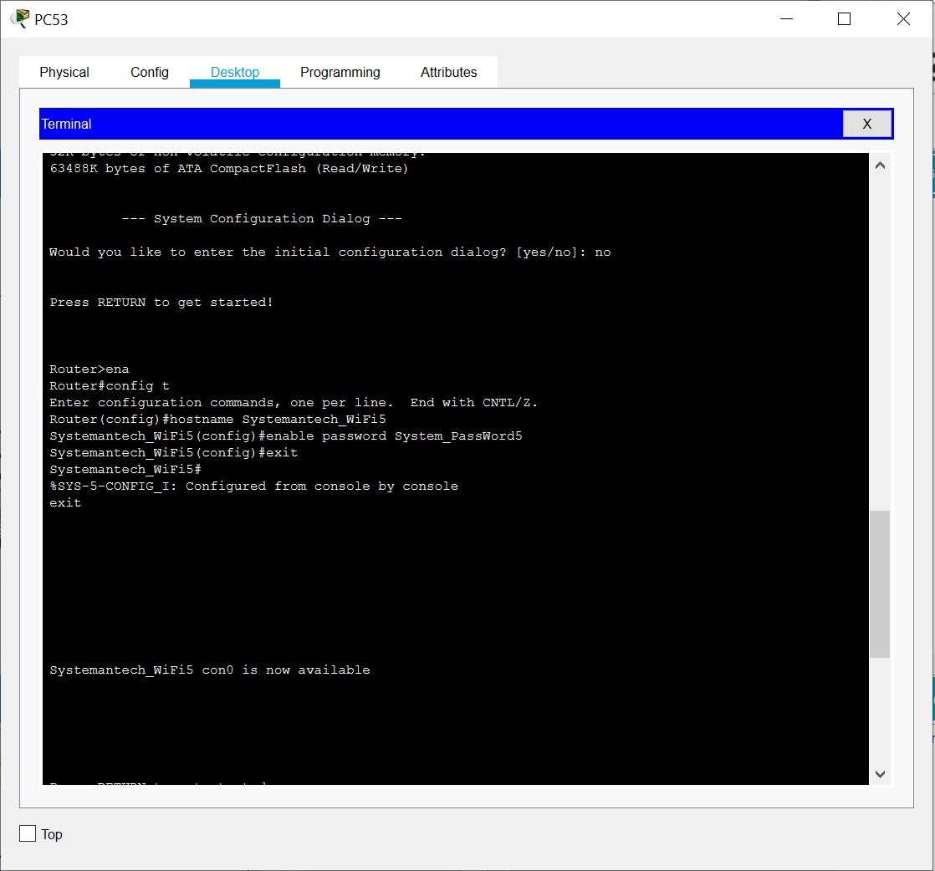

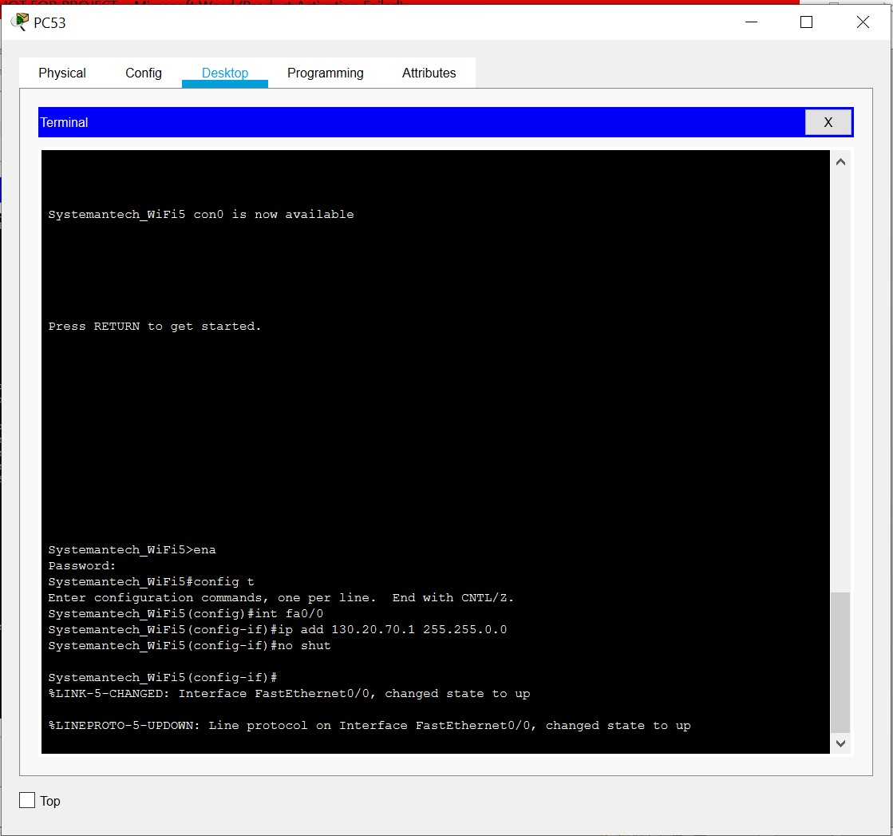

## Serial 1/0: HUMAN RESOURCE DEPARTMENT TO MARKETING DEPARTMENT

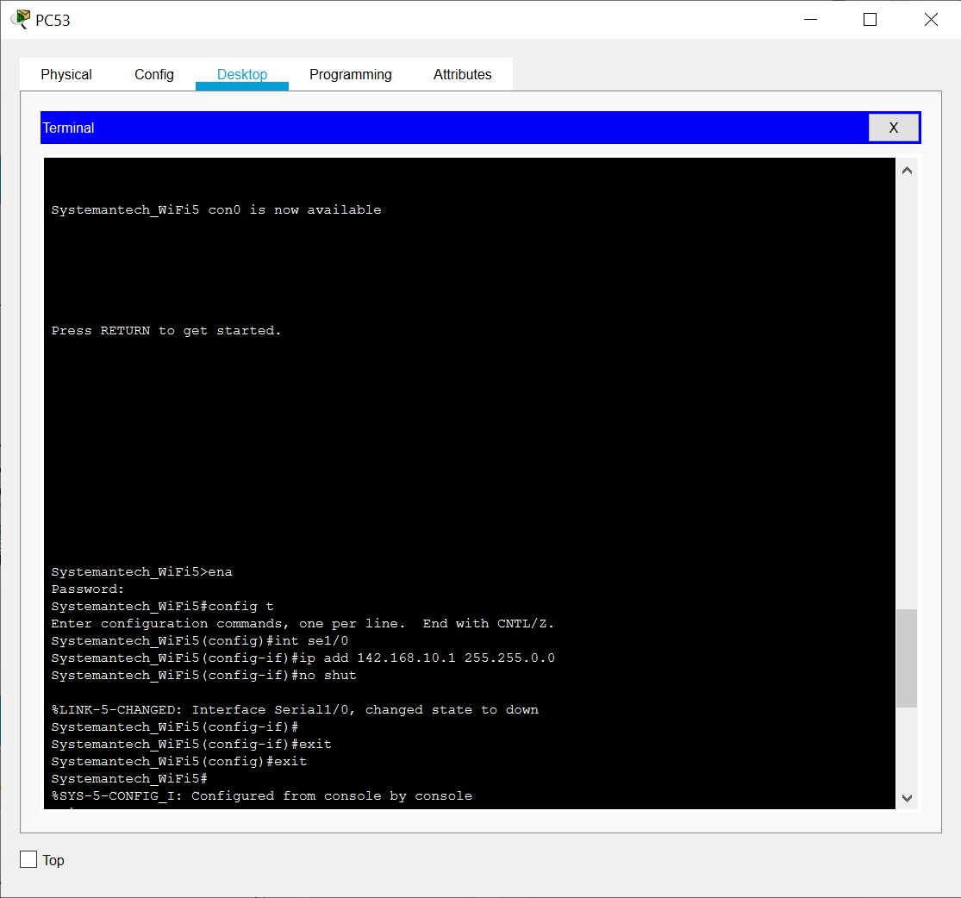

## Serial 1/2: HUMAN RESOURCE DEPARTMENT TO ACCOUNTING DEPARTMENT

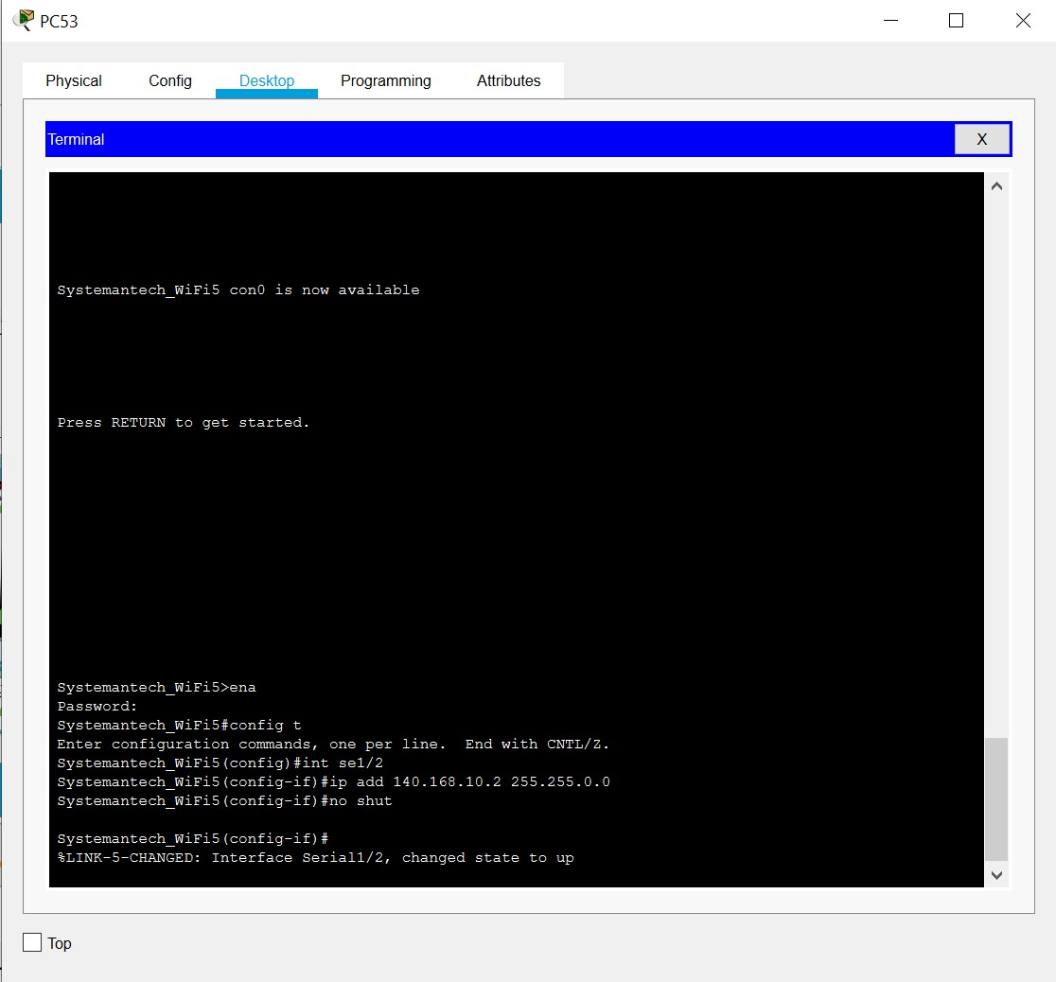

## PC67: SYSTEM ADMIN DEPARTMENT

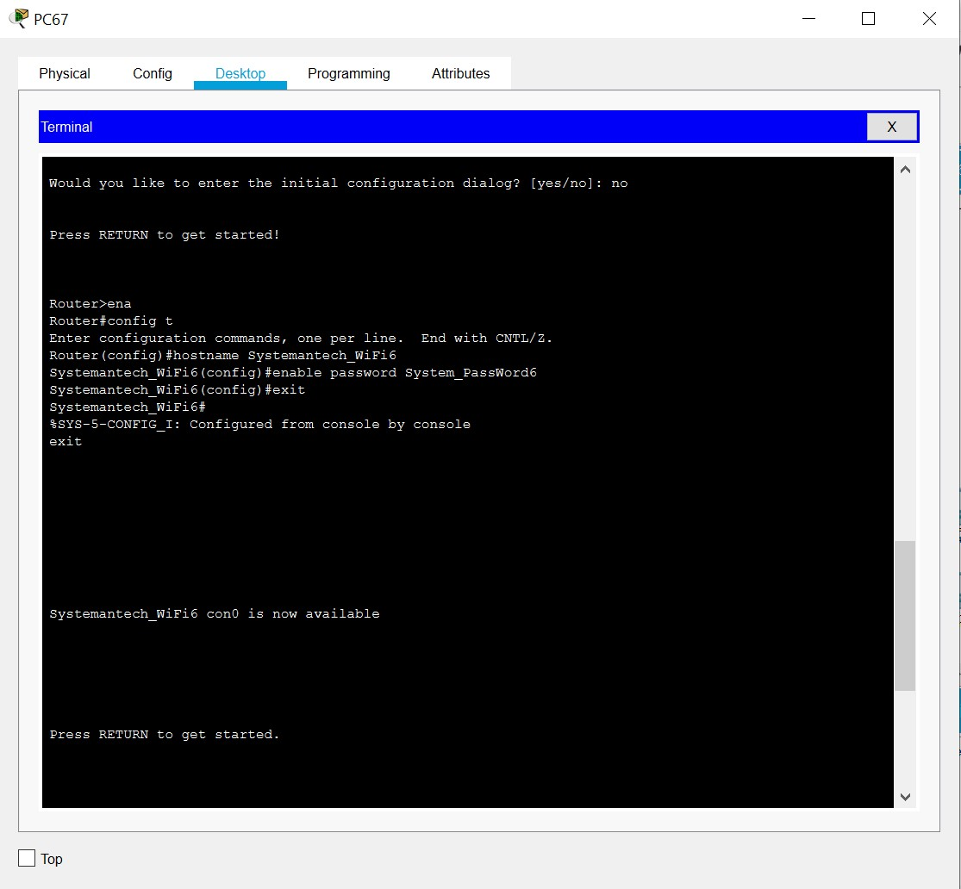

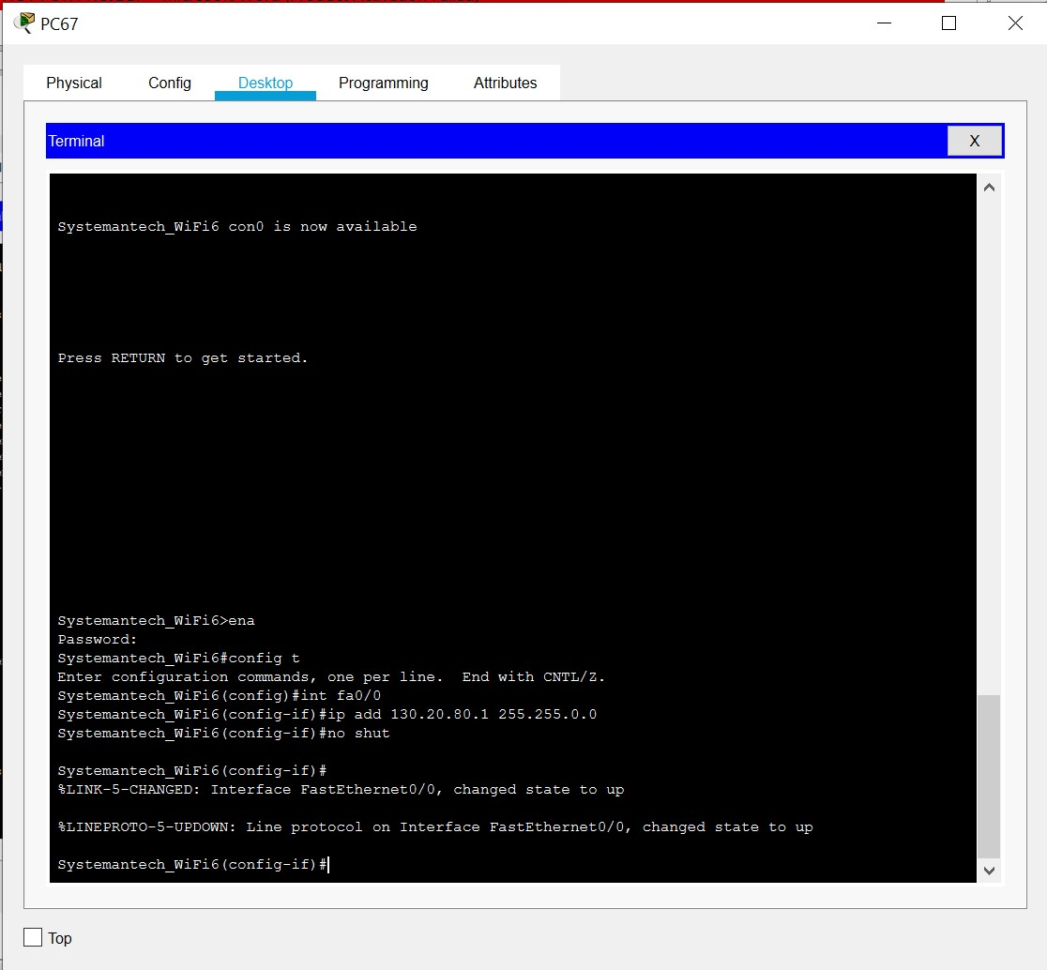

## Serial 1/0: SYSTEM ADMIN DEPARTMENT TO SYSTEEM DEPARTMENT

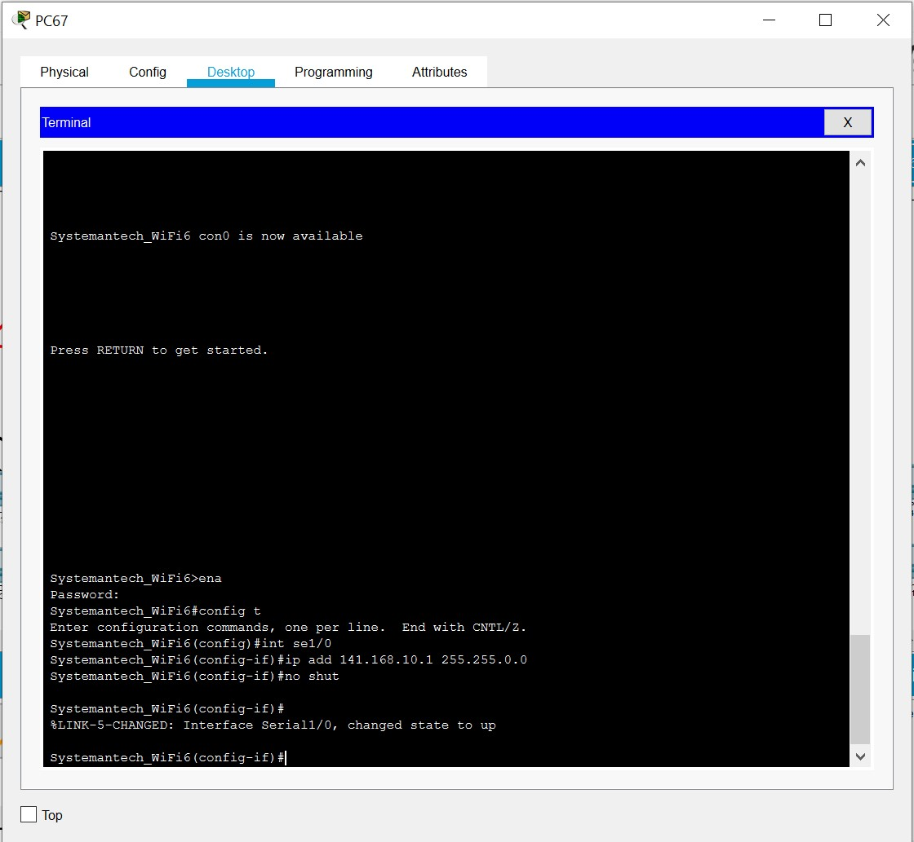

## Serial 1/1: SYSTEM ADMIN DEPARTMENT TO IT SUPPORT DEPARTMENT

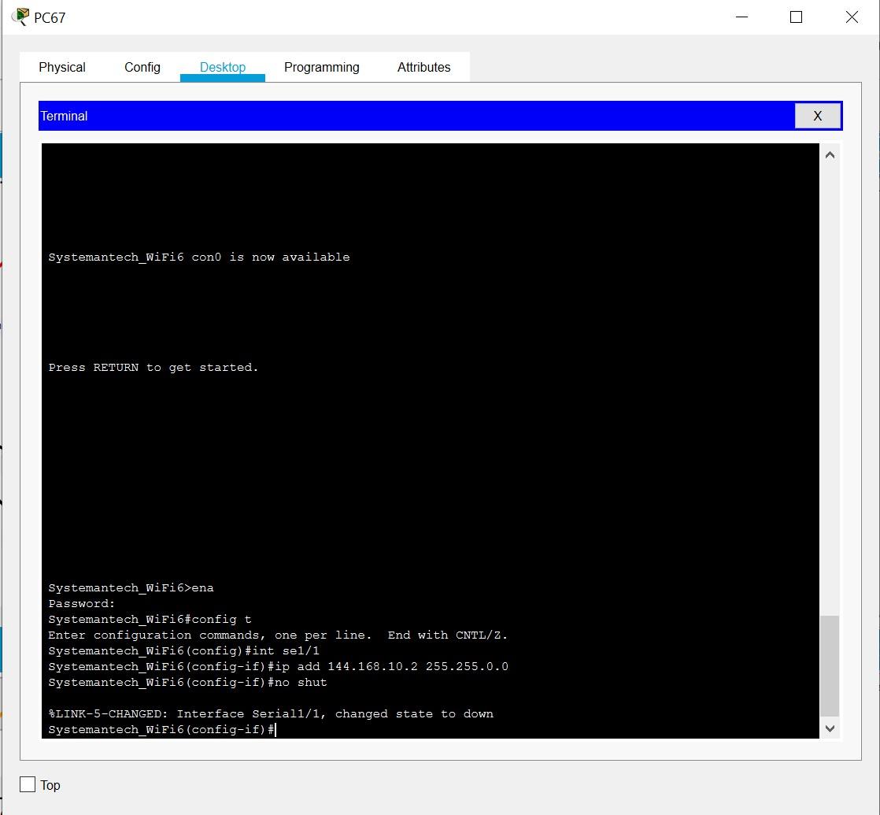

## PC 77: CUSTOMER SERVICE

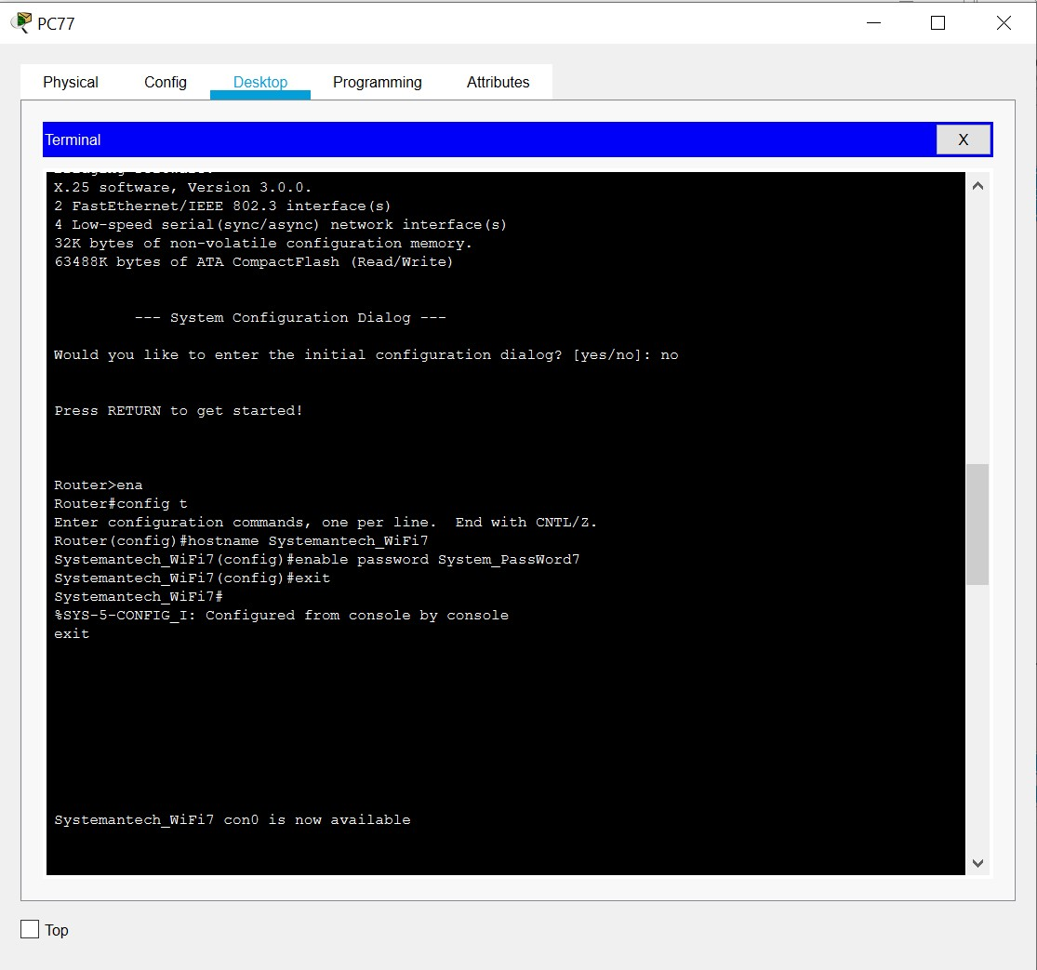

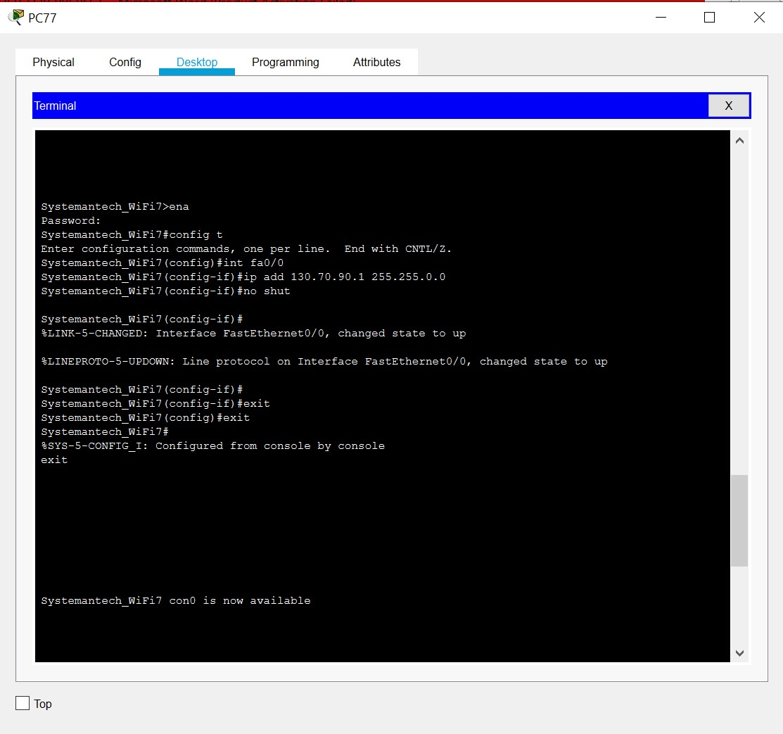

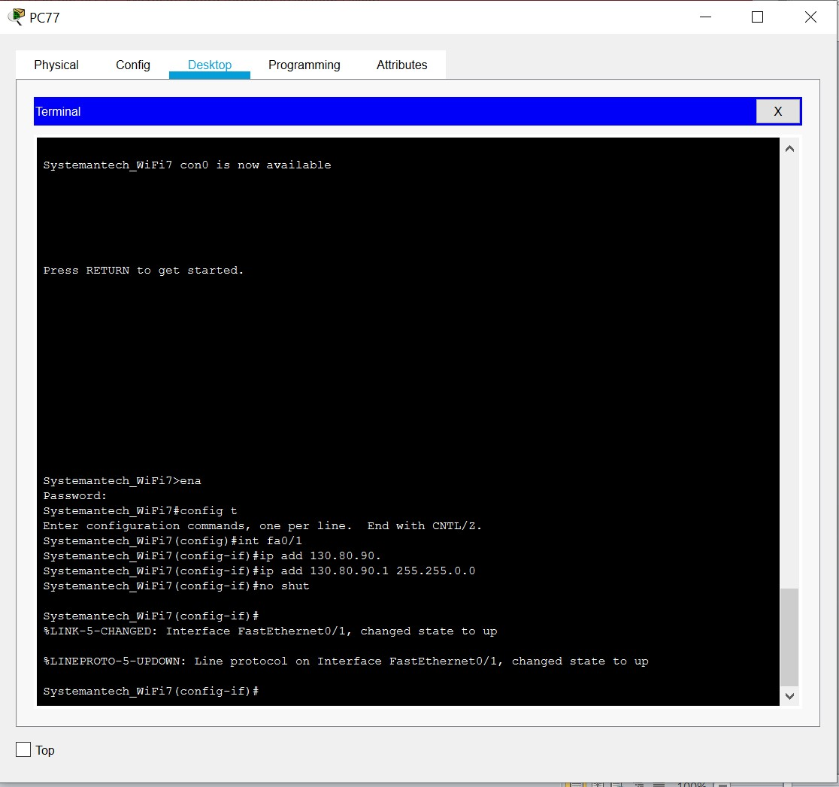

## Serial1/1: CUSTOMER SERVICE TO ACCOUNTING DEPARTMENT

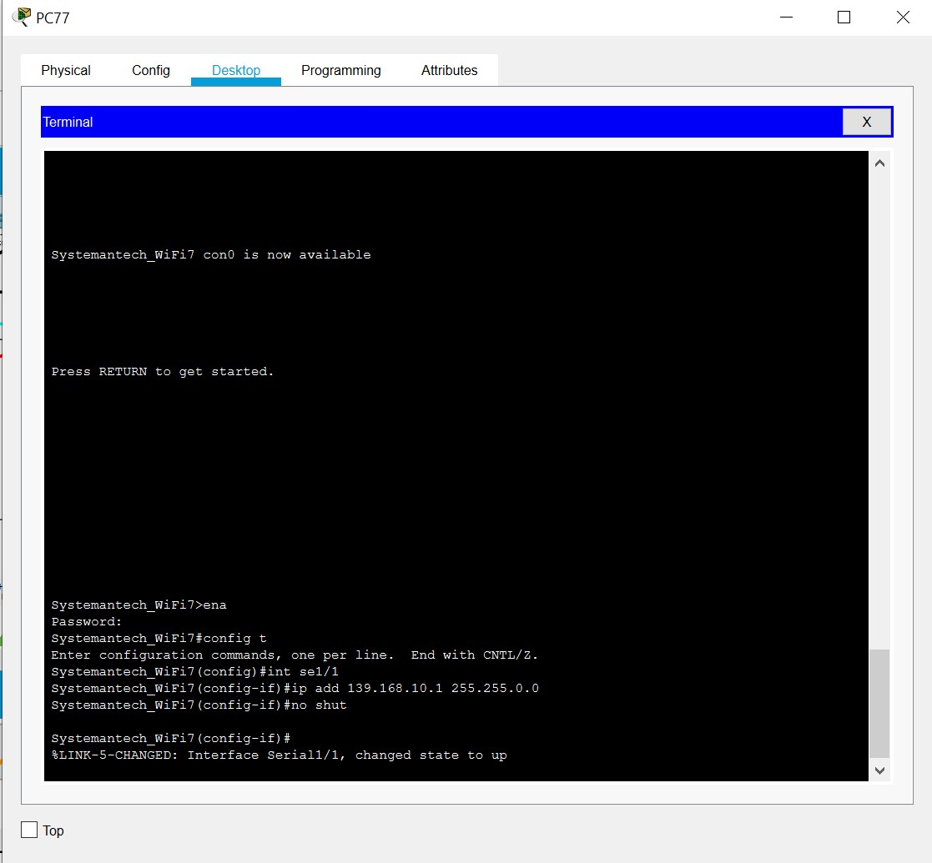

## PC125: MARKETING DEPARTMENT

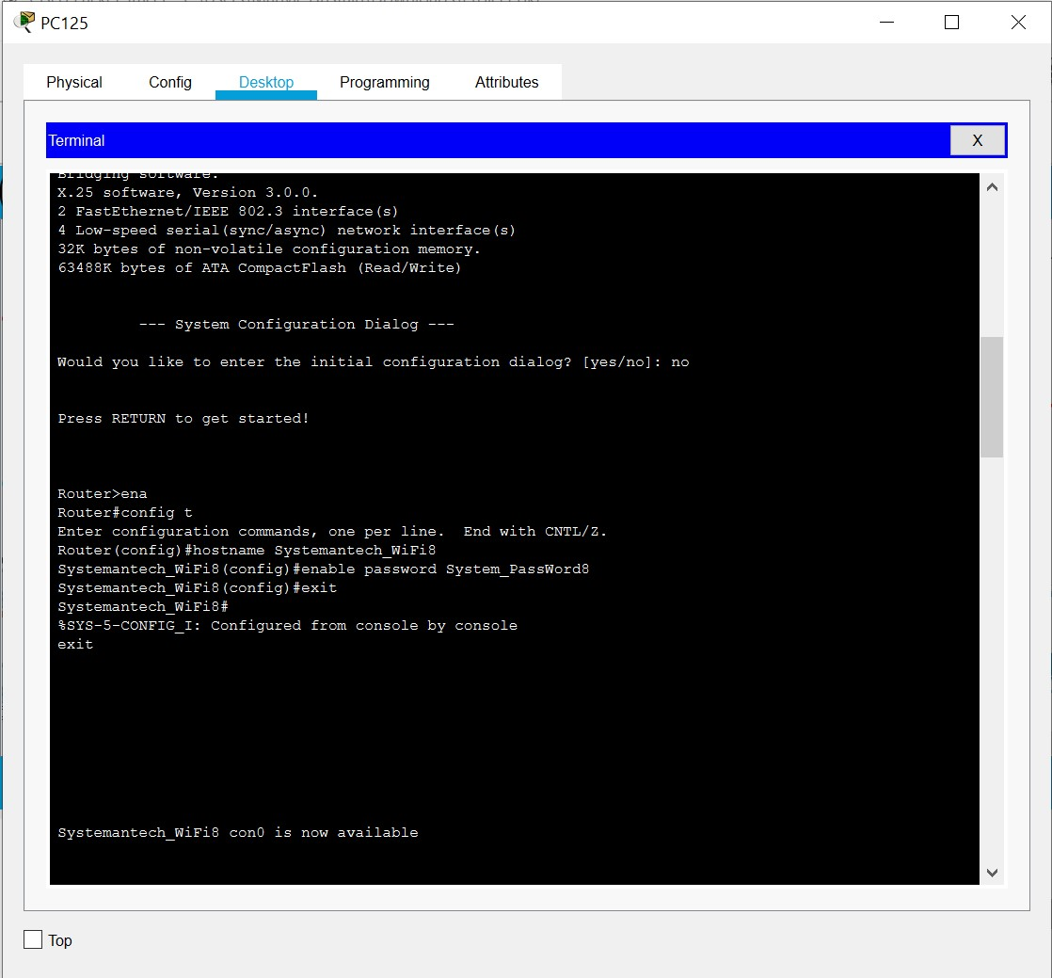

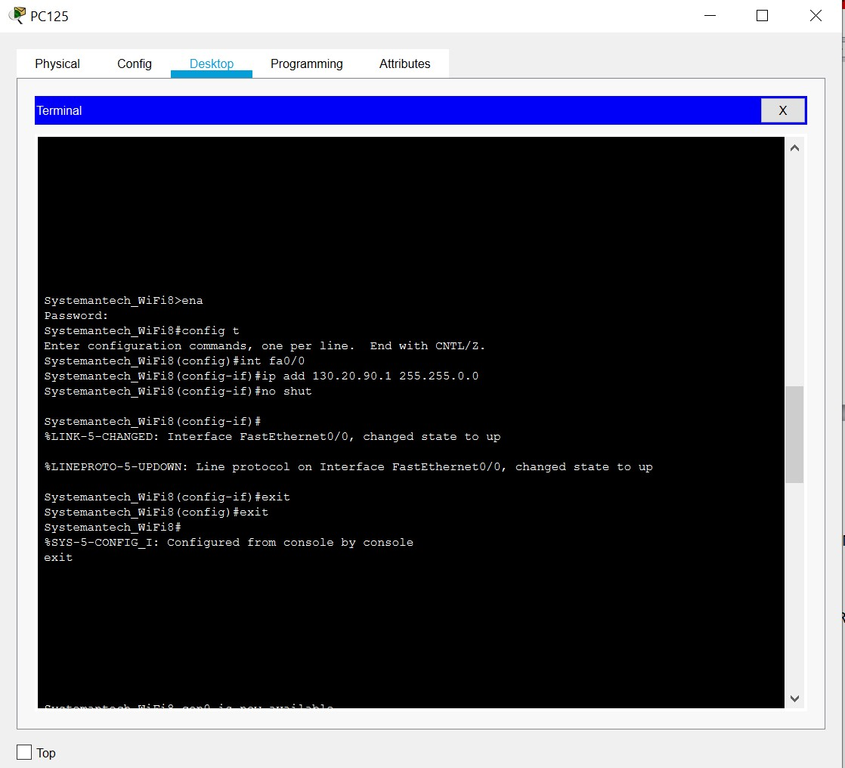

## Serial1/0: MARKETING DEPARTMENT TO HUMAN RESOUCES DEPARTMENT

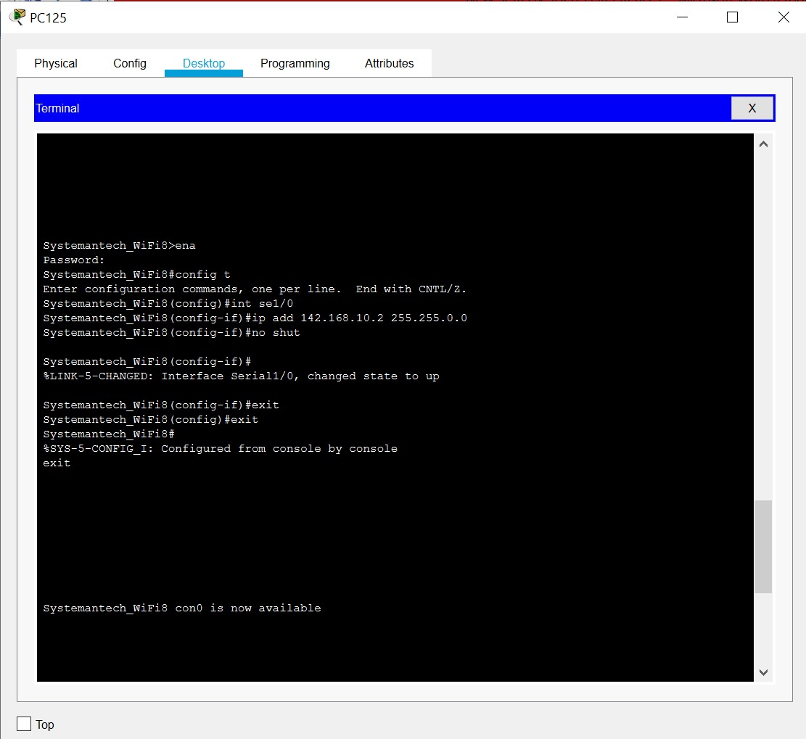

## Serial1/1: MARKETING DEPARTMENT TO FINANCE DEPARTMENT

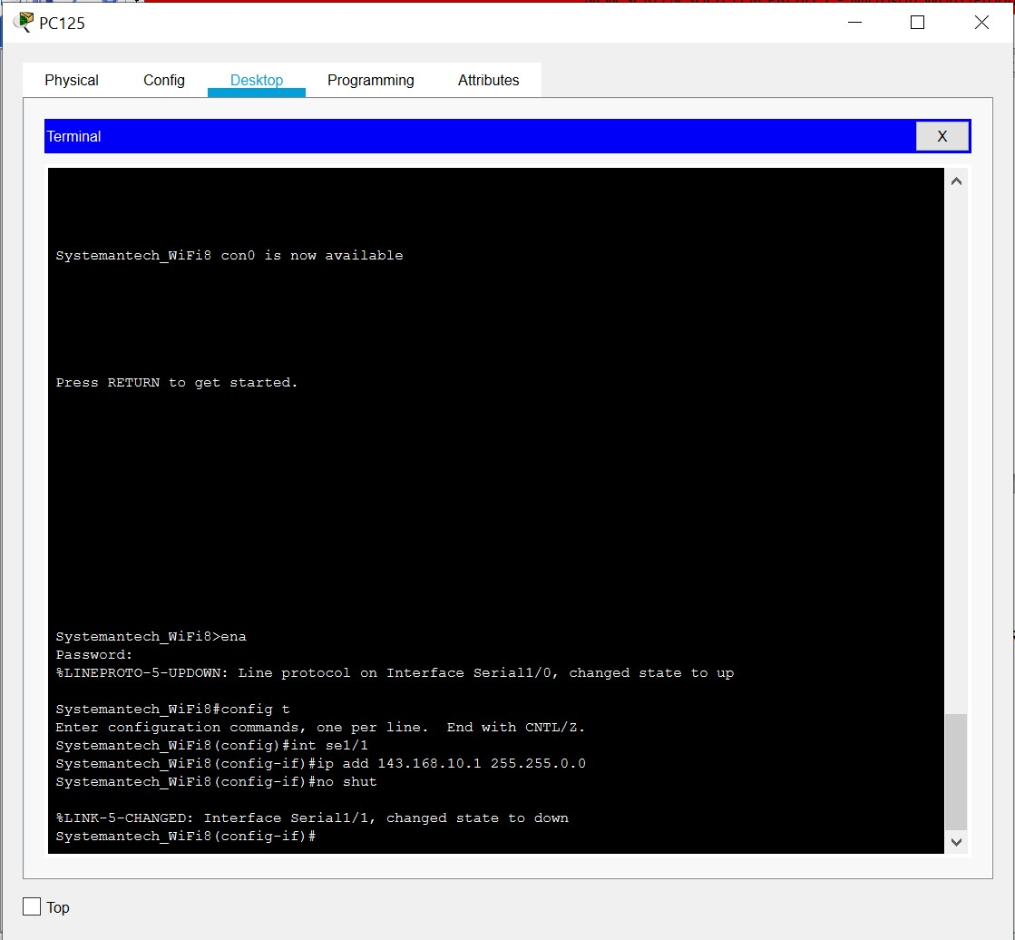

## PC 139: IT SUPPORT DEPARTMENT

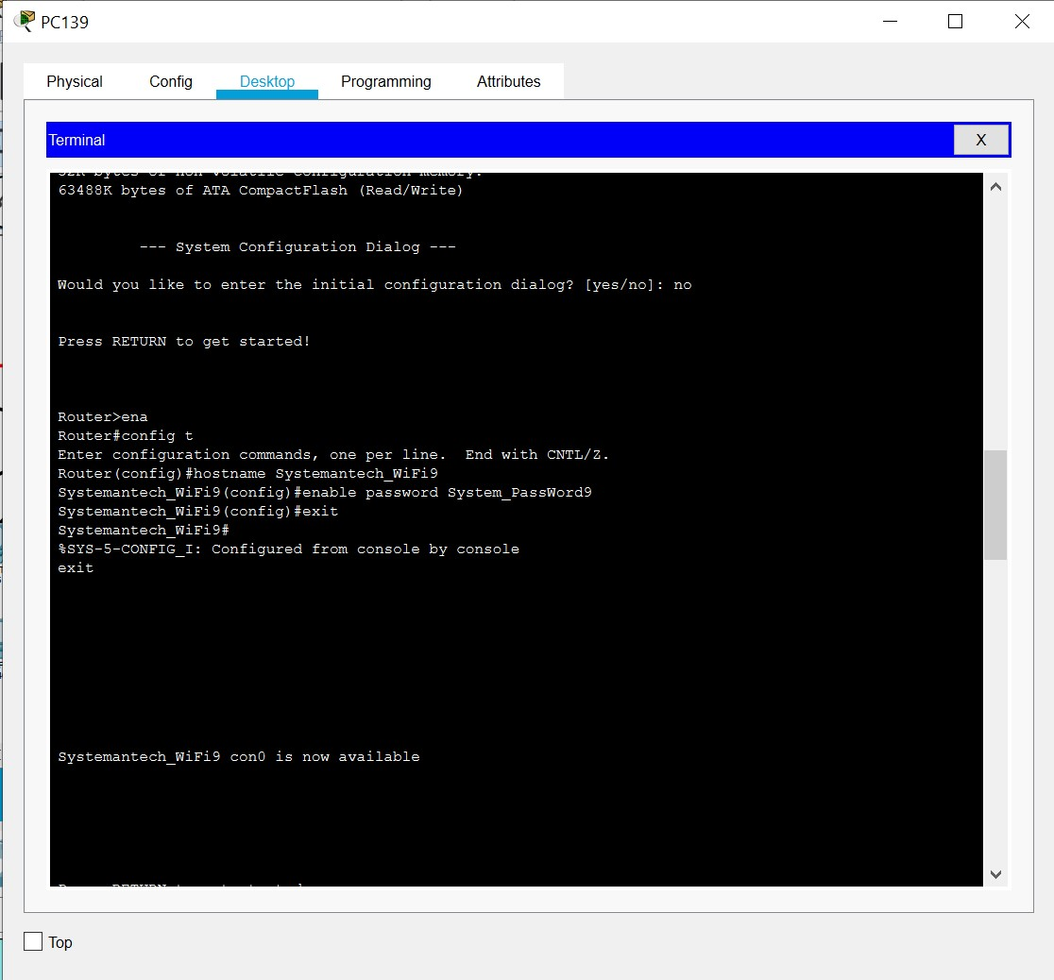

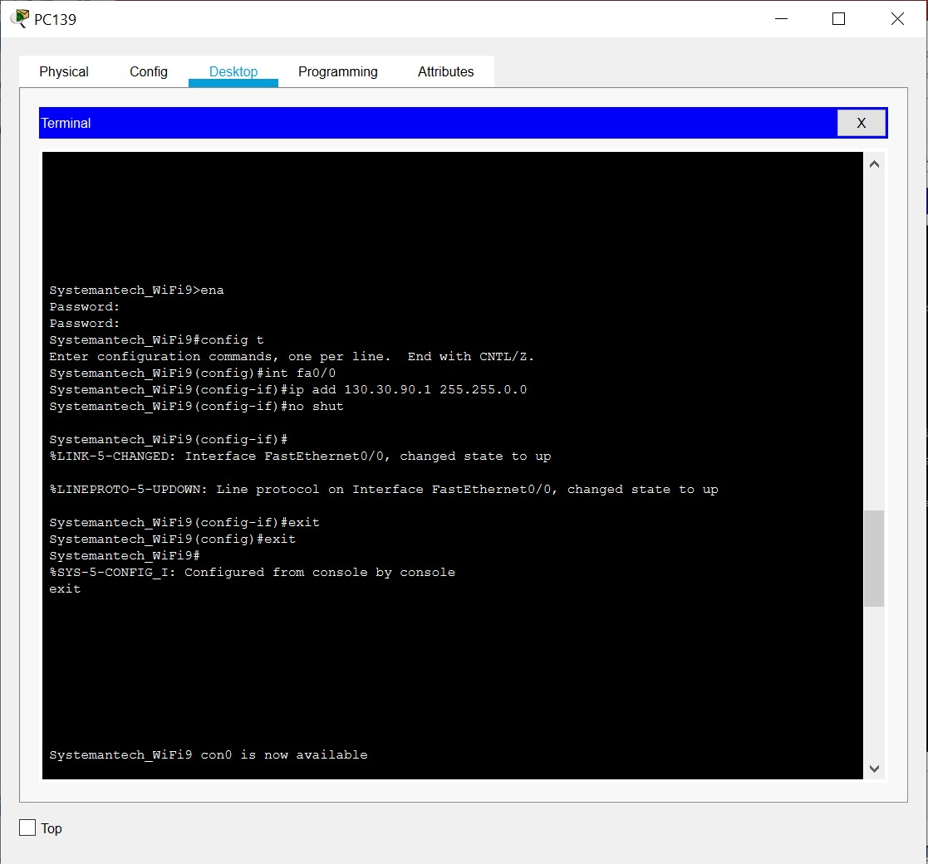

## Serial1/0: IT SUPPORT DEPARTMENT TO QUALITY ASSURANCE

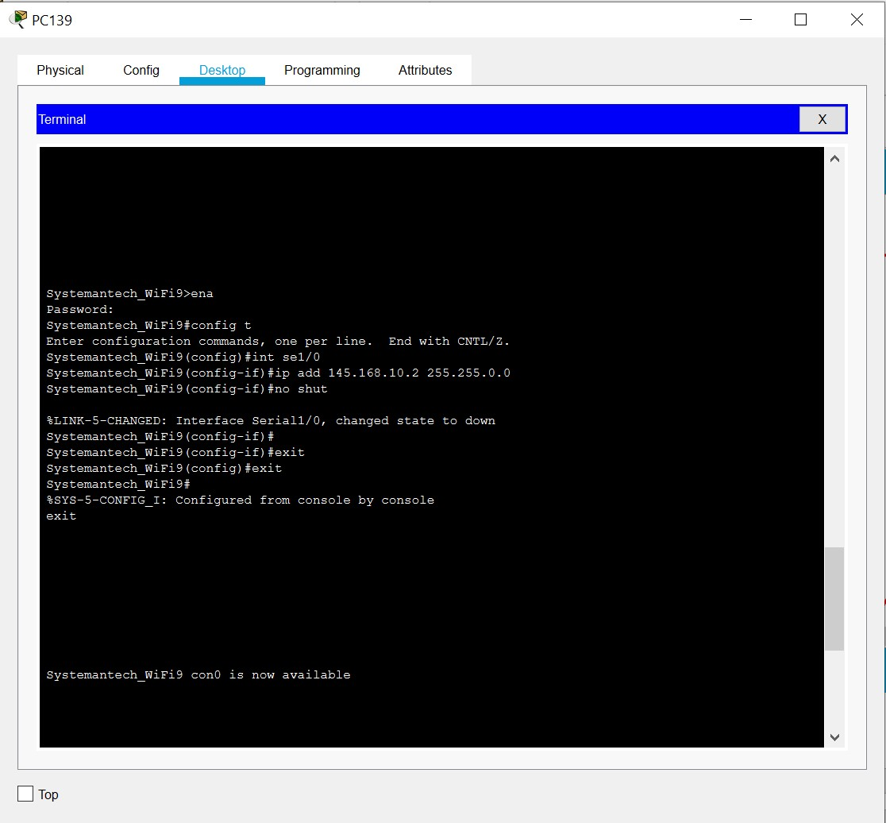

## Serial1/1: IT SUPPORT DEPARTMENT TO SYSTEM ADMIN

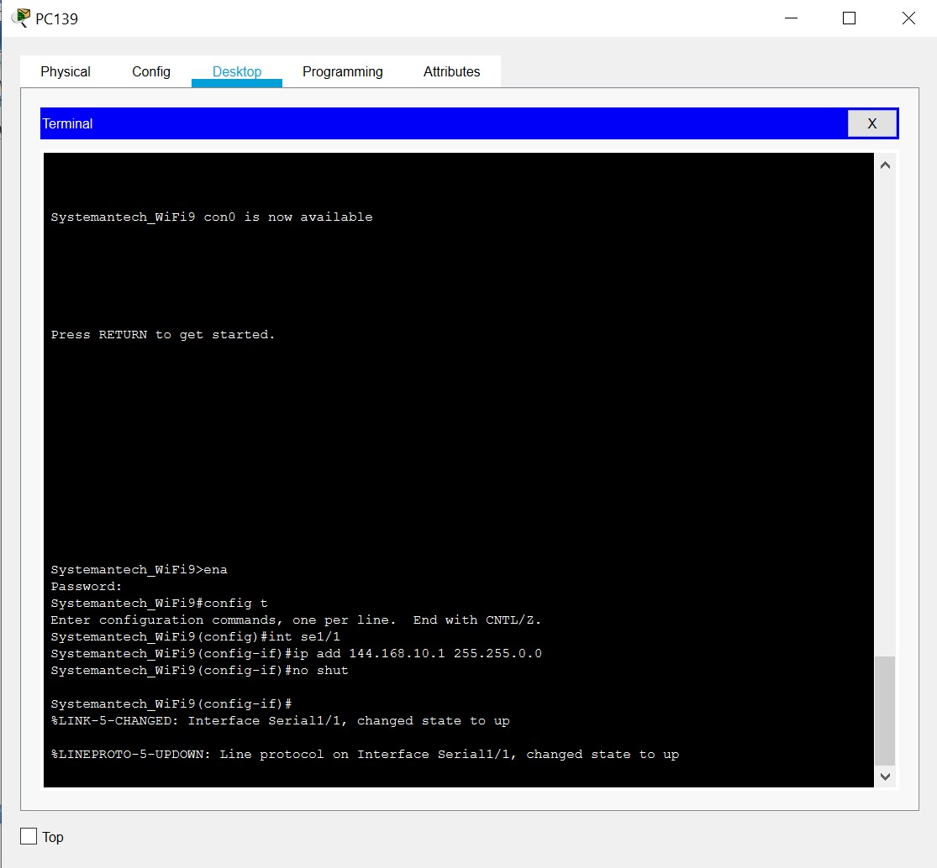

## PC 161: FINANCE DEPARTMENT



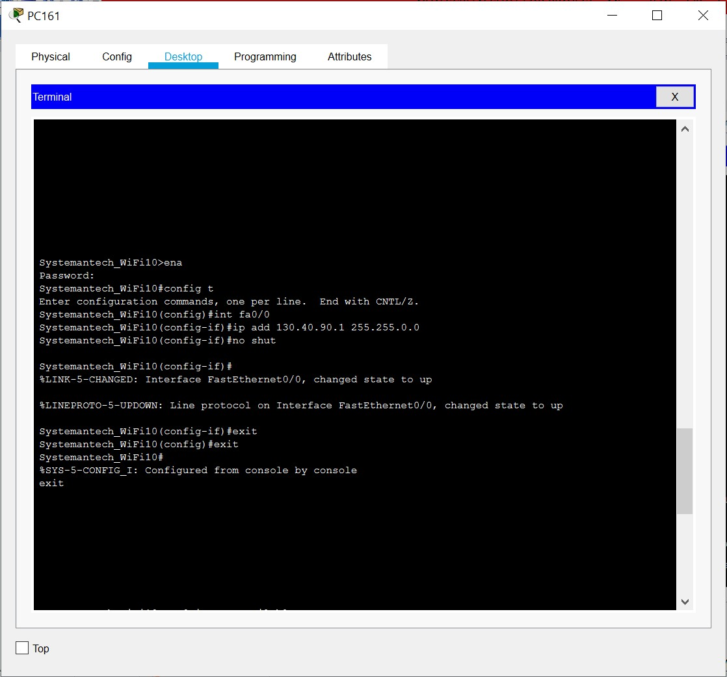

## Serial 1/1: FINANCE DEPARTMENT TO MARKETING DEPARTMENT

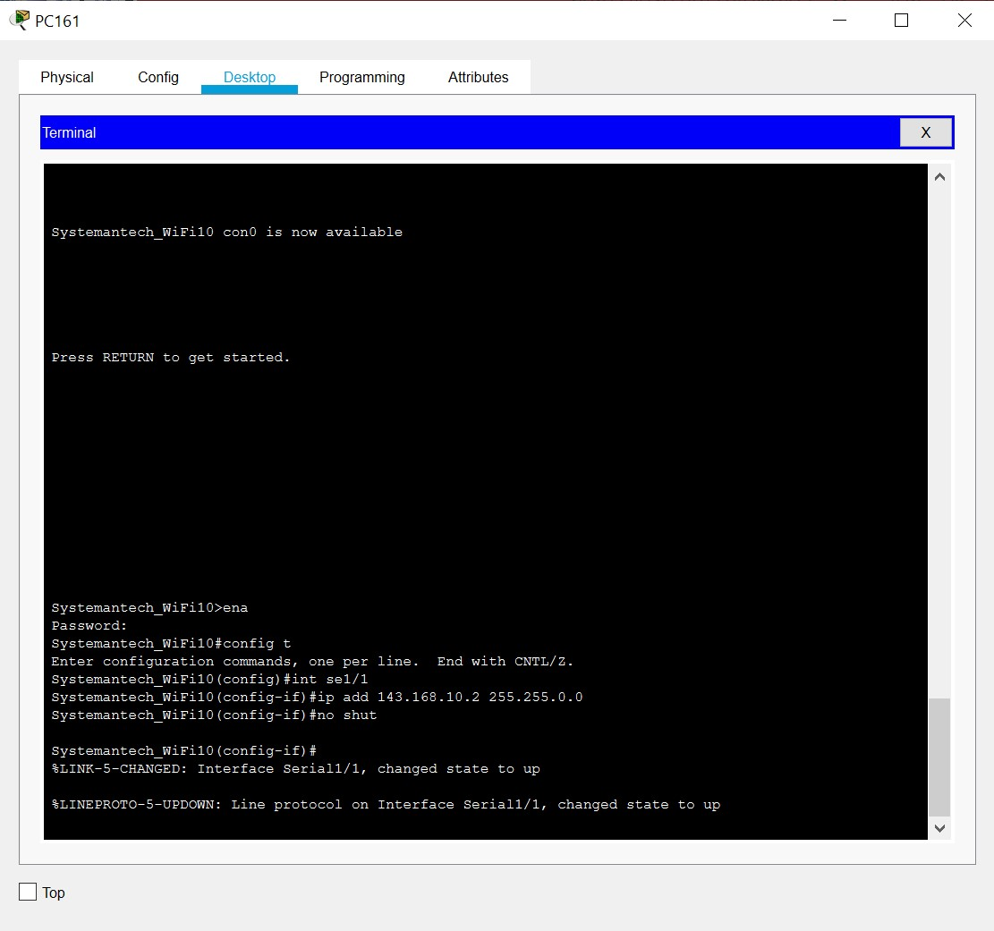

## PC 151: QUALITY ASSURANCE DEPARTMENT

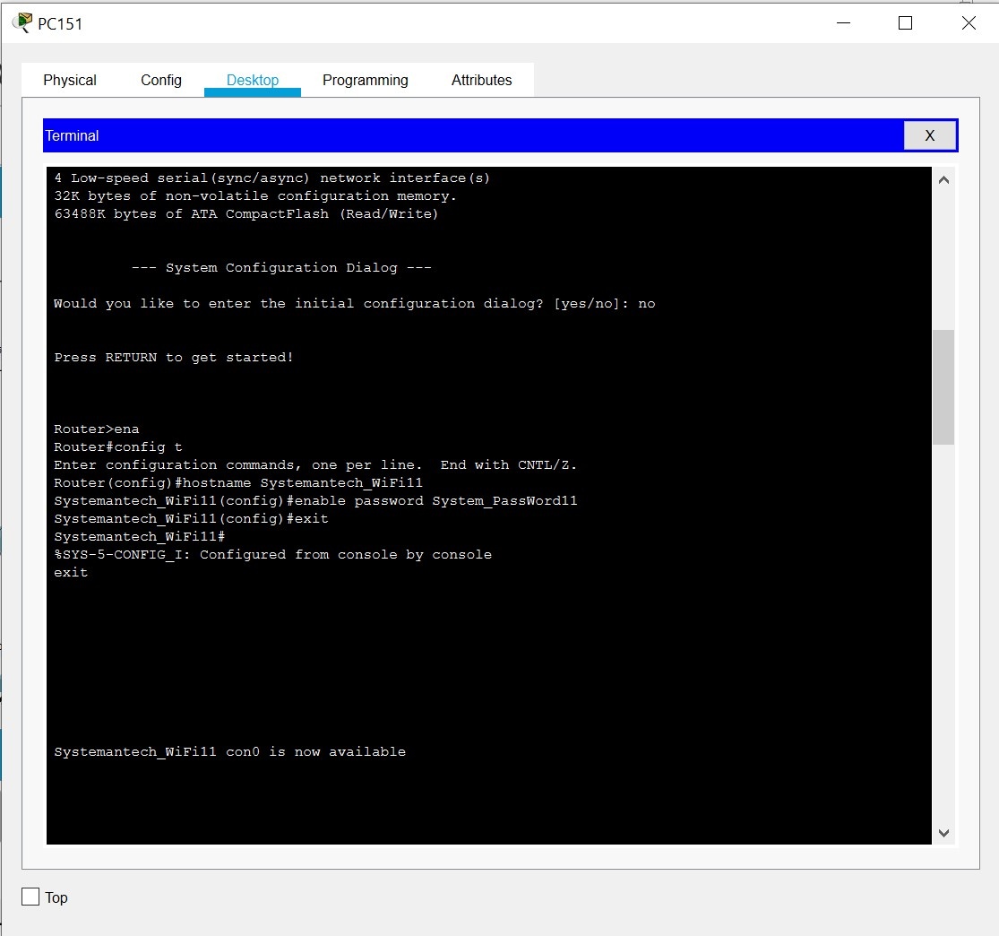

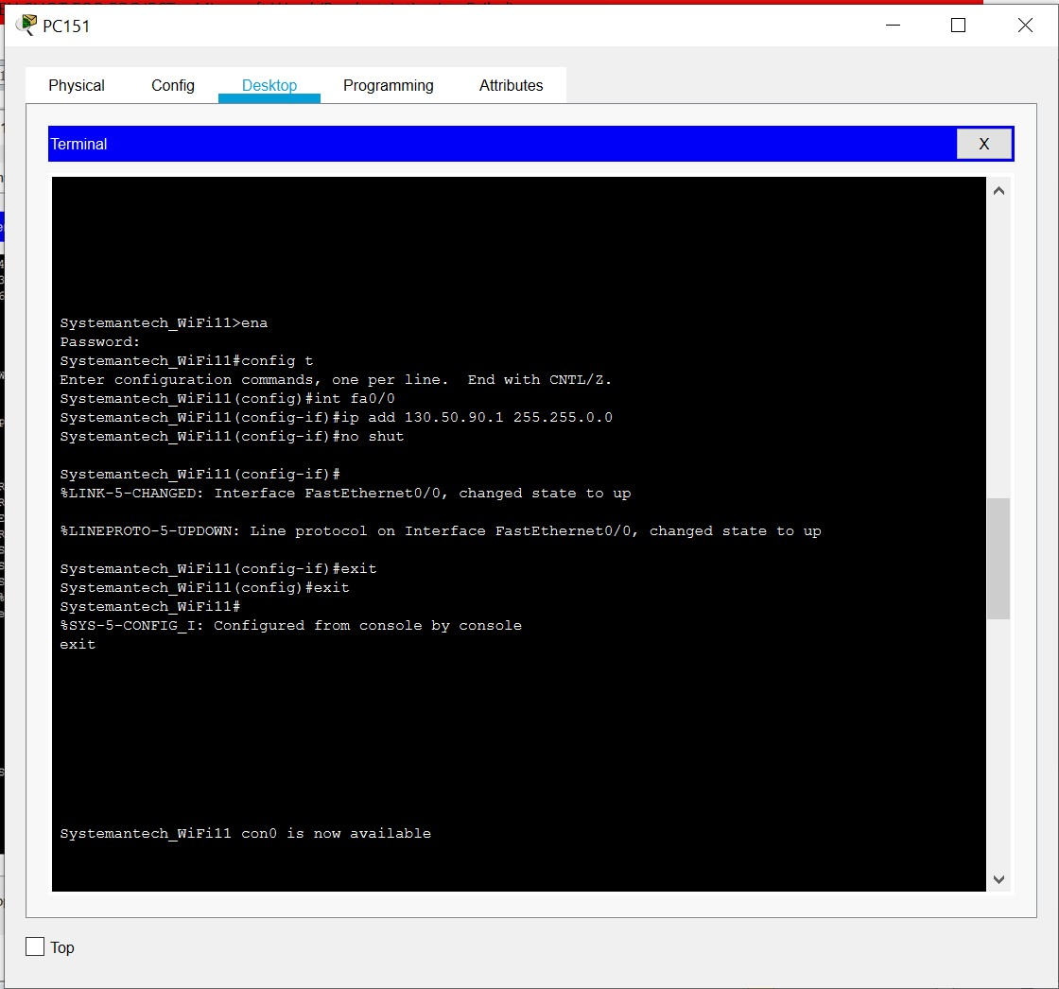

## Serial 1/0: QUALITY ASSURANCE DEPARTMENT TO TRAINING ROOM 2

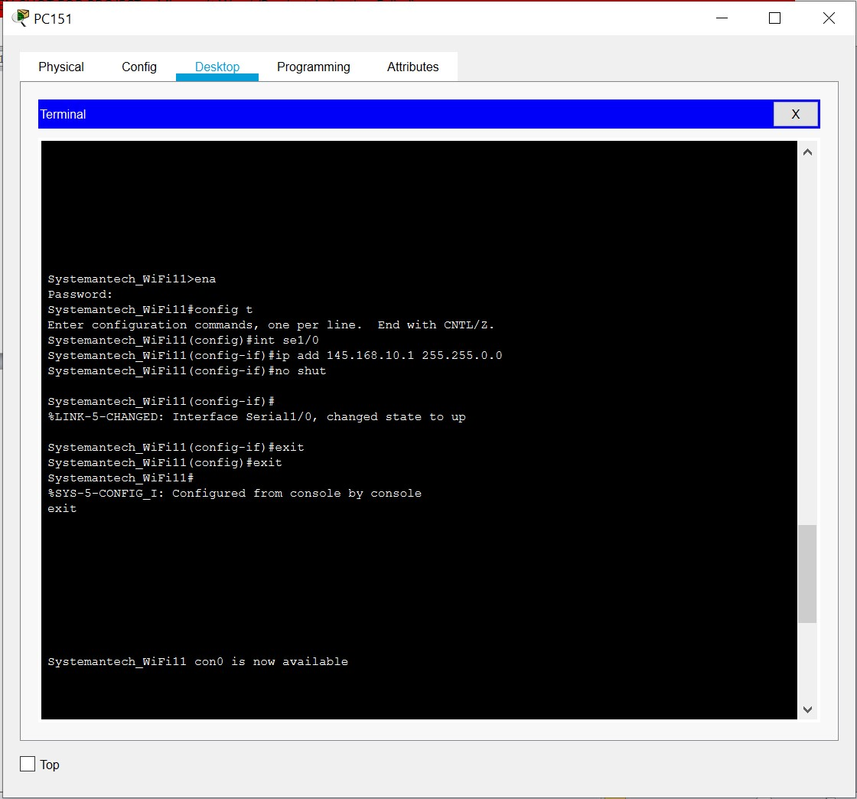

## Serial 1/1: QUALITY ASSURANCE DEPARTMENT TO IT SUPPORT DEPARTMENT

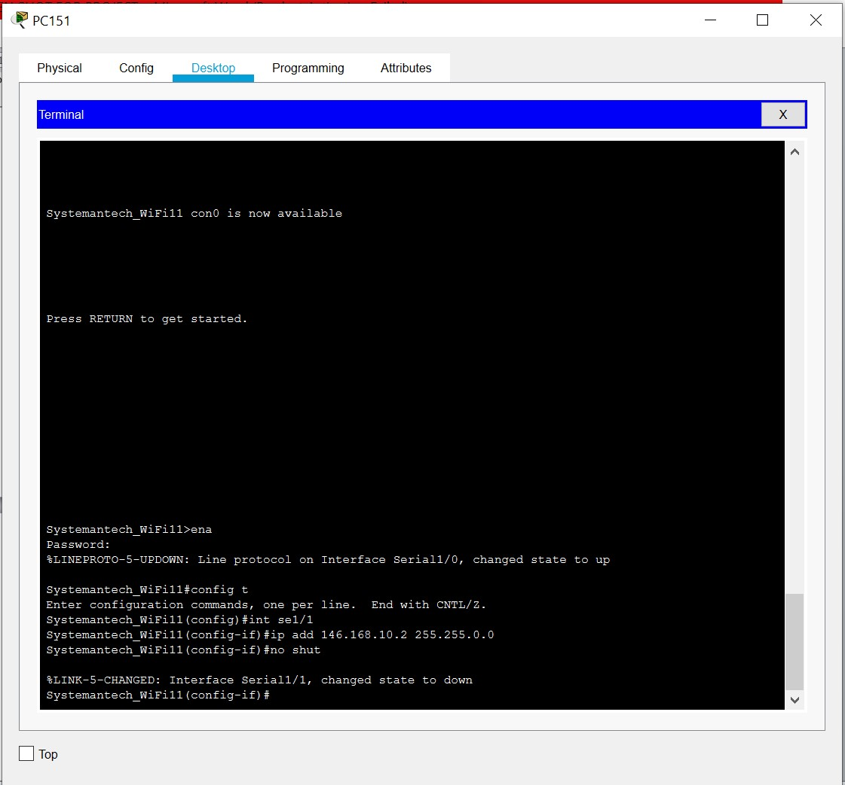

## PC 171: TRAINING ROOM 2

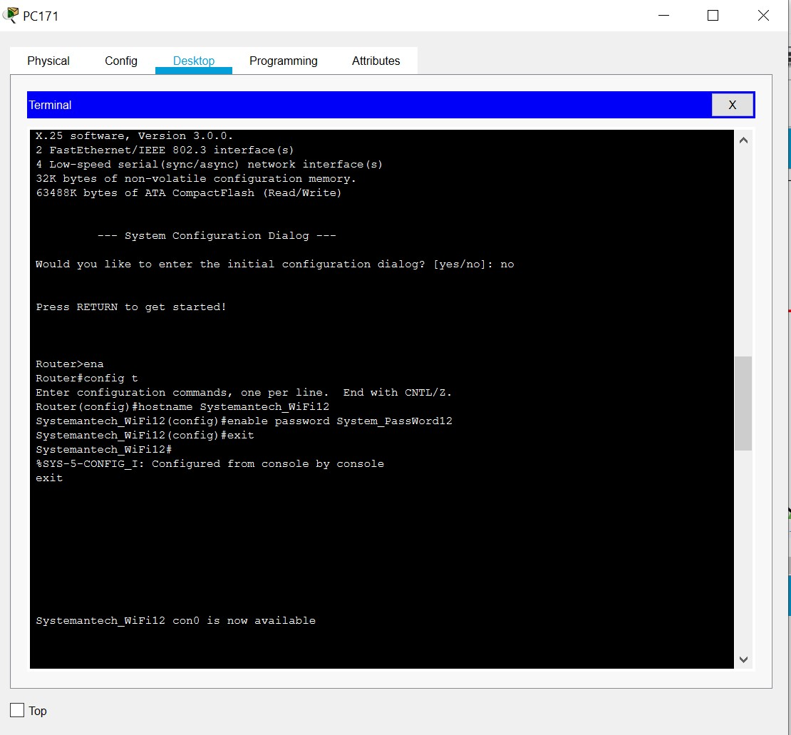

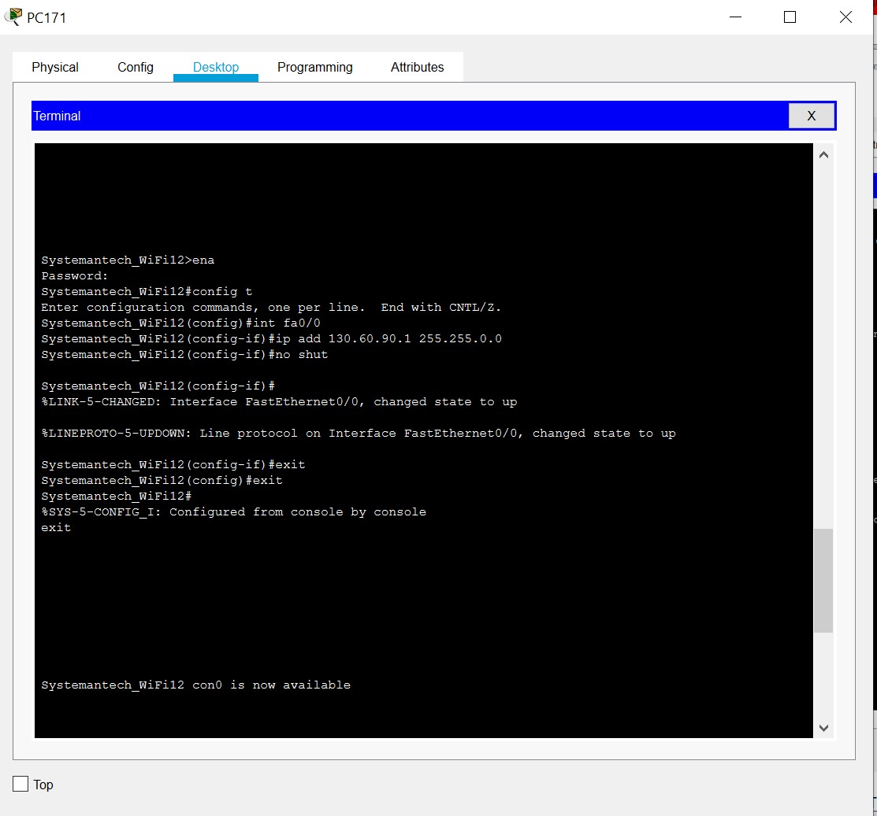

Serial1/1: TRAINING ROOM 2 TO QUALITY ASSURANCE DEPARTMENT

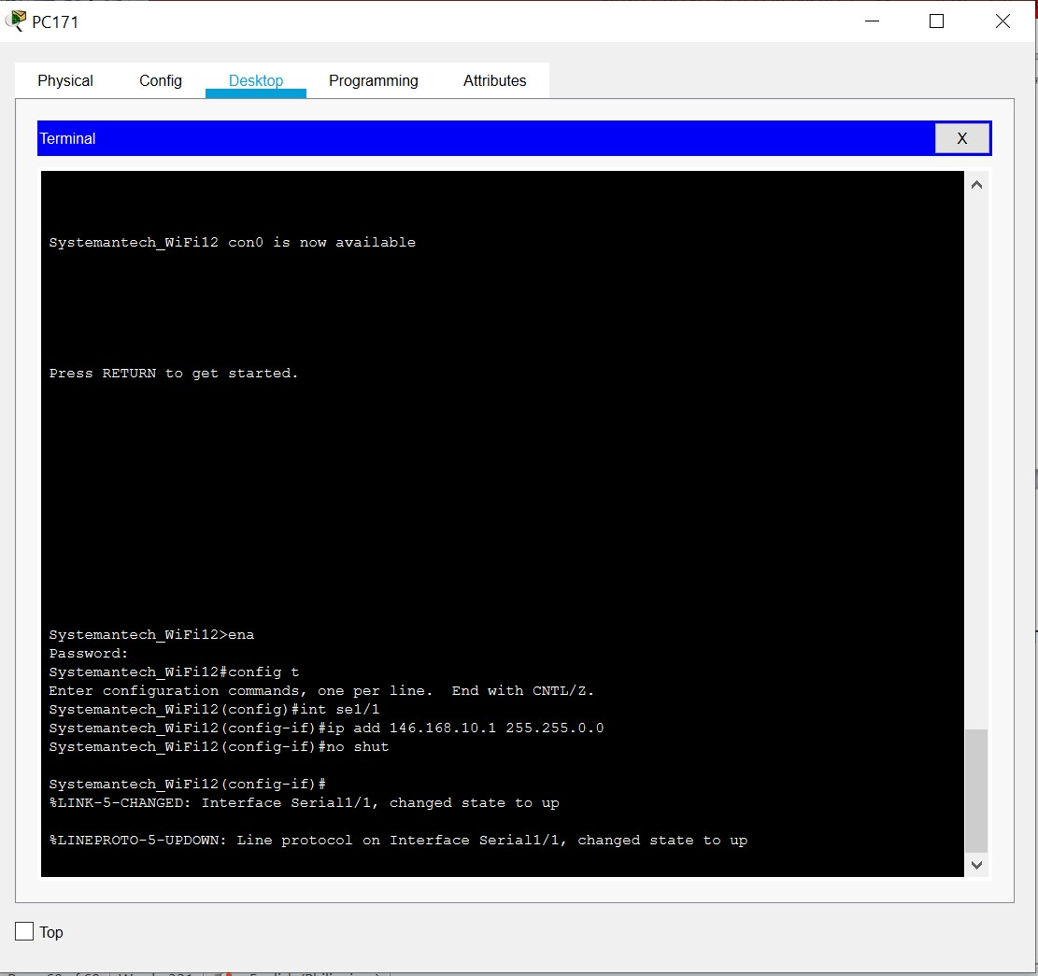

• Up and running configurations

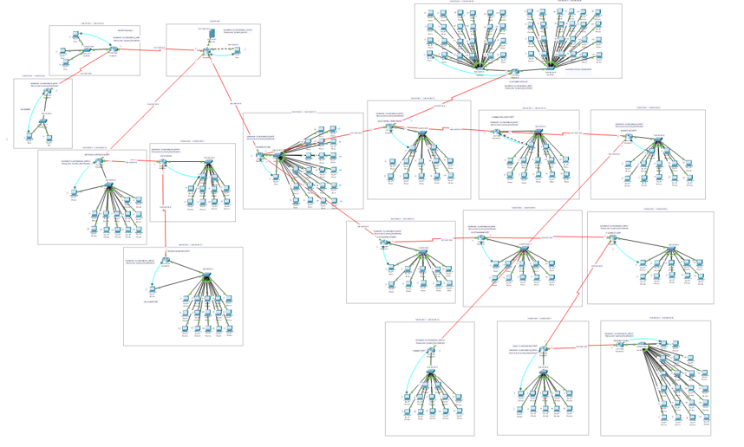

# 1.5 Recommendation and Summary

Based on our experienced, we recommend future students who are going to take this subject Data and Digital Communications and are going to make network project proposal to, first, focus on the lesson when the teacher is having a discussion to learn and to be able to apply it when doing this project so that they won’t have a hard time doing it. Also to gather information, do research about relevant information on how to create a network project proposal. We highly recommend watching videos and look for published network project proposal to serve as their guidelines on how to make their own project. When you have all the information’s gathered, it will be easier to do it. And based on our experience doing this project, we realized that it is not easy, especially on making a logical cabling layout, it was hard for us because we didn’t know what cable to use at first and none of us knows how to do the cabling layout. That’s why we are recommending you future students to put extra effort on studying it and do research about it.

In summary, this project helped us enhanced our knowledge about this subject, and it helped us learn about choosing the right network equipment and cabling layout and equipment based on the needs of the company. We also learn how to configure the network, setting up IP addresses on each departments of the company with the use of CISCO packet tracer to see the network up and running and if there is logical connection with each other. This project also teaches us how to measure our costing and budgeting of the proposed network. Above all, this network project proposal made us understand better on how to set up a network and it is a great experience and learning for us if we want to pursue a networking career.

# 1.6 Curriculum Vitae

JULIUS V. ARISTAIN

**EXPERIENCE**

**2018**

**–**

**2020**

SPES

–

Trainee

–

Taguig Municipality

**EDUCATION**

**Tertiary**

STI COLLEGE GLOBAL CITY

(2019

–

Present)

University Parkway Drive or 32nd Avenue, Taguig, 1634 Metro

Manila

**Secondary**

**STI COLLEGE**

**GLOBAL CITY**

Junior High School

(2017

–

2019)

University Parkway Drive or 32nd Avenue, Taguig, 1634 Metro

Manila

**GENERAL RICARDO PAPA MEMORIAL HIGH SCHOOL**

(2013

–

2017)

Col. P. Cruz, Tuktukan, Taguig City, Metro Manila

**Primary**

**TAGUIG ELEMENTARY SCHOOL**

(2007

–

2013)

Liwayway, Taguig, 1637 Kalakhang Maynila

**SKILLS**

•

Multi

-

tasking

•

Time management

•

Creative

•

Adaptability

•

Fast learner

**PERSONAL INFORMATION**

04

C Kampupot St. Wawa

Taguig City

09296938255

035235823

Juliusaristain213@gmail.com



**IAN CHRISTOPHER ICAONAPO**

#9 penida street

Barangay central signal

Taguig

city

+639266454050

icaonapo@gmail.com



ELEMENTARY SCHOOL

Don Andress Elementary School

SECONDARY SCHOOL

Galas National High School

**VOCATIONAL (COOKERY 2016)**

Saint Vincents College

TERTIARY SCHOOL

STI College Global City(currently 3rd year college)

**CARRIER OBJECTIVE:**

To be employed to any position in which my skills will be applied

**TECHNICAL SKILLS:**

* Hardware Troubleshooting
* System and Network Troubleshooting and Configurations
* Microsoft Office (Word, Excel, Powerpoint and Access)
* Adobe Creative Suite (Photoshop, )

**PERSONAL SKILLS:**

* Highly organized and efficient
* Ability to work independently or as a part of a team
* Can work under pressure

**REFERENCES**

* Hein madelo - 09093212341



HENDRICK MARC

J.

MADELO

**EDUCATION**

**Tertiary:**

STI C

ollege Global City

University Parkway Drive,

Taguig Metro Manila

(2019

–

Present)

**Secondary:**

San Joaquin Kalawaan High School

1601

Elizco Rd, Pasig, 1601 Metro Manila

(20

10

-

2014

)

**Primary:**

Kalawaan Elementary School

928

P.

Visitacion, Pasig, 1600 Metro Manila

(20

04

-

20

10

)

**SKILLS**

•

Hard Working

•

Computer Literate

•

Adaptability

•

Time Management

•

S

elf

-

discipline

*I here*

*by certify that the information above made by me are true*

*and correct to the best of my knowledge and belief*

.

AV Cruz St. Kalawaan

219

Pasig City

+639682116735

mhendrickmarc@gmail.com

**PERSONAL PROFILE**

To be able to

expand my learnings,

knowledge, and skills

while making a

significant contribution to the success

.

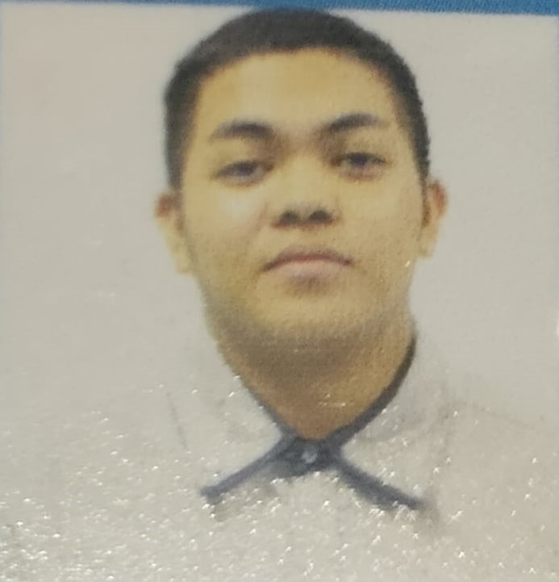

ANALIZA

T.

MAGALLANES

**EXPERIENCE**

**2018**

**–**

**2019**

E

-

Learning

(

OJT

)

5917

Algier, Makati

City

, 1210

**E**

**DUCATION**

**TERTIARY**

STI COLLEGE GLOBAL CITY

U

niversity

Parkway

Drive

, Tagui

g, Metro Manila

(

2019

–

Present)

**SECONDARY**

M

A

KATI HIGH SCHOOL

)

SHS

(

General Luna St., Brgy. Po

blacion,

Makati City

(

K12,

2017

–

20

19

)

MAKATI HIGH SCHOOL

General Luna St., Brgy. Po

blacion,

Makati City

(201

3

–

2017)

**P**

**RIMARY**

TAGAYTAY ELEMENTARY SCHOOL

Brgy. Tagaytay

,

Sor

s

ogon

, Albay

(

2007

–

2012)

**SK**

**IL**

**LS**

•

Having wholesome values of honesty and integrity

•

Hard Working

•

Good Communication Skills

•

Have a

h

ealthy attitude towards work

•

Self

-

motivation

•

Creativity

I hereby certify that the information above made by me are

true and

correct to the best of my knowledge and belief.

527

J.P. Rizal Ave. Cor

Sacramento St

.

, Brgy. Olympia

Makati City, 1207

+6

39771569933

prtty.

analizaaa@gmail.com

**PERSONAL PROFILE**

T

o be able to intensify my skills and

kn

owledge that is related to my course

and to give a good service.



